Wisconsin Storage Box

Your simple moving & storage solution

Office Location: 1668 9th Avenue
Grafton, WI 53024
(262) 377-2062
www.wisconsinstoragebox.com

16’ Storage Box $190/month
20’ Storage Box$220/month
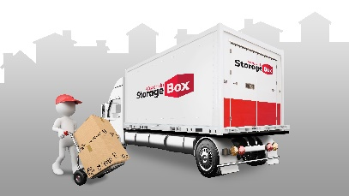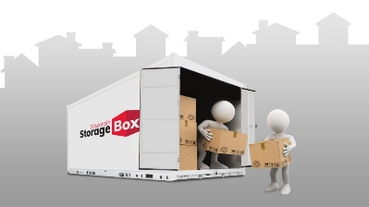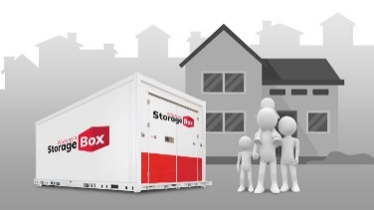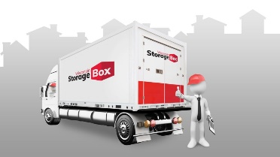
We Bring It You Pack It You Store It or We Store It We Move It

Call or request a quote online

