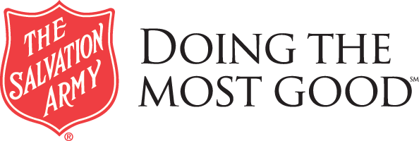
FOR IMMEDIATE RELEASE
Media Contact: Amy Evans (231) 622-1057 or amy_evans@usc.salvationarmy.org

THE SALVATION ARMY RECEIVES GRANT FROM THE GREAT LAKES ENERGY PEOPLE FUND TO REPAIR RETAINING WALL
June 14, 2018, Petoskey, MI- The Salvation Army, Petoskey Corps has received a $1,850.00 grant from The Great Lakes Energy People Fund to do minor repairs to the crumbling retaining wall around the perimeter of the front parking lot and Community Center.
The Community Center houses many programs and services such as Emergency Financial Assistance, After School, Teen Center, Community Meals, Pantry, Chapel and more. “Our Community Center is the place people come for help and hope” says Development Director, Amy Evans. “It is vital that we keep the structure maintained so we can keep the doors open for those in need in our community”.
Members of Great Lakes Energy support the People Fund by voluntarily rounding up their bills to the next highest dollar. The rounded up amount is distributed to non-profit organizations and charitable activities that benefit people in the communities served by the cooperative. Contact Great Lakes Energy at 888-GT-Lakes or visit gtlakes.com for more information.
The Salvation Army, an international movement, is an evangelical part of the Universal Christian Church. Its message is based on the Bible. Its ministry is motivated by the love of God. Its mission is to preach the gospel of Jesus Christ and to meet human needs in His name without discrimination. For more information about our ministry and programs, please visit us at www.sapetoskey.org or call us at (231)347-3531.

