04737 Fuller Road, East Jordan, MI 49727
(231) 536-3369 |www.miravenhill.org info@miravenhill.org
Raven Hill Discovery Center is a 501(c)(3) tax-exempt corporation.
Mission: Raven Hill provides a place that enhances hands-on and lifelong learning for all ages by connecting science, history & the arts.

To: friends and family everywhere
From: Cheri and Raven Hill
Date: May 1, 2020
Re: Update

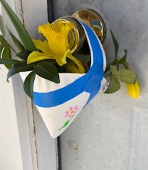
Happy May Day, everyone! How many of you remember being a kid and making small paper cone-shaped baskets on May Day, filling them with flowers and delivering them to the neighbors. We would sneak up to the front door & leave the flowers, ringing the bell and running away! Can’t really deliver your May Day basket this year, so am sending a picture instead! Interestingly enough, after researching May Day, I discovered that it has its roots in astronomy. May 1st is halfway between the spring equinox & the summer solstice! It’s one of the Celtic cross-quarter days, which celebrates the midway points between all solstices & equinoxes of the year!

Raven Hill continues to shelter in place. We are busy behind the scenes with our Home Learning Opportunities on Facebook and the web, as well as a Photo Journal page and today we added a History Journal page to the website. Check them all out! There’s a new one at least every weekday, sometimes on weekends!

We are also trying to figure out our future: how to be hands-on and yet enforce social distancing and deep cleaning between uses of the musical instruments, small toys and other “exhibits” in the main museum room. There is also a question of how or if we can continue to have the animal room. Again, it is a question of how to make it work with distancing & cleanliness. We are also working on exhibits, events and programs for 2021. The Smithsonian Labor Days History of Work exhibit has been rescheduled to August & September of 2021. And of course, we are trying to figure out funding to get us through to 2021. Your ideas are welcome and your support is appreciated.

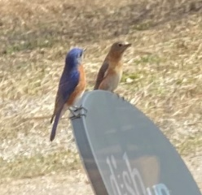
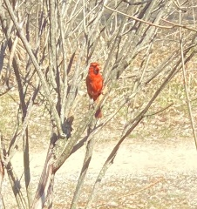
Here at home, the cardinals and bluebirds have finally stopped trying to shelter in place inside my house. They must have realized that I was not going to let them in! Or maybe they just decided that their reflection was not another bluebird or cardinal in their territory! Either way, glad they are no longer hitting my windows.

For those of you who did not hear, Pat Wulff passed away last Friday, April 24th around 11:39am with her daughter, Barb, by her side (Not COVID). She will be cremated and her ashes will be buried in Cincinnati by her parents, husband and son. There will be no announcement and no funeral service. Pat was a great supporter of Raven Hill in many ways. She will be missed. Glad that the volunteers got together and put up the flag pole in her honor back in 2016. We will celebrate her life, once we can all be together again.

Thinking of you all on this beautiful sunny day. Please share positive thoughts and support with others during these trying times. Stay safe, everyone, and call me any time: 231.675.6025. I would love to hear your voice and learn how you are doing. Stay safe and well, Cheri

