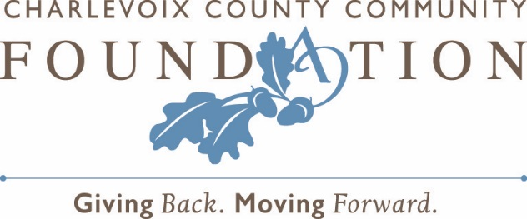

For Immediate Publication
March 24, 2020
Contact: Chip Hansen, President
231.536.2440

Urgent Needs Fund Makes Grants to Help Neighbors Impacted by COVID-19

There are lots of needs right now. They are likely to continue for some time. By supporting local nonprofit organizations, community members can help meet some of those needs for individuals and families who are experiencing loss of income caused by COVID-19.
Food pantries and human services organizations that provide help with utilities and other necessities will see community needs increase in the weeks ahead. Donations to those organizations will ease the burdens faced by many who are unable to work due to necessary social distancing.

In response to this situation, the Charlevoix County Community Foundation (C3F) has made $25,000 in grants to partner organizations. “Our goal will be to mobilize additional resources from the Urgent Needs Fund and others to respond to the developing COVID-19 crisis that is impacting friends and neighbors across Charlevoix County,” said Chip Hansen, President of the Community Foundation. To provide resources to nonprofits over the next weeks and months, and to help ensure funding will be available in the longer term, C3F encourages community members who want to help to make contributions to the Urgent Needs Fund at c3f.org.

Nonprofit partners who are providing critical services to individuals and families who are disproportionately impacted by the instability and economic consequences caused by COVID-19 are eligible for further support as well. “The Community Foundation will be using the Urgent Needs Fund to help partner organizations, though the funding is limited,” notes Hansen. “We have provided an Urgent Needs grant application through our website to help partners receive support. We will also work to connect donor advisors – individuals, families, and businesses that have charitable funds here at the Community Foundation – with our community’s needs,” he explains.

The Charlevoix County Community Foundation is a grassroots charitable organization made up of various funds – all of them established by local donors – to enhance the quality of life in Charlevoix County, now and for generations to come. For more information about the grant-making process, establishing a fund, or making a gift, please contact the Charlevoix County Community Foundation online at www.c3f.org.

###

