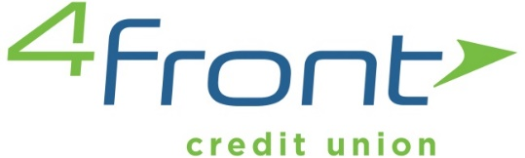
NEWS
RELEASE

CONTACT: Meghan Morelli FOR IMMEDIATE RELEASE
Community Relations Specialist Tuesday, July 31, 2018
231.932.5252
mmorelli@4frontcu.com

4Front Credit Union appoints two to impactful new positions
Area financial services provider taps Eychaner and Morelli to lead technology and community efforts

4Front Credit Union has named Zach Eychaner vice president of its new Digital Services department. Eychaner previously managed the 77,000-member institution’s contact center. Eychaner guides the delivery of streamlined account management tools through non-branch channels, including 4Front’s contact center, virtual banking and related platforms, and VideoTeller – 4Front’s recently introduced interactive teller machines. A native of Houghton Lake, Eychaner’s 15 years of credit union experience include extended stints at several leading southern Michigan institutions.

Meghan Morelli has joined 4Front Credit Union as its Community Relations Specialist. An area television news reporter and anchor for almost six years, Morelli previously served northern Michigan in a very unique way. Leading 4Front’s local involvement efforts will allow her to continue doing so, but in a different capacity. Morelli will further enhance 4Front’s community engagement, managing the credit union’s sponsorship and charitable giving efforts. She’ll also partner with area schools to coordinate financial literacy programs and connect 4Front team members with impactful local initiatives.

“We’re thrilled to expand our team of financial experts with the additions of Zach and Meghan,” said 4Front CEO David Leusink. “Both are dynamic, forward thinking team players who will lead supremely important focus areas, respectively – member account management technology and community connectedness.”
####

