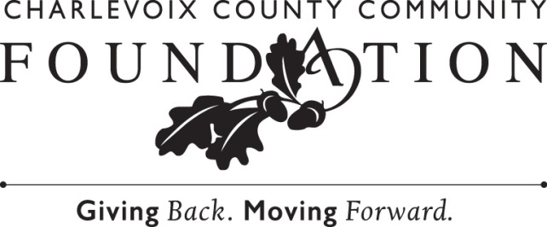

For Immediate Publication Contact: Chip Hansen, President
February 20, 2023 Charlevoix County Community Foundation
231-536-2440

Chip Hansen Announces Retirement from Charlevoix County Community Foundation

After serving as the Community Foundation’s President for the past 13 years, Chip Hansen has announced that he will retire at the end of April 2023.
During Hansen’s tenure as President, the assets of the Community Foundation grew from $19.4 million in July 2010 to more than $55 million today. The number of charitable funds has grown to 330. Total grants and scholarships have increased from $1 million to more than $2.5 million annually. More than 80 Legacy Society members have been added as well, and these future gifts will ensure that the Community Foundation will continue to work at the intersection of resources and opportunity well into the future. He has expanded the role of the Community Foundation as a visible and engaged leader in the community locally, while also enriching the field of philanthropy regionally and statewide. Along with others, Hansen organized a group of regional community foundation leaders who meet quarterly to share resources and ideas. He has served on several Council of Michigan Foundation (CMF) planning committees and is currently serving as one of four co-chairs of CMF’s 50th Anniversary Committee. “Chip has been a dedicated and faithful advocate for all of us in Charlevoix County. His tireless work at the Charlevoix County Community Foundation will leave a measurable impact on our area for generations to come,” says Board Chair Monica Peck. “All of us who have had the pleasure of working with Chip have benefited from his kind and innovative leadership.”
Hansen reflects that “it’s been the honor of a lifetime to have had the opportunity to lead the Charlevoix County Community Foundation and to have worked alongside so many good-hearted people . . . humble and generous donors, committed nonprofit partners, dedicated current and former members of the Board of Trustees, and an incredibly talented team of staff members through the years. It’s gratifying to reflect on the good that we’ve done together, and exciting to think about what the future will hold for the Community Foundation, as it has the right team at the right time to continue moving the community forward.”
The Board of Trustees selected the Community Foundation’s Vice President Sara Ward to succeed as President effective as of May 1, 2023. Ward has distinguished herself in 15 years in the field, including 7 years at the Charlevoix County Community Foundation, as a thoughtful, innovative, and collaborative leader with a passion for community philanthropy. “I have seen what can be accomplished with relationships, resources, creativity, and commitment, which is why I believe in community philanthropy,” explains Ward. “By bringing people and resources together for the past 30 years, the Community Foundation really has made a difference. I’m grateful for the opportunity to work with our highly-capable team, dedicated trustees, and generous community members to continue that positive impact close to home.”
Board Chair Peck shares: “In the months ahead, Chip and Sara will continue to work closely together to ensure that the transition in leadership is both smooth and complete. The Trustees are enthusiastic about the next chapter at the Community Foundation.”
The Charlevoix County Community Foundation is a grassroots charitable organization made up of various funds – all of them established by local donors. Some funds are earmarked for specific causes, and others are open-ended to meet changing needs. The funds are held in permanent endowment, so they can continue to grow and generate income to enhance the quality of life in Charlevoix County, now and for generations to come. For more information about the grant-making process, establishing a fund, or making a gift, please contact the Charlevoix County Community Foundation at (231) 536-2440, or online at www.c3f.org.

-end-

Photo Caption: Chip Hansen has served as the President of the Charlevoix County Community Foundation since July 2010. He has announced that he will retire at the end of April 2023.

