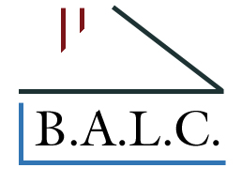

Member Spotlight Form
Please complete the following form to provide us with additional information about your company and we will promote you during our Member Spotlight.
Being featured is totally free of charge to our members!

Member Information
Enter your contact information as you would like it to appear in all marketing materials.

Company Name *
Must be listed as BALC Member in good standing.

Description of Services *
Please provide a brief description of your company services.

Special Highlights
What are you most proud of? Have you received any awards or recognition? BALC Involvement / Years joined & committees served on:

What sets you apart? Include Years you have been in the industry, Business specialty, Business motto or quote about your business, Latest Trend in your industry,
In 1-3 sentences tell a consumer why they should use your services.

Logos, Photos, Videos *
What files can you share that will enhance your Member Spotlight? (Check any and all that you will provide)
Company Logo
Photos
Video
Other

Submit the form by emailing to BALaporteCounty@gmail.com

We will be in touch with you to schedule your Member Spotlight.

You can also send your company logo, images, and or video content or email questions to Cindy at BALaporteCounty@gmail.com

