Tomatoes
We are just starting our tomato season and over the coming weeks our farmers will pack one to more varieties of tomatoes in each box – the varieties will be randomly divided among boxes.
Cherokee Purple Heirloom has skin and flesh ranging from a deep red to purple in color, with a rich sweet flavor, mildly acidic. They are exceptionally juicy!
﻿
Perhaps the best known heirloom tomato, Brandywine is a large tomato, pinkish in color with a perfect balance of sweet and acidic – a full flavor tomato!
Bing Cherry A classic cherry tomato, bright red, plump and sweet like candy. Use your cherry tomatoes for snacking on or in any summer salad. These are perfect tomatoes for skewering whole on veggie kababs over the grill. Nice in a Caprese Salad. You can certainly use them in salsa and I recommend making a chunky salsa by quartering your cherry tomatoes. Sun Sugar Cherry A petite, super sweet and tangy variety are great for introducing kids to tomatoes for the first time. Beautiful yellow-orange in color, Sun Sugars are perfect for displaying on a platter of mixed tomatoes, drizzled in olive oil or cut in half and mixed with sliced cucumbers and a touch of salt. They will add another color to your salsa, so quarter or dice them coarsely and throw in! Amish Paste Heirloom: A wonderful meaty, thick walled variety with few seeds and a low water content suited for canning or cooking down for sauce. If you aren't interested in making sauce, these are equally good diced and tossed into pasta or other dishes. They are good to use when making a thicker, chunkier salsa. Black Krim Heirloom: Moderate-sized, fairly round with dark skin and dark flesh ranging in color from deep red to maroon or even purplish black - giving a good indication of their deep rich flavor. Black Krim are simultaneously meaty and juicy, sweet and acidic, with a very intense and complex flavor. This is Susanne's favorite tomato variety! Pink Oxheart: An adorable heart shaped heirloom tomatoes, pale and pinkish in color, meaty and firm in texture, with minimal seeds and open seed-cavity - much like the Amish Paste, but larger in size. Sweet and tasty! These will make a good thick chunky salsa!
Big Beef: A well-known large standard slicing variety, great for sandwiches. Juicy and tasty! These can get quite large and will make a fair amount of salsa! Any of our shareholders grow up on Tomato Sandwiches? A summer tradition with many Minnesota families.

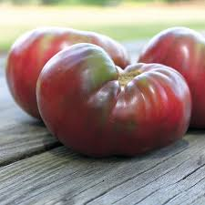  Cherokee Purple Heirloom Tomato | 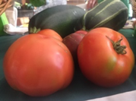  Brandywine Heirloom Tomato | 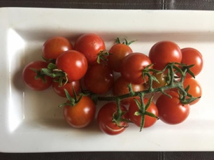  Bing Cherry | 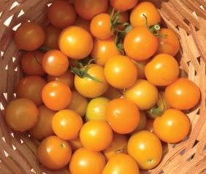  Sun Sugar Cherry

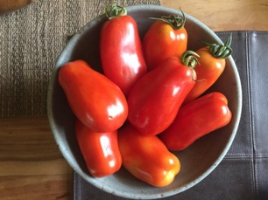  Amish Paste Heirloom Tomato | 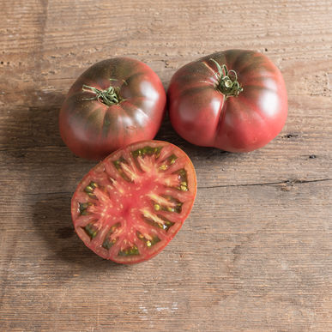  Black Krim Heirloom Tomato | 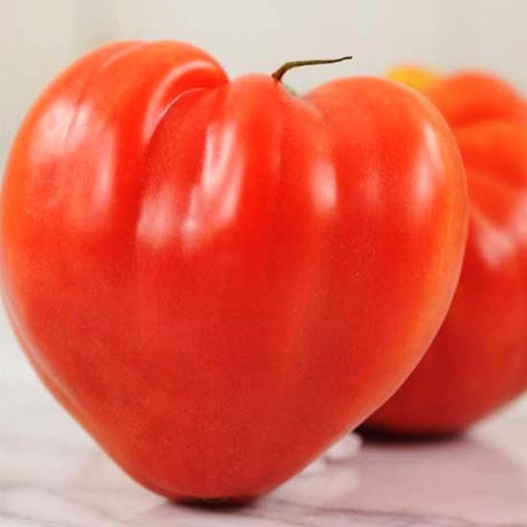  Pink Oxhart | 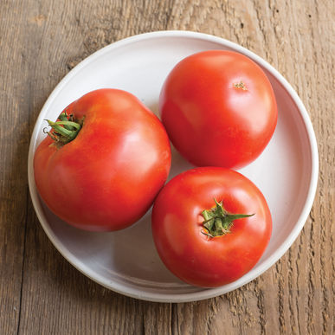  Big Beef Slicing Tomato

