

N E W S L E T T E R

June 2025
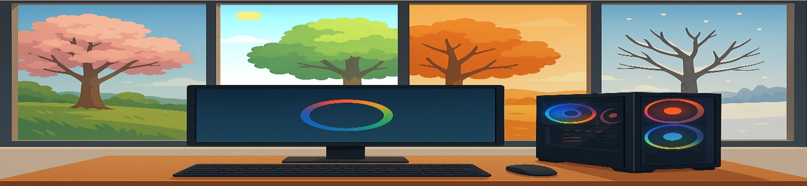

How Long Should a Computer Really Last?

What are Cookies?
If you're wondering whether it's time to replace your computer or give it a little upgrade, you're not alone, and we get this question a lot. The answer is: it depends.
There's no magic number of years a computer is supposed to last. Some go strong for ten years, while others barely reach their third birthday. The difference often comes down to what you bought in the first place and how it's been used.
Let's walk through what actually affects how long your computer can keep up with you.

What Kind of Computer Did You Start With?
Think back to when you first bought your computer. Was it a top-of-the-line model with room to grow, or was it a budget-friendly option that just did the job?
A more powerful computer at the start usually has more speed overhead. That means it wasn't working at full capacity right away, so it can handle growing demands for longer. Budget computers, on the other hand, often run close to their limits right out of the box. That can make them feel outdated much sooner.
So, if your computer was already struggling with a few tabs open in the browser back then, it might not be able to catch up with today’s demands; never have had much breathing room to start with.

Why Does It Feel Like My Computer Is Getting Slower?
Here's the thing: your computer hasn't become slower; its specifications are the same as the day you bought it. What has changed is the software.
Operating systems, apps, and even your Web browser are constantly being updated. These updates often come with more features, bigger file sizes, and higher demands on your computer's resources. Over time, your once-speedy system starts to feel like it's dragging its feet, not because it's broken, but because it's trying to keep up with software that's expecting newer hardware.
In some cases, we can help by swapping out heavy software for something lighter. There are less-demanding versions of browsers, office software, and even operating systems. If you're not ready to part ways with your computer just yet, this can be a great short-term solution.

When Software Outgrows Your Hardware
Eventually, your computer might hit a wall where it can no longer be updated, and this is especially common with Macs. Once your operating system stops receiving updates, the apps you use, such as your Web browser, email program, or even basic productivity tools, may also stop supporting that version.
That's more than just an inconvenience; it's a security risk. Web-accessible apps that can't update leave the door open to security holes. New exploits are found daily, and you're exposed if you can't patch your system.
If we spot that your system has reached this point, we'll be honest with you. Sometimes it's just not worth trying to stretch it any further.

TOPIC CONTINUES ON NEXT PAGE

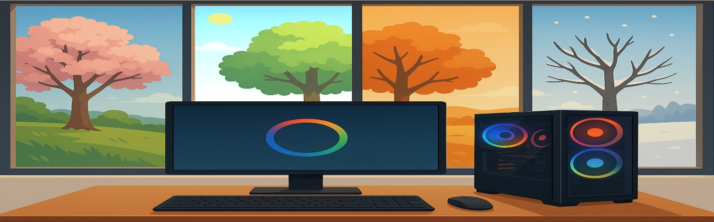

How Long Should a Computer Last?

>>>Continued from prior page<<<

What are Cookies?

Can You Upgrade Instead of Replacing?
In many cases, yes. We've breathed new life into plenty of older computers with a few simple upgrades.
One of the biggest performance boosts you can get is replacing a traditional hard drive with a solid-state drive (SSD). It's one of those changes you feel straight away. Your computer boots faster, apps open quicker, and everything just feels smoother.
Adding more RAM can also help, especially if you like to keep lots of browser tabs open or work with large files. These upgrades are often more affordable than you'd think and can add a few more good years to your machine.

When It's Time to Let Go
Of course, upgrades aren't always the answer. Sometimes the cost of upgrading an older computer is more than what it's worth, especially if multiple parts are outdated. Or maybe you've outgrown what the machine can realistically handle.

That's where we come in. If your computer is running slow or you're unsure whether to fix or replace it, give us a call at 940-282-0290.
We'll take a proper look, talk through your options, and help you find the best path forward, whether that's a quick tune-up, some targeted upgrades, or helping you choose a new machine that won't let you down.
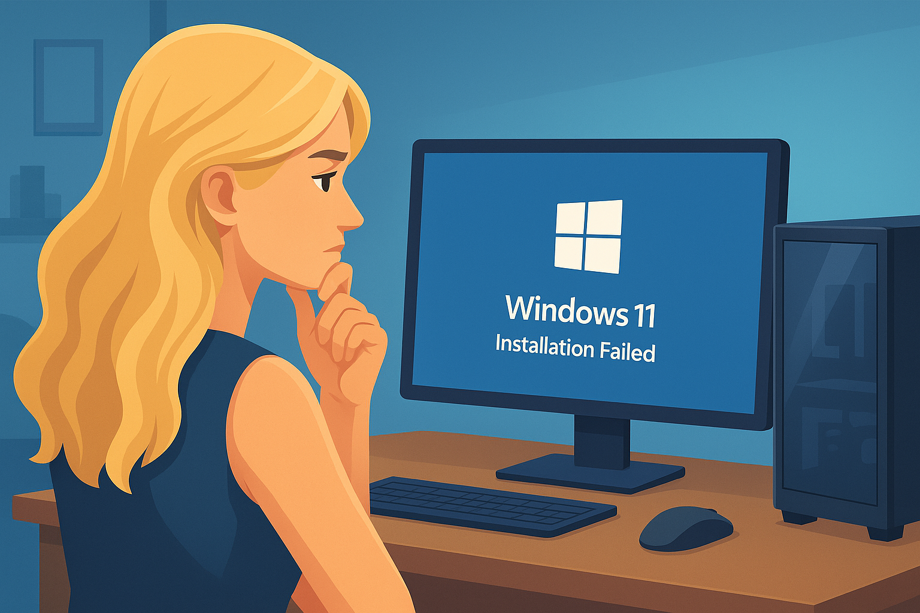

Why Can’t I Upgrade to Windows 11?

What are Cookies?
If you're trying to upgrade your computer to Windows 11 and hitting a brick wall, you're not alone. We've had quite a few customers asking us the same thing: "Why can't I upgrade to Windows 11?" The short answer is that Windows 11 has stricter system requirements than previous versions of Windows.
Let's walk through the reasons why it might not be working for you and what your options are.

Windows 11 Has Stricter Requirements Than Before
Unlike previous upgrades, where almost any Windows 7 or 8 computer could move to Windows 10, Windows 11 has a few more hoops to jump through. For the first time, not every computer is invited to the party.
Microsoft made this version with a strong focus on newer hardware, which means if your computer is more than a few years old, you might be left out unless you undertake some upgrades.

TPM Is the Biggest Sticking Point
TPM stands for Trusted Platform Module. It’s a small security chip built into most newer computers, but many older ones don't have it. If you don't have TPM version 2.0, Windows 11 will not install.
If your computer is from around 2018 or later, there's a good chance it has TPM; it might just be turned off in your BIOS settings. If your computer is older, it may not have one at all. In that case, the upgrade might not be possible without replacing the motherboard.

UEFI and Secure Boot Might Be Required
UEFI is the modern replacement for the old BIOS system. It’s what you briefly see when your computer first powers on, that black screen with white text before the Windows logo appears.
Windows 11 needs both UEFI and a setting called Secure Boot to be turned on. Sometimes these are available in the BIOS but not switched on. Other times, if your computer was set up a certain way, switching it on might stop it from starting up properly.
This can be tricky to do yourself unless you are comfortable navigating BIOS menus and boot modes.

Not Enough RAM or Storage Space
Windows 11 needs at least 4GB of RAM and 64GB of storage space to install. Most modern computers should have this, but we've seen some older mini-PCs and budget laptops that fall short.
The good news is that RAM and storage can often be upgraded. The not-so-good news is that some smaller devices have soldered components or no extra slots, which means you might not be able to upgrade without replacing the device entirely.

It Looks Like You Can Upgrade, But You Still Can't
Here's a frustrating one. You run the PC Health Check tool or another compatibility checker, and it says you're all good, but when you try to upgrade, it still won't go through.
This could be due to firmware bugs, out-of-date BIOS versions, hidden security settings, or even leftover upgrade blockers from older failed updates. It's confusing, and it's not just you.

TOPIC CONTINUES ON NEXT PAGE

Why Can’t I Upgrade to Windows 11?

>>>Continued from prior page<<<

We can often sort this out by digging a little deeper into your system's update logs and BIOS version, and adjusting the configuration if needed.

Do You Need Windows 11 Right Now?
Not immediately. Microsoft will keep supporting Windows 10 with updates until October 14, 2025. But after that, it will stop getting security updates, which means using it could become risky.
If you leave it too late, you might find yourself scrambling for help when everyone else is doing the same. It is better to find out now whether your computer is ready or what you'll need to do to get it there.

What You Can Do Next
If you're not sure whether or not your computer can upgrade, we recommend running the official Windows 11 compatibility checker from Microsoft. But don't be surprised if the results are confusing.
You can also bring your computer to us, and we'll do a full check for you. We'll look at:
- Whether your system meets all the upgrade requirements.
- If there's anything in your BIOS that needs to be changed.
- Whether a hardware upgrade, such as adding TPM or RAM, is possible.
- What are your options if it turns out your system isn't compatible at all?

How We Can Help
We help people every day who are stuck somewhere between "I think I can upgrade" and "Why won't this thing work?"
Whether it's unlocking TPM, changing BIOS settings, or upgrading components, we can handle it. And if your system just won't cut it, we can help you choose a new one that won't break the bank and will last you for years to come.
If your computer won't upgrade to Windows 11, and you're not sure what to do next, we're here to help.
Give us a call at 940-282-0290 or drop by our shop at 2017 State Hwy 16 S, Graham, TX 76450 (directly across from the Dollar General store). We'll make it simple.

