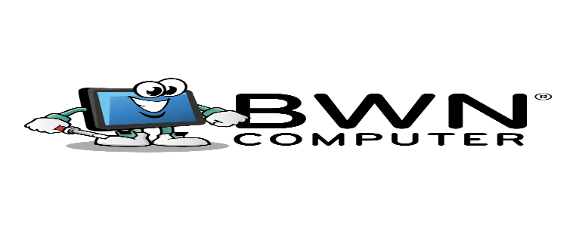

# N E W S L E T T E R

**May 2025**



# Technical Support and Computer Training: Getting the Most Out of Your Tech

# What are Cookies?

Technology can open up a world of possibilities but only if it works how you want it to. From streaming your favorite shows to checking your bus timetable, more and more everyday things now rely on having a working computer, smartphone, or tablet.

If you're feeling a bit left behind, you're not alone. We're here to help with friendly, face-to-face tech support and computer training. Whether you're just getting started or want to learn a little more, we can make it simple.

**Getting New Devices Set Up the Right Way**

Have a new gadget sitting in the box? We can help you get it up and running properly, whether it's an Apple TV, Chromecast, or a smart speaker, we'll:

1. Connect it to your TV or network.
2. Get your streaming apps such as Netflix, Disney+, and Amazon Prime working.
3. Walk you through how to use the remote or app so you feel confident using it.

The same applies to printers. Setting one up the right way can be fiddly, especially if you want to print wirelessly. We'll take care of:

1. Installing the printer on your computer or device.
2. Connecting it to your Wi-Fi.
3. Showing you how to use all the main features, such as scanning and copying.

**Learn How to Use Everyday Services Online**

It's becoming more common for companies to direct you to their website for things such as:

1. Paying bills.
2. Accessing schedules or public transport timetables.
3. Booking appointments.

We can sit down with you and walk through how to:

1. Find and bookmark the right websites.
2. Use your council, bank, or service provider's site properly.
3. Use search tools such as Google to get what you need faster.

If you'd like help using Facebook or video chat apps such as Zoom or WhatsApp, we can guide you through that as well.

***TOPIC CONTINUES ON NEXT PAGE***



# Technical Support and Computer Training: Getting the Most Out of Your Tech

# >>>Continued from prior page<<<

# What are Cookies?

**Get Your Home Wi-Fi Set Up and Working**

Trying to set up Wi-Fi for the first time? Or maybe your connection keeps dropping out? We can:

1. Help choose the right spot for your modem.
2. Set up your Wi-Fi network and name it something you'll remember.
3. Connect your devices, including laptops, smart TVs, tablets, and phones.
4. Show you how to reconnect later if anything ever drops out.

Having a solid home Wi-Fi setup makes everything run smoother, from streaming videos to video-calling the grandkids.

**Access Email from Anywhere**

Being able to check your email from your phone or tablet is handy, but getting it set up can be confusing. We can:

1. Set up your email account on your smartphone or tablet.
2. Make sure everything syncs properly.
3. Show you how to read, reply to, and send emails.

We'll even explain how to spot scam or spam emails, so you feel more confident using email every day.

**We Come to You and Speak Your Language**

You don't need to learn tech jargon or do it all yourself. We make it easy, and we come to you. Whether you want something fixed or want to learn how to use something new, we'll go at your pace.

Our goal is to help you get more out of your technology, without stress.

If you'd like help setting something up, fixing an issue, or learning how to do something online, give us a call anytime at 940-282-0290. We'd love to help.



# Why Pirated Software isn’t Worth the Risk

# What are Cookies?

You've probably heard about pirated software before, maybe from a friend or an online forum where someone mentions getting expensive software for free. And let's be honest, in a home setting, it might feel like the chances of getting into trouble are pretty slim.

But there's another side to the story.

It's not just about avoiding legal issues. The real concern is what pirated software can do to your computer and your privacy. Let's walk through it together.

**Cracks and Patches Can Open the Door to Malware**

To get pirated software working, people often use something called a *crack* or a *patch*. This is a tiny program that edits part of the software to skip the normal checks that make sure it's a paid, legal copy.

Sounds clever, right?

But here's the thing: that little crack is literally rewriting the program's code. And once it's doing that, it can just as easily add something nasty while it's at it, such as malware or spyware.

You might not even notice at first. Your software may seem to work fine. But in the background, your computer could be silently leaking data, running slower, or being used as part of a bigger network of infected machines.

We've seen computers come in with antivirus completely disabled, all because of a dodgy patch file.

**Key Generators Often Come with a Hidden Surprise**

Some software uses license keys – a long mix of letters and numbers – to prove it's genuine. Pirates often bundle in a *key generator* (sometimes called a "keygen") that claims to create a valid key for you.

But think about this: whoever made that keygen knows you're probably going to run it. They know you're expecting a pop-up window and a bit of code. And they know you're more likely to click "Allow" if your computer asks whether it can run.

It's the perfect opportunity for someone to slip in a virus. And because the file was downloaded from an unofficial source, your computer doesn't know if it's safe or not until it's too late.

**Torrents Don't Just Download: They Upload Too**

If you're using torrents to get pirated software, there's something you might not know. Even if your download is only 10 percent complete, your computer is already sharing that 10 percent with others.

That's how torrents work; they're built to share pieces of files between users. But it also means your IP address (your internet connection's unique label) is visible to anyone else downloading the same file.

Some software companies monitor these torrents. They track IP addresses and send copyright infringement letters through internet providers. You might never get one, but some home users do.

And even if you're not caught, you're still uploading copyrighted material to other people. That's a risk many people don't realize they're taking.

***TOPIC CONTINUES ON NEXT PAGE***

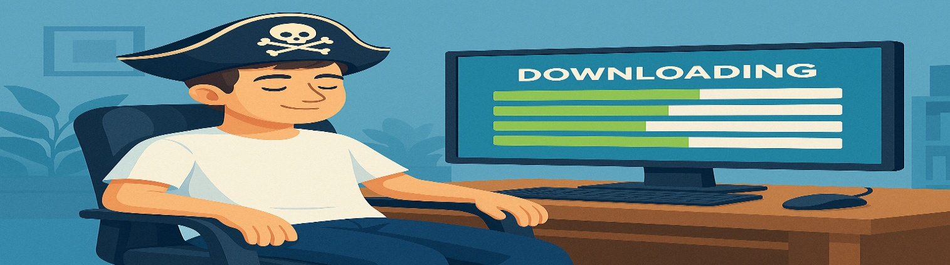

# Why Pirated Software isn’t Worth the Risk

# >>>Continued from prior page<<<

**You Never Know What's Been Changed**

Let's say you've downloaded the pirated software and patched it, and everything seems to work just fine.

But here's the uncomfortable truth: you don't know what else has been changed under the hood.

Modern software is complex. It can do hundreds of things in the background, such as checking for updates, connecting to cloud services, or storing temporary files. If someone's gone in and changed how the software checks its legitimacy, what's stopping them from changing what data it sends out?

We've seen pirated programs that quietly install browser hijackers, pop-up ads, cryptocurrency miners, and even full-on backdoors that allow someone else to poke around your system without you knowing.

And most of the time, the damage isn't obvious right away.

**A Safer Way Forward**

We're not here to lecture you – everyone wants to save a bit of money – but when it comes to software, cutting corners can backfire in ways that aren't worth the risk.

We're more than happy to help you find legal, affordable software options that don't break the bank. In fact, there are many free and low-cost alternatives that do the job just as well as the big-name programs.

We can also check your system for suspicious software, clean it up if something seems off, and help set up safe apps that fit what you need, without any shady patches or keygens.

**Need Help or Just Want a Chat?**

Whether your computer's already acting up or you just want someone to point you in the right direction, we're here to help.

Give us a call at 940-282-0290, shoot us a message, or drop in.

No pressure, no tech-speak, just real help from someone who knows what they're doing.