 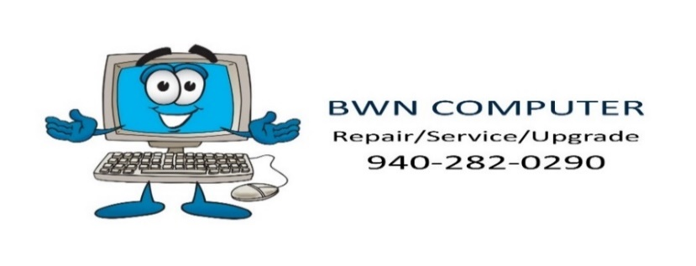

# N E W S L E T T E R

**February 2020**

# The Advantages of Ad Blocking

Unless you’re in the advertising business, you probably try to avoid ads. You pay extra to stream ad-free content online. You leave the room if you are actually watching live TV shows with ads. You filter spam out of your inbox. You immediately click out of ads on the Web pages you visit. But are you actively blocking online ads? You should be. They are more than an annoyance. They could be a security risk.

Cybercriminals are smart and savvy crooks. They don't advertise what they are doing, and it's not that easy to spot, but they do buy legitimate ad space to lure users to malicious sites.

Malvertising uses legitimate online advertising networks to target you with malicious code. Sites you know and trust that use legitimate ad networks can end up serving up the malicious ads. Cybercriminals have run ads on the New York Times, Spotify, and the London Stock Exchange redirecting to malicious websites.

Adware is another risk. Packaged with legitimate software, adware runs on your computer without your knowledge. It displays unwanted advertising, redirects search requests to ad websites, and mines your data.

The cybercriminal wants to steal your ID, or your financial and contact data, or to encrypt your information, spy on, or hijack your computer.

They can do this with exciting ads ($9 iPads?!) or alerts (often warning about infections) to get your click. But they can also take a drive-by download approach. In these cases, you don’t even need to click on anything. You load the Web page hosting the ad (or malicious pop-up window). You’re directed to a page that finds browser or software security vulnerabilities to access your machine.

**Protecting Against Malvertising**

Keep your software up to date and run antivirus checks to protect against downloads and malicious code. Avoiding Flash and Java helps too, as they are commonly exploited by malvertisers.

Cybercriminals mostly target Windows users, because the huge user base gives them the best return on investment. But Macs are just as vulnerable to malvertising attacks. — Malwarebytes

Installing an ad blocker plugin prevents the ad loading in the first place. These take away the annoyance of ads and help you avoid falling victim to a malicious attack hidden in an ad. At the same time, you will enjoy cleaner Web browsing, and you won’t have to worry about distracting ads flashing at you while you read.

Your pages will also load faster. The ads often run a lot of code on top of the website code your computer needs to read and load. The images or video, for instance, can make a difference to data usage. So, the less you have to load, the faster you’ll get to the content you wanted. This can also help to preserve the battery life of your mobile devices!

There are some other considerations, though. For one, not all adblocker plugins can be trusted. Some will mine your data and sell it to advertisers, which is exactly what you don’t want happening. Also, some websites won’t load correctly without the ad code. You can turn off ads on a site-by-site basis. After all, some free sites that you frequent might rely on ad revenue, so there may be sites you trust that you want to support by turning off your ad blocker just for those sites.

**For the peace of mind that comes with ad blocking and keeping your computer security current, give us a call at 940-282-0290.**

# A Custom-Build Computer Can Be a Good Deal

Big-box stores have big names and aisles of computers on offer. They post tempting deals on pre-built computers. But how does buying one of those computers compare to purchasing a custom-built one?

When you shop in a big-box store, you are one of the many people those salespeople are going to work with in a day. If you’re lucky, you may get to speak with someone actually assigned to the computer area on a regular basis.

Working with us to customize a computer, you get individualized expert service. Our specialists know computer users have different needs. You deserve a computer that matches what you’re trying to do. You might want to run the latest-and-greatest games at full graphic quality. Someone else wants something basic to support only email and Web surfing. Or how about a stock day trader who doesn't need a fast computer but wants to run six screens at once?

It may be easier to walk into a big-box store and walk out with a desktop computer, but the big-box computer aims to appeal to everyone; it isn’t customized to each of these different aims.

**Problems with Pre-Built Computers**

The computers sold for less in big-box stores have cut corners to bring down costs. They can use lower-quality parts. There’s also limit to upgradability of the parts. Prebuilt brand-name systems often use proprietary parts unique to that manufacturer. This makes it difficult and expensive to replace a part.

You could end up saving money by paying for a system that has only 4 GB of RAM. Sure, the sticker price was lower, but your computer won’t run as well. Today, you need a computer with at least 8 GB of RAM. Depending on how you plan to use the computer, we might even suggest 16 GB.

The big-box stores sell computers from brand-name manufacturers pre-loaded with bloatware. The manufacturer keeps prices down by installing unwanted software in return for kickbacks. So, you paid less, but your computer runs slower from day one because it’s brimming with software you didn’t want. A customized computer comes only with what you need.

Our specialists can explain the benefits of the processing, power supply, and other parts. Picking every part of your computer, you can also count on high-quality parts that are easy to upgrade.

**A Personal, Expert Relationship**

Another selling point for big-box stores is the warranty. This is one more way they’re making money off the sale of your computer. But keep in mind that most of these stores aren’t going to fix your computer on-site. You explain your problem to a retail employee – again, maybe someone knowledgeable about computers (fingers crossed). Then you wait as the computer gets sent into a central repair base, where someone you haven’t spoken with is working on your computer. Then you wait for the computer to come back, hopefully fixed. Something that would take our experts 30 minutes to fix has you waiting a week. That’s a big deal if you depend on that computer on a daily basis.

When you buy from computer specialists, you're working with a qualified computer technician. You’re building a relationship with someone who knows you and your computer, and you’ll always know where your computer is during the repair process. Additionally, since all parts are hand-picked, you might enjoy individual part warranties.

**Why settle for a standard, pre-built option made to appeal to the largest number of people? Contact our experts today to start putting together your purpose-built, personalized computer. Call 940-282-0290.**