

Office of Medicaid Development and Administration
Medicaid Services System (MSS)
User Guide
January 7, 2026

Department of Developmental Disabilities
Division of Information Technology Services
30 East Broad Street, 13th Floor
Columbus, Ohio 43215

Table of Contents
Accessing the Application 1
First time users 1
Returning Users 4
Searching 6
Direct Links 7
Creating a Site 7
Individual Summary 9
Adding Add-Ons 9
Adding a Provider Negotiated Rate 10
Waiver Service Summary 10
Adding a Service 10
Editing a Service 11
Waiver Cost Projection 11
Service Payment Authorization (SPA) 12
Payment Authorization Waiver Service (PAWS) 13
Navigating to PAWS 13
Viewing PAWS 13
Editing PAWS 14
Nursing Services 15
Adding Nursing Services 15
Nursing Cost Projections 16
Admin Security (Admins only) 17
Approving or Denying a User Role Request 17
Viewing or Updating an Existing User Role 18

Accessing the Application
To access the MSS application, you must have a valid OHID User ID and be an authorized user of the Ohio Department of Administrative Services (DAS) and the Department of Developmental Disabilities (DODD) services.

First time users
- To start, access the OHID Portal at ohid.ohio.gov. Log in using your OHID User ID and Password, then select Log In.

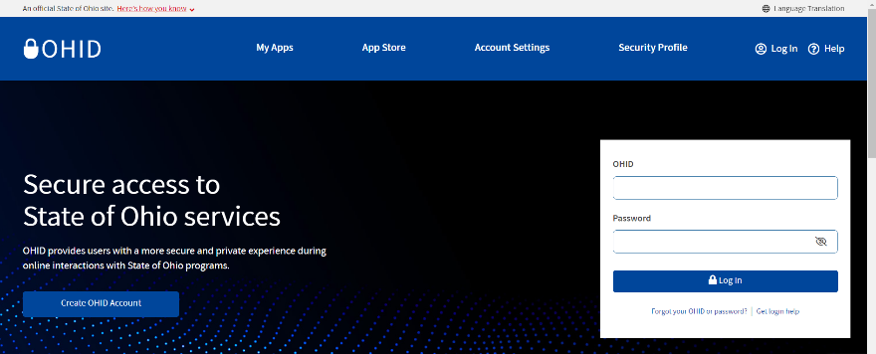
If you don’t have an OHID User ID, refer to the OHID User ID Creation Guide.
- After logging in, select the App Store tab from the navigation menu on the left side.
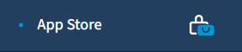
- Enter DODD in the search box and press Enter or click Search.
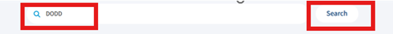
- Find the My DODD app and click Request Access.
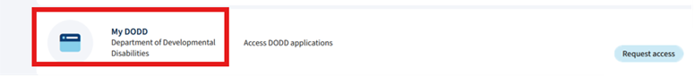
- A dialog box will appear. Select the checkbox next to I agree and then click Send request.
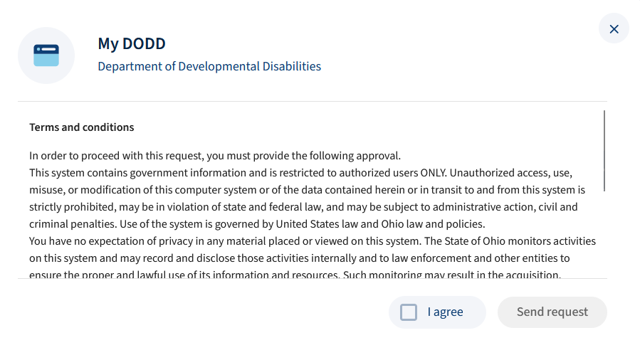
- A popup will confirm your access. Click Open app.
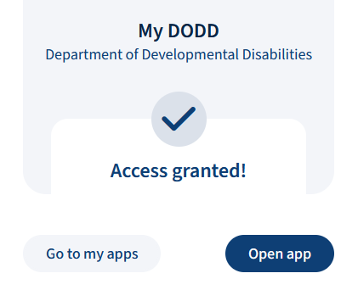
Although access is usually instantaneous, it can sometimes take a little while. Once your request is submitted, you will be notified by email when your request has been processed. Do not resubmit your request until you have been notified of the results. Once notified, return to ohid.ohio.gov and log back in again. Go to MY APPS and click Open App next to MY DODD to continue.
- Choose a profile then click Next.
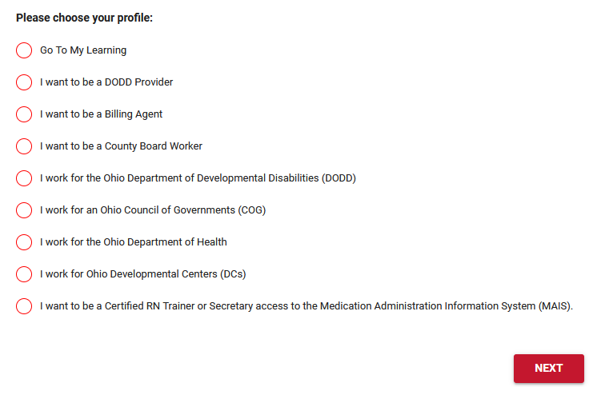
- Click Apps Store in the blue navigation bar.
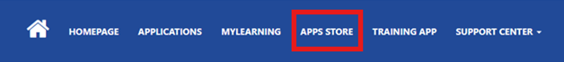

- Find the MSS tile and select Request Access.
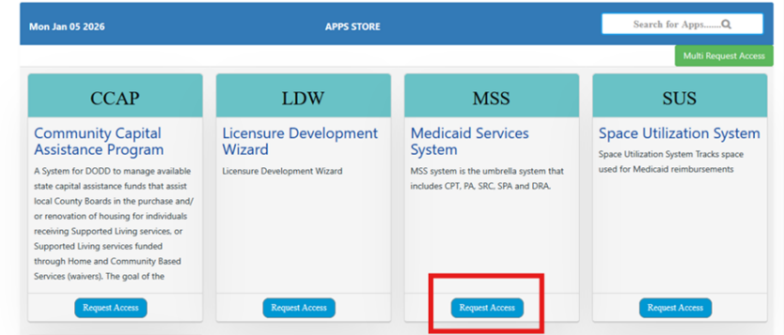
- Choose County Board from the Role Name field. In the Reason for Access field, enter MSS Production and verify the County in the list, then click Submit.
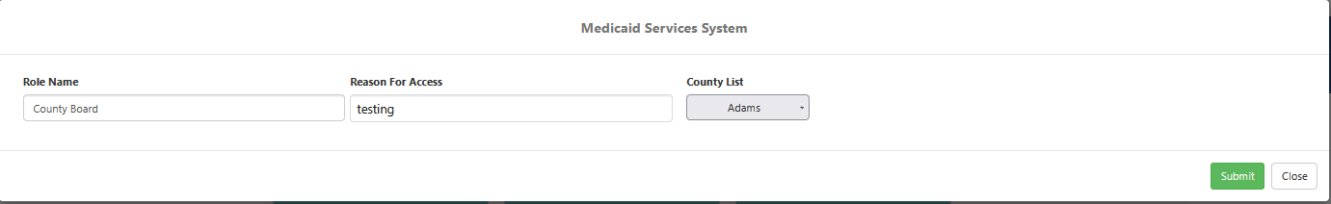
- You will receive a confirmation email.
- Click My Apps in the blue navigation bar of the My DODD application.
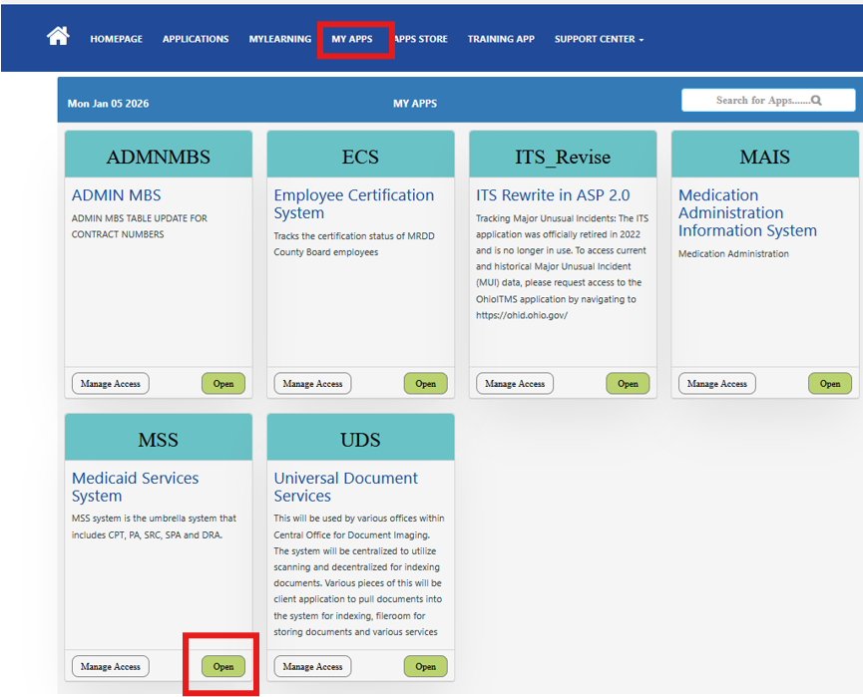
- Find the MSS tile and click Open.

Returning Users
- To begin, go to the OH|ID Portal at ohid.ohio.gov, log in with your OHID User ID and Password, and click Log In.
- After logging in, select the My Apps tab from the navigation menu on the left side.

- Find the My DODD application and select Open.

- Once you click Open, you might see the page shown below. If you do, click Continue. If not, move to the next step.
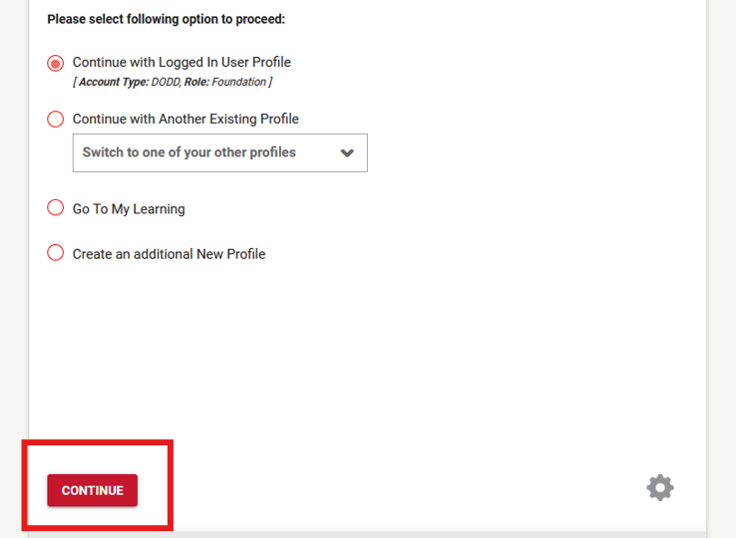
- In the My DODD application, select My Apps from the blue navigation bar.
- Find the MSS tile and click Open.

Searching
- There are two ways to access the Search function:
- Click the Search tile on the homepage.

- Click the menu button ( ) in the top-left corner, then select Search.
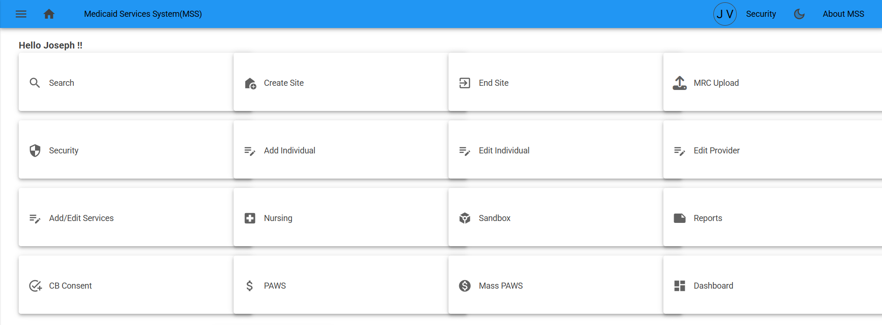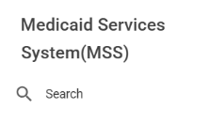
- Fill in the search fields, then click Search. Use these tips while conducting a search:
- If you enter a DODD number, you don’t need to enter any other information.
- If you search by name, you must first enter the County.
- The Name search field will show results after you type the first three characters. Select one of the suggested results or type the full name before clicking Search.
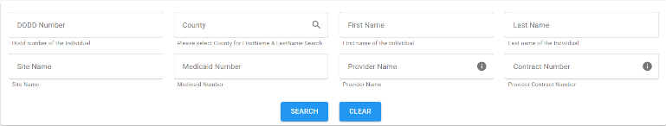
If you receive a message stating “Individual or Site is not found”, double-check your search criteria to make sure it is correct. If the criteria is correct, the individual does not have a site, and you’ll need to create one.
- Results will appear in two ways:
- If the individual is at a single site, you’ll see the individual’s name.
- If the individual is at a multi-site, you’ll see a location.
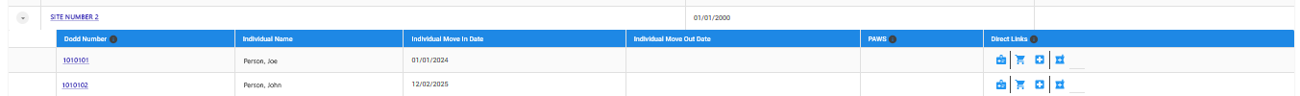
Click the arrow next to either result to expand it and view additional information. All blue text and icons are clickable links.

Direct Links
When you search for an individual, you will see blue icons to the right of their information. These icons are direct links to details about that person:
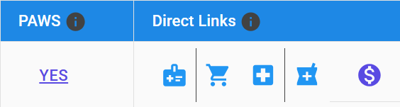
- Waiver Service Summary ( )
- Waiver Cost Projection ( )
- Nursing Service Summary ( )
- Nursing Cost Projection ( )
- PAWS ( ) or you can click YES in the PAWS column, if applicable.

Creating a Site
- Click the Create Site tile on the homepage.
- Fill in the search field, then click Search. Use these tips to guide your search:
- If you enter a DODD number, you don’t need to enter any other information.
- If you search by name, you must first enter the county.
- The Name field will display results after you type the first three characters. Select a result from the list or type the full name before clicking Search.
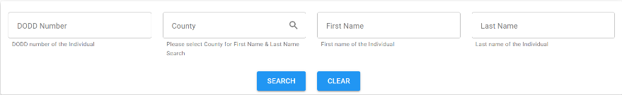
- The List of Individual(s) will appear. Click the green person icon to select the appropriate person.
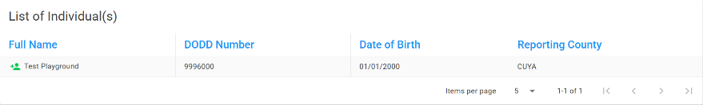
- The person you selected will appear in the Selected Individual(s) list. If you are creating a multi-site, you can add more people. Once your list is complete, click Continue to Site Creation.
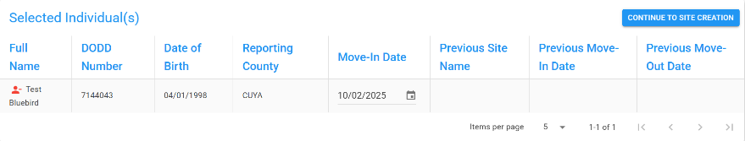

You may edit the Move-In date at this point to reflect the individual’s actual move-in date. To remove a person from the Selected Individual(s) list, click the red person icon ( ).
- Most of the information on the next page will be locked; however, you’ll need to enter a Site Effective Date. The Management County will automatically default to the selected person’s county. When you’re finished, click Create Site.
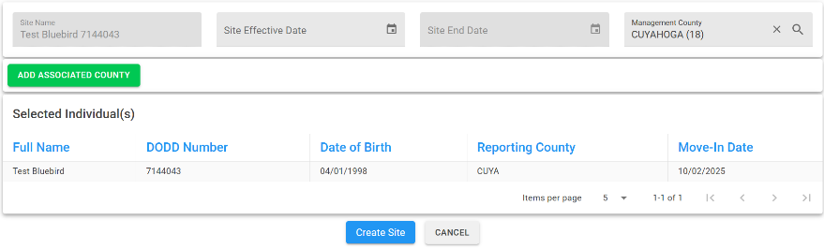
- If needed, click Add Associated County. This will display additional fields where you can enter a county. When you’re finished, click the Save icon.
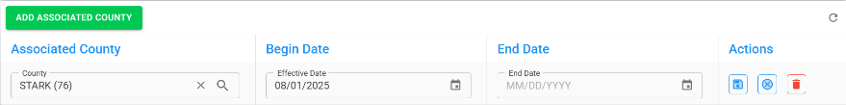
The Site Summary page has two tabs: Active Items and History. Click the History tab to view all previously associated individuals and counties for that site.

Individual Summary
Navigate to a Site Summary page using the Search tool on the homepage.
- On the Site Summary page, you can either click on the person’s DODD number or use the menu button ( ) in the top-left corner to select Individual Summary.
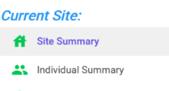
- The Individual Summary page displays details about the individual, site, common law, provider rate, budget, and site history. Near the top of the page, you’ll find tabs for Active Items and History. Use these tabs to view both current and historical information.


Adding Add-Ons
- Scroll down to the Add-Ons section under the active tab. Then, select an Add-On from the dropdown, enter a start date and end date, then click Add.
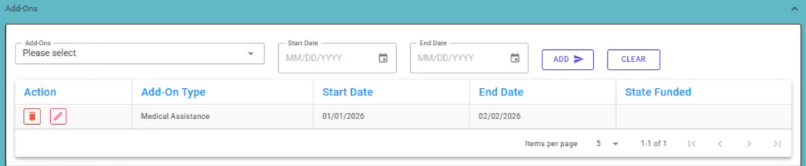
0
ICF, Behavioral Support, and Medical Asssistance Add-ons do not require ERMS confirmation. For State-Funded Behavioral Support and Complex Care Add-ons, an ERMS validation process will occur.

Adding a Provider Negotiated Rate
- Scroll down to the Provider Negotiated Rate section under the active tab. Then, search for and select a provider, enter a start date, end date, and the negotiated rate, then click Add.
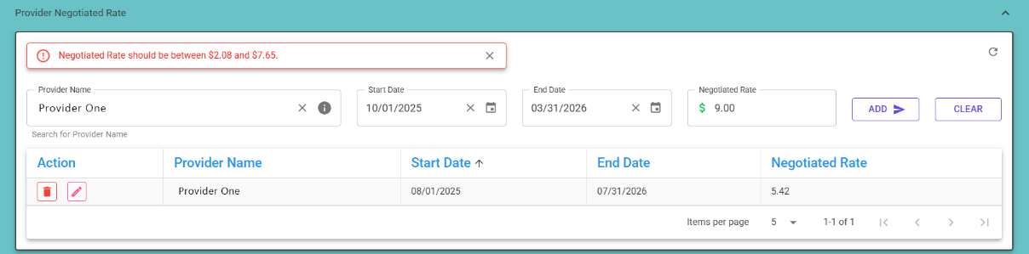
As shown in the above screenshot, you’ll receive an error if you enter a negotiated rate outside the accepted range.

Waiver Service Summary

Adding a Service
- Navigate to a Site Summary page using the Search function on the homepage. Then, click the menu button ( ) in the top-left corner and select Waiver Service Summary.
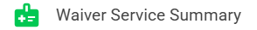
- If you have a move-in date, you can begin adding waiver services. Start by selecting a Waiver Span.
- Enter the provider type, then search by provider name or contract number (check Contract # box to search by contract number). Next, add certified services. Only services that are certified for the selected provider and available during the selected span will appear in the service list.
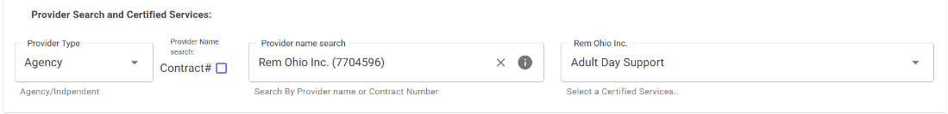
s
s
s
- After selecting a service, an additional section will appear below where you can enter details for that selected service. Once all details are entered, click Apply.
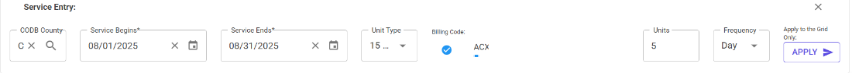
- The service will appear in the list below, along with its cost. Be sure to click the Save icon before adding additional services or navigating away from the page.
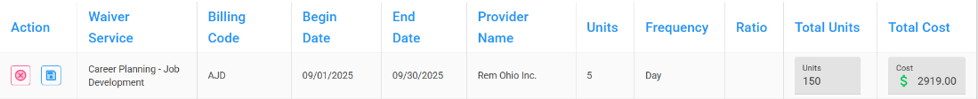
If you encounter any issues during this process, scroll to the top of the page and look for error messages. These messages will appear in red and provide details about what went wrong.

Editing a Service
- On the Waiver Service Summary page, scroll down to the list of services, and click the pencil icon next to the service you want to edit. The entire row will highlight in yellow.
- The details line will now be editable. Make the necessary changes, then click Update.

Waiver Cost Projection
- Once all services are added and correct, click the Waiver Cost Projection button.

- The waiver cost projection will appear. If you want a detailed breakdown, click Expand All. This will reveal all the services and associated costs. Alternatively, you can click on and expand individual lines (e.g., Budget Type, Site Name, Span Dates).
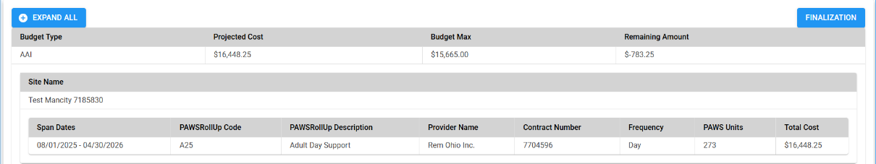
- When services are ready for finalization, click the Finalization button.
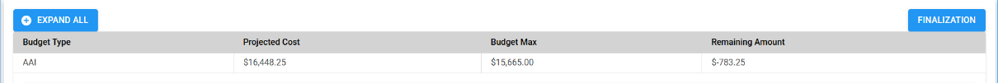
- A popup will appear confirming the Finalization was saved successfully. Click Continue.

Service Payment Authorization (SPA)
Once you have finalized waiver services, you can use the Service Payment Authorization process to approve or disapprove the Payment Authorization Waiver Service (PAWS) submission.
- From the homepage, click the Service Payment Authorization (SPA) tile.
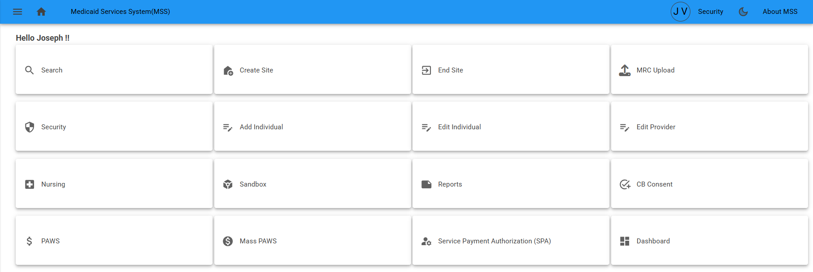
- Enter the Management County. This will generate any pending approvals.
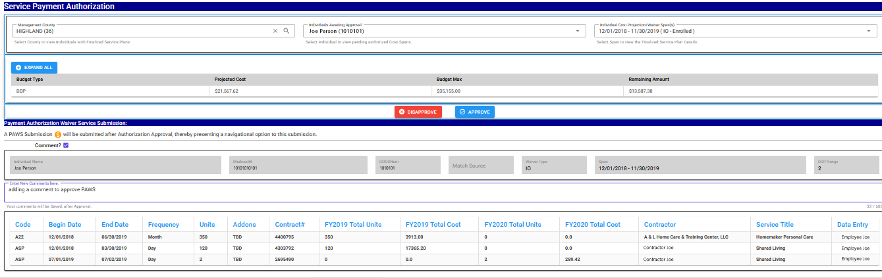
- If you want to add a comment before approving or disapproving, check the comment box. A field will populate where you can type your message. Comments will be saved after approval.
- Review the pending PAWS submission and use the Approve or Disapprove buttons once a decision has been made.
- A popup will appear confirming services in the waiver span were successfully approved or disapproved. Click Continue.

Payment Authorization Waiver Service (PAWS)
Once the PAWS submission is approved, you can view the PAWS.

Navigating to PAWS
- Search for an individual by clicking either the Search tile or PAWS tile on the homepage. After locating the individual, click the carrot beside Site Name to use the available direct links to access that person’s PAWS. If no PAWS links appear, it means the individual does not have an active PAWS.
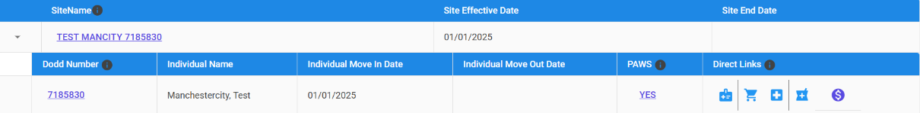

Viewing PAWS
If you are not an Admin, you can view a person’s PAWS but cannot make any edits.
- In the PAWS summary, go to the Plan Info tab and click the View Plan action button (blue icon).
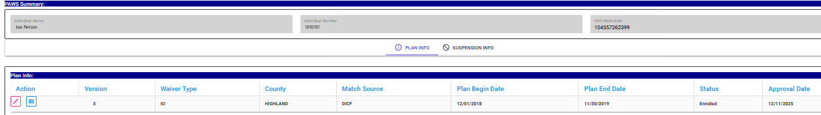
- Click the Select Version dropdown menu to navigate between versions.
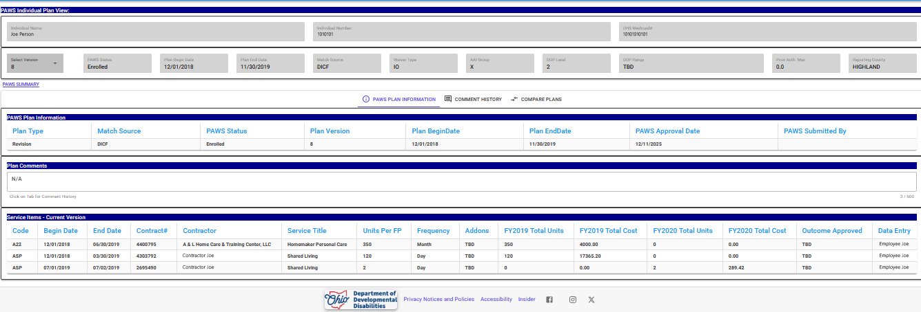
- While viewing, there are three tabs: PAWS Plan Information, Comment History, and Compare Plans. Click a tab to navigate between them.
The Comment History tab displays previous authorizations and added notes. It also shows the last time each version was updated.
- You can view previous versions but cannot make changes to them. All edits must be made to the current version.

Editing PAWS
As an Admin, you can view and edit a person’s PAWS.
- In the PAWS summary, go to the Plan Info tab and click the Edit action button (pencil icon).
- While editing, view and add comments to the Plan Comments section.
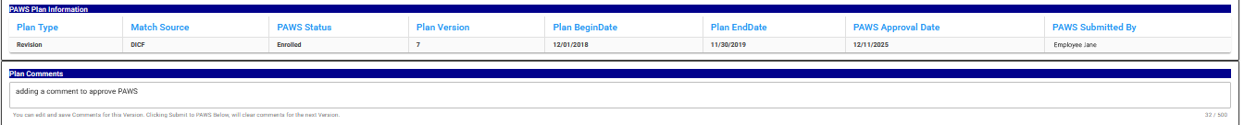
- To edit a Service Item, click the Edit action button (pencil icon) located to the right of the line item.
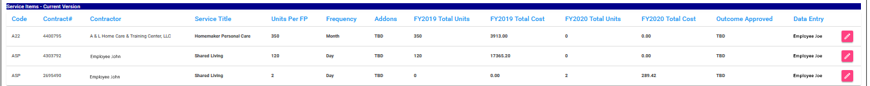
- You can edit Units and Cost, but changes cannot exceed 10%. After making edits, click the check mark to save.
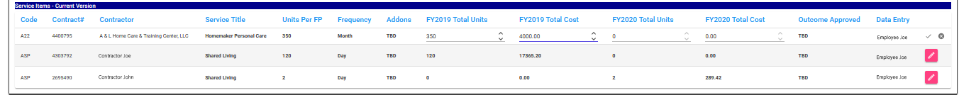
If you enter Edit Mode for a Service Item and decide not to make changes, click the X next to the check mark to cancel.
- After making your edits, click Submit to PAWS at the bottom of the page.
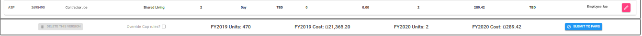
- This will take you back to the PAWS Summary page, and the version number will be updated.

Nursing Services

Adding Nursing Services
- Use the search feature to locate an individual, then click the Nursing Services Summary direct link ( ).
- Complete the fields to reflect the nursing service that will be provided during the waiver span, then click Add Nursing Service.
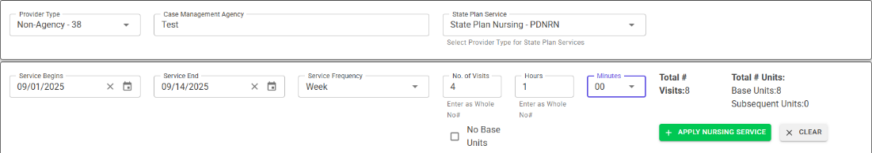
- The service will be automatically saved in the list of services below. You can edit or delete the service using the action buttons on the left.
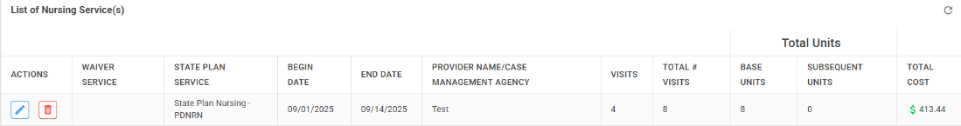

Nursing Cost Projections
- Choose one of the following options to access Nursing Cost Projection
- Option 1: Use the search feature to locate an individual, then click the Nursing Cost Projection direct link ( ).
- Option 2: Go to the Nursing Waiver Summary page and click the Nursing Cost Projection button.
- All nursing cost details for the selected person and waiver span will be displayed.
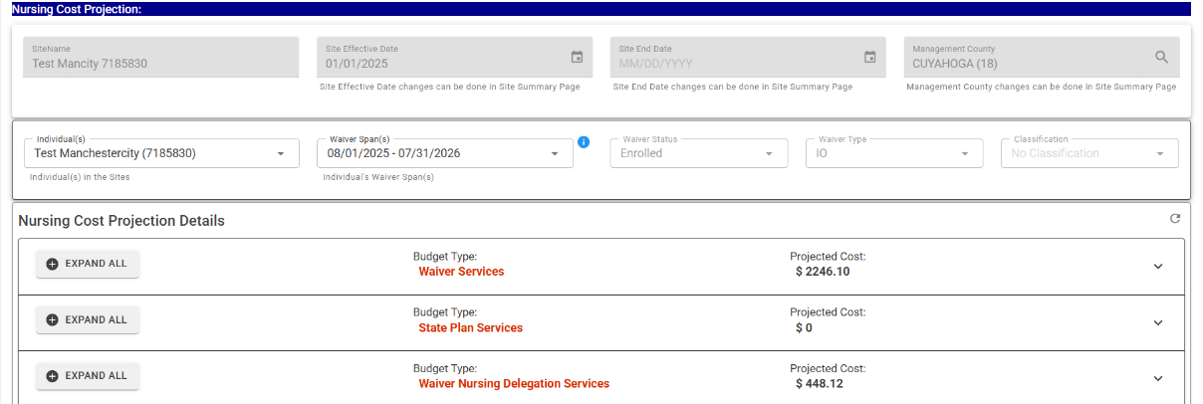
Only cost projections for nursing services will be displayed (e.g., Nursing Waiver Services, Nursing State Plan Services, Waiver Nursing Delegation Services)
- There are two ways to view the cost details:
- Expand All – Click this option to display all details for the service.
- Dropdown Arrow – Click the arrow to the right of the service to expand individual items, starting with the month.
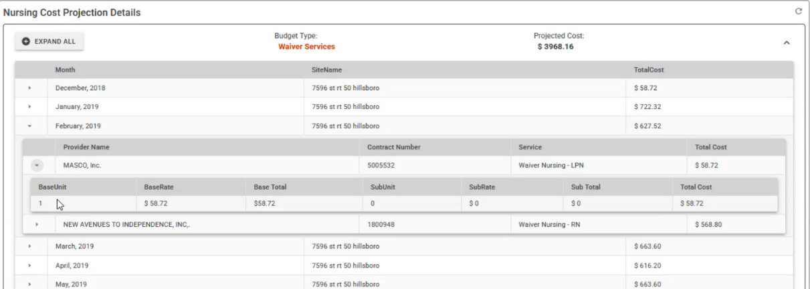
If you click Expand All, the button will change to Collapse All. Use this option to view or hide all details at once. Any arrow you click to expand a section or line can be clicked again to collapse it.

Admin Security (Admins only)
Admin Security is where you can authorize or deny role requests. You can revoke a user’s current role access.

Approving or Denying a User Role Request
- In the blue navigation bar at the top of the page, click Security.
- From the list of pending user-submitted role requests, click Update next to the user you want to approve or deny.
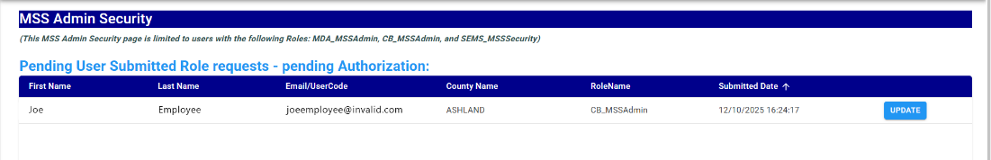
- All roles requested will appear. Choose Authorize or Deny the appropriate roles using the associated buttons. If applicable, you can add a comment below that will be logged and emailed.
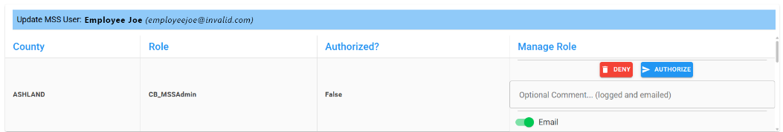
Make sure to toggle the email function (located under the comment box) on or off depending on your preference.

Viewing or Updating an Existing User Role
- In the blue navigation bar at the top of the page, click Security.
- Use the Current Authorized User (Grouped by Role) or the full Current Authorized MSS Users list to locate the user you want to view or update. Click Update in the same row.
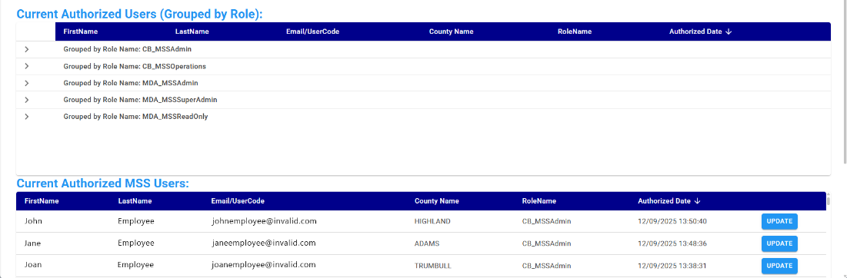
- You can view all roles associated with this user. If applicable, click Revoke to remove role.
