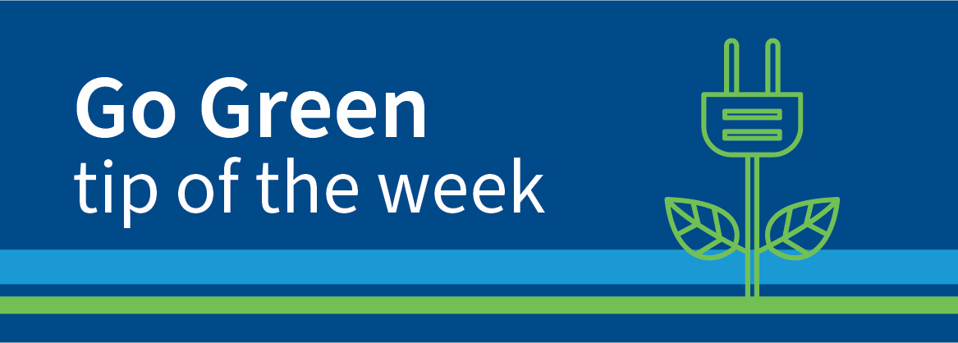
March 12, 2024
Shamrockin’ ways to Go Green this St. Patrick’s Day

Get inspired this St. Patrick's Day and start with one of these easy steps towards an eco-friendly lifestyle:

1. Shut off and unplug electronics when you are not using them. Don't be fooled - just because your computer is asleep and your coffee maker isn't brewing away, doesn't mean they aren't still sucking up energy! Not only is this habit good for the environment, it's also good for your energy bill!
2. Switch to Eco-friendly cleaning products in your home. Many household cleaners contain chemicals that are not only harmful to the environment, but to your health! Make your own cleaner using water and ingredients like tea tree oil, vinegar, or baking soda, or head to any local store to pick up trusted brands such as Mrs. Meyers, Method, or Seventh Generation.
3. Speaking of cleaning, save paper and money by switching out your paper towels and magic erasers for re-usable, and/or biodegradable cleaning cloths. For example, bamboo cleaning towels are durable enough to handle tough scrubbing, and most can be washed and re-used up to 100 times! Made from sustainable and renewable sources, they leave minimal or no imprint on the earth at the end of the product life cycle.
4. Purchase a set of re-usable shopping bags and keep a few in your car at all times. You can even get affordable insulated bags to keep your perishables safe on the drive home!
5. Get the junk out of your trunk (literally!) — extra weight in your car decreases fuel efficiency.

