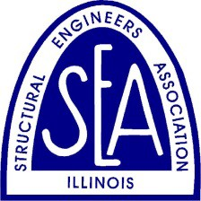
THE STRUCTURAL ENGINEERS ASSOCIATION OF ILLINOIS
John F. Parmer Award

Nomination for 2020

The John F. Parmer Award is presented to a structural engineer in recognition of outstanding lifelong contributions in the field of structural engineering. This award is presented jointly by SEAOI and the Structural Engineers Foundation. The candidate must be an individual whose distinguished career is acknowledged by his or her peers to be an example of excellence.

Please complete the nomination form for the John F. Parmer Award, entering all information in the fields below, and submit using the "Submit Form" button at the top of the form.

Nominations should be submitted to scrain@SEAOI.org by Monday March 23, 2020.

Nominee information

Name:
Company:
Email:

Your Information (leave blank if nominating yourself) Name:

Company:
Email:

Recommendation statement: Why is the nominee deserving of this award?

