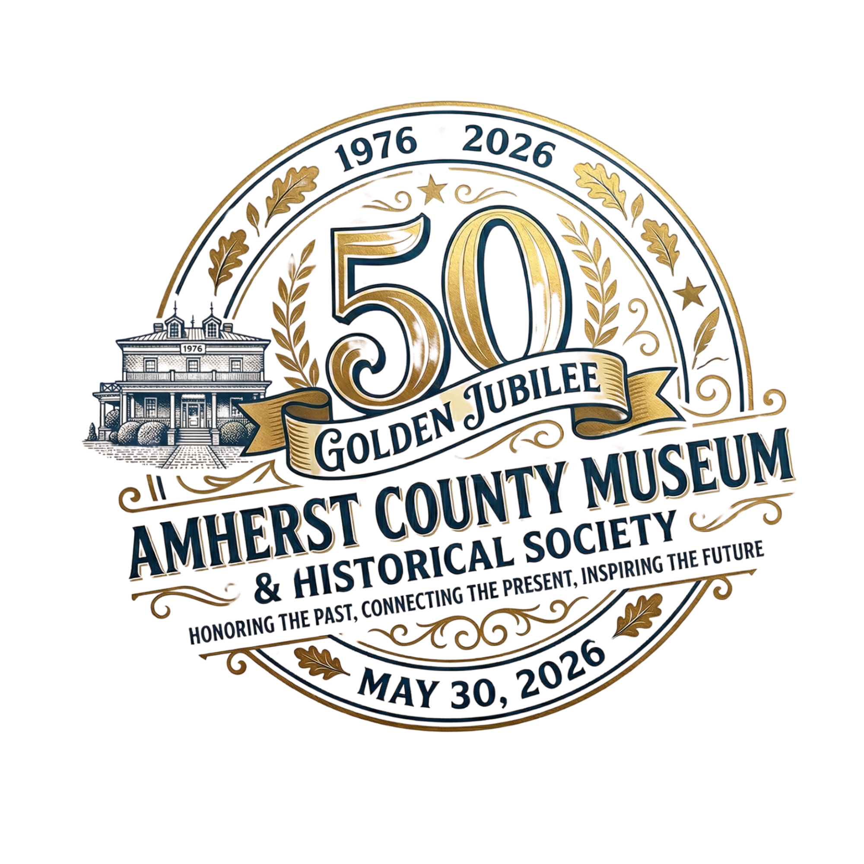

FOR IMMEDIATE RELEASE
Amherst County Museum and Historical Society Announces Golden Jubilee: Celebrating 50 Years of Preserving Heritage
AMHERST, VA — The Amherst County Museum and Historical Society (ACMHS) is pleased to announce its Golden Jubilee: Celebrating 50 Years of Preserving County and Town History. This landmark celebration will be held on Saturday, May 30, 2026, marking five decades of dedicated service to the preservation and promotion of Amherst County’s rich cultural legacy.
Founded in 1976, the Museum has served as the "memory bank" for the town and county. The upcoming Golden Jubilee, themed "Amherst: Past, Present, and Future," will not only honor founder Sherrie Snead McLeRoy and her committee of volunteers who established the institution, but will also highlight the vibrant community of today and the vision for the next 50 years.
"This milestone is about more than just looking back at old photographs," says Mike Cargill, Anniversary Committee Chair. "It’s about celebrating the people who make Amherst County and Town what it is today and ensuring our stories are preserved for the generations of 2076 and beyond."
A few highlights of the May 30th celebration include:
- The "Voices of Amherst" Project: A live oral history recording initiative to capture the stories of long-time residents.

- The 2076 Time Capsule: A community-wide effort to seal material and messages for future residents to open in 50 years.

- Historical Exhibits: Curated displays of the museum’s first 50 years and 250 years of the County’s history in collaboration with the 250th Celebration of our nation’s Independence.
- “Amherst Through My Lens” Photo Contest: A juried photography exhibition for residents and Museum members.
About the Amherst County Museum and Historical Society:
Located in the heart of Amherst County, the ACMHS is a non-profit organization dedicated to discovering, collecting, and preserving objects related to the history and genealogy of the county and its people.
The Committee is currently seeking volunteers, historical photographs, and local sponsors to help make this community-wide event a success. Residents interested in contributing stories or artifacts are encouraged to contact the museum.
Media Contact: Octavia Starbuck, Director, staff@amherstcountymuseum.org, 434-946-9068, www.amherstcountymuseum.org

