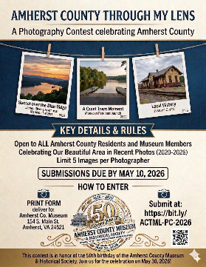 PHOTO CONTEST FORM 
A Photography Contest Celebrating Amherst County
Name_____________________________________
Phone # ___________________________________
Email______________________________________

Entry#1____________________________________
Entry#2____________________________________
Entry#3____________________________________Entry#4____________________________________Entry#5____________________________________
Open to ALL Amherst Town and County Residents as well as Museum Members
SUBMISSIONS DUE BY MAY 10, 2026
Hand-deliver to Amherst County Museum, 154 South Main Street, Amherst or submit to: https://bit.ly/ACTML-PC-2026

