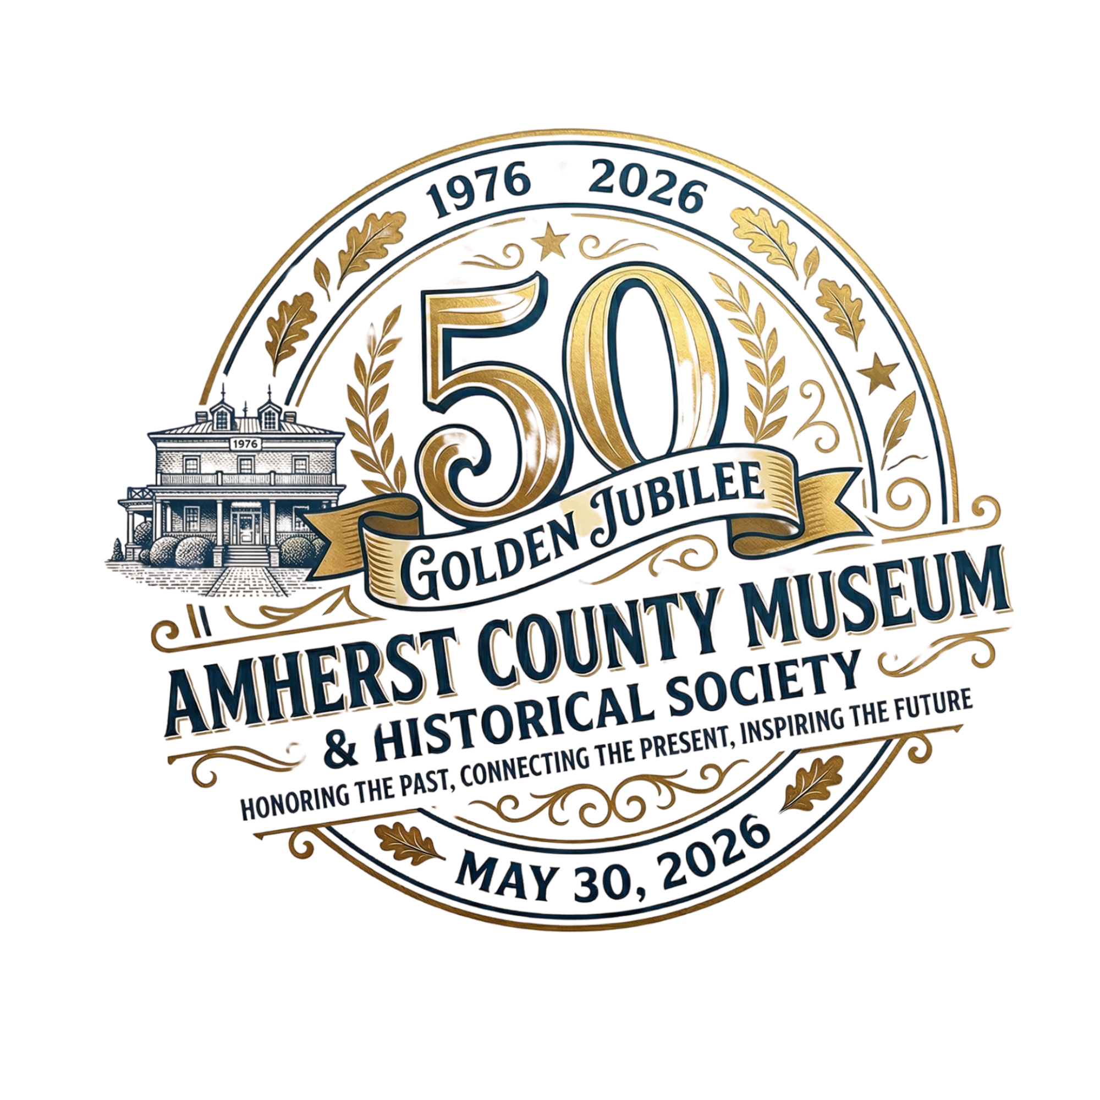
Dear School or Community or Tribal Organization:
On May 30, 2026, The Amherst County Museum and Historical Society will celebrate its 50th anniversary of recording and preserving the history of Amherst County. The Museum is seeking Junior Curators, age 14 to 18, to do a project (individually or as a group) that will be exhibited at the Museum’s anniversary on May 30th.
Young people who wanted to be a junior curator would be asked to attend a meeting with Museum Director Octavia Starbuck, bringing an idea for a simple visual historical project they would like to complete by May 20th, 2026. The exhibit would be shown at the Museum’s 50th Anniversary on May 30th, and a copy of each exhibit would be buried in the Museum’s Time Capsule.
The Museum is seeking exhibits representing different areas of the County. A group of students is welcome to work together on a project – for example, a group such as a scouting group, a school or community dance or singing group, a sports group, a religious youth group, a history club, etc.
Projects can illustrate the history of a neighborhood, a building, an organization, a group or a family in the past 50 years of Amherst County. Copies of exhibits will be placed in the time capsule to be buried on the Museum grounds, and opened and exhibited again in 2075.
Mrs. Starbuck is also interested in having junior curators work as volunteer interns at the Museum on an ongoing basis after May 30th. People who enjoy working on the anniversary history project are welcome to speak to her about summer internships or internships during the 2026-2027 school year. Her contacts are 434-946-9068 or staff@amherstcountymuseum.org.
There will be two meetings at the Museum in which Mrs. Starbuck will describe what is needed for the project and make suggestions as to sources you can use to help find information for your project. Dates for the meetings at the Museum are Tuesday, April 21 at 4:00 p.m. and Thursday, April 23at 4:00 p.m. The project is due on May 20, where it will be exhibited on May 30th at the Museum.
Please call Mrs. Starbuck if you would like to participate individually or as a group (number in group): 434-946-9068 (you may leave a message).

