December is HIV/AIDS Awareness Month

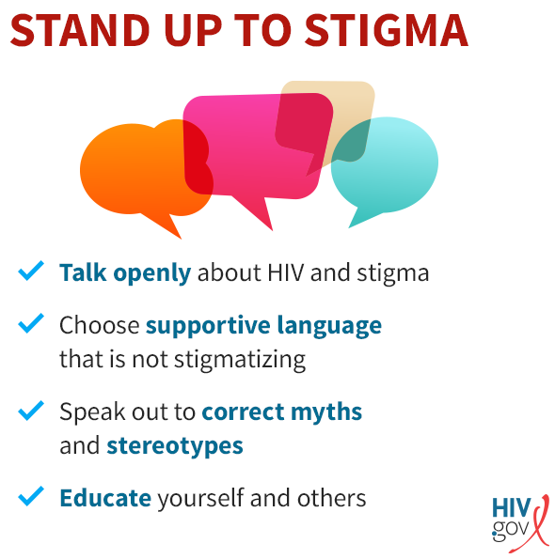
HIV/AIDS Awareness Month provides an opportunity to raise awareness around HIV/AIDS, commemorate those who have passed on, and celebrate victories, such as increased access to treatment and prevention services.
Faith communities can get involved by:
- Offering educational opportunities with guest speakers from local HIV service organizations.
- Including information about the HIV epidemic and the importance of getting tested in congregational newsletters, social media and other communication outlets.
- Participating in fundraising or advocacy activities.
- Speaking out against HIV stigma.
- Assisting with onsite or mobile testing events by being a greeter, registrar, health educator or HIV tester.
- Volunteering at a local HIV service organization, providing administrative support, such as filing, data entry or answering phones, helping with special events, providing language skills, and offering professional services, such as legal assistance or medical care, if licensed.

Prayer: Keep us mindful of our sisters and brothers nearby and around the world who are living with HIV and AIDS. We ask that they feel your healing presence. Fill us with hope as we develop new therapeutics and await a cure.

12/2020

