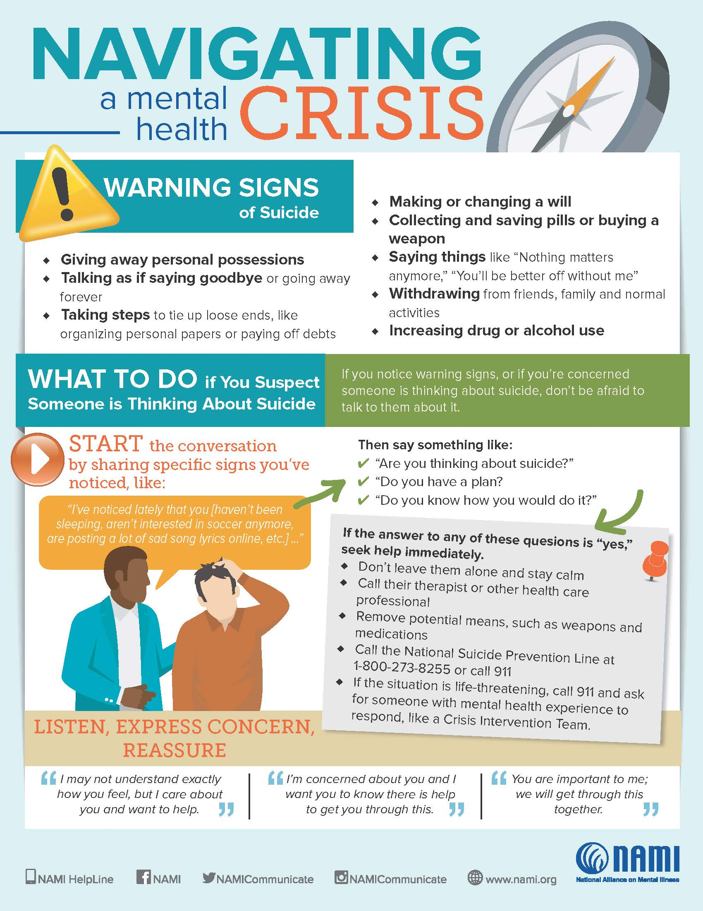

If you or someone you know is in crisis, or is experiencing suicidal thoughts, call the National Suicide Prevention Lifeline at
800-273-TALK (8255) or call 911 immediately.

Suicide Prevention

Faith communities provide a natural setting for suicide prevention. Spiritual beliefs and practices can help people experience greater hope and meaning in their lives. Faith communities also can provide opportunities for developing positive relationships with others and can be an important source of support during difficult times.
Faith communities can raise awareness of suicide, including its warning signs, how to support those at risk for suicide and where to access help, through flyers, posters, newsletter articles, online classes and other outlets.
Other ways faith communities can make a difference:
- Create a support group for suicide loss survivors - friends and family members affected by the suicide loss of a loved one.
- Have plans in place to respond to people showing warning signs of suicide.
- Offer support to members facing challenges with their relationships, jobs, health, or other concerns.
- Expand options for temporary help for those struggling to make ends meet.
- Encourage members to seek help, and provide referrals to mental health, substance use disorder, legal, or financial counseling services as needed.
- Apply policies that create a healthy environment and reduce stigma about seeking help.
Prayer: Guide us in caring for one another. Give us courage to reach out to those experiencing pain of mind and spirit. May we share Your comfort and love with them.

