Caring for one another: Promoting healthy eating and active living


Faith communities are places where we gather to worship, pray, serve, and care for one another in mind, body, and spirit. Among the ways we can do that: encourage one another to eat well and stay active.
Making positive changes in just those two areas can reap numerous benefits, especially for those living with chronic disease. Healthy eating and active living can improve mental health, as well. Researchers have found that exercises like running, swimming, biking, walking and even dancing can reduce both anxiety and depression.
We can promote healthy eating in our faith communities by:
- Requiring healthy foods and snacks at congregational functions
- Offering nutritious snacks during children’s programming
- Setting up a congregational farmer’s market
We can promote active living in our faith communities by:
- Starting a walking club
- Including a health minute during worship services
- Building physical activity breaks into meetings, activities, and children’s programs.
Prayer:
Thank you for blessing us with community. Encourage us to care for one another in mind, body, and spirit. May we be a blessing to those in our congregation, family, and others in our midst.




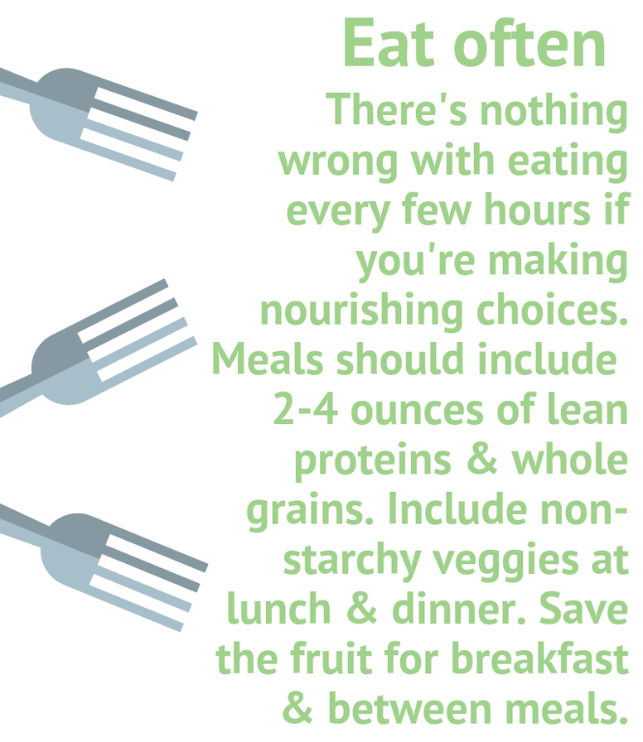
5 Simple Ways to Make
Healthy Happen

