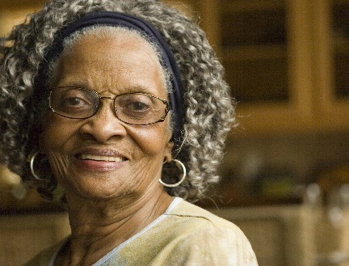
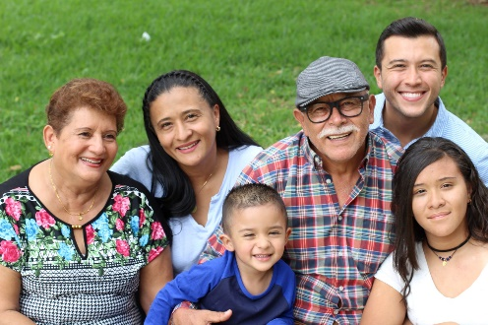

Faith communities: well positioned to promote health equity

Did you know that the social connections we make in our places of worship can influence our long-term health in ways every bit as powerful as adequate sleep, a good diet, and not smoking?
Faith communities can be places of hope and healing, where we practice spiritual life together, build positive and loving relationships and work to bring justice and healing into our world. According to the National Academy of Sciences, faith-based organizations not only have great potential to positively impact congregants’ health—they are well-positioned to promote the health of those living in their communities, as well. Why faith communities?
- Faith organizations can represent credible and caring members in which the community has confidence.
- In almost all faith organizations, a critical call to provide service for those in need and those most vulnerable is integral to their doctrines of faith.
- Faith organizations are already on the front lines where community issues are first identified at a point when they can be resolved.
- Faith organizations are a key partner in advocating for, developing, or providing health care services, and addressing social determinants of health—the complex factors that allow health disparities to persist in our communities.


Learn about social determinants of health - the multiple, interconnected, and complex factors, such as poverty, lack of education and structural racism, that allow health disparities to persist in our communities.

Advocate for legislation and the use of civic resources (e.g., food, shelter, child care, respite, and older adult care) to advance health equity.

Publicize FindHelp.org, a free resource that allows you to find free and low-cost resources in your community, such as: food, safe housing, childcare, transportation, employment, legal assistance, and more.

Access resources 24/7 via FindHelp.org or the code below.
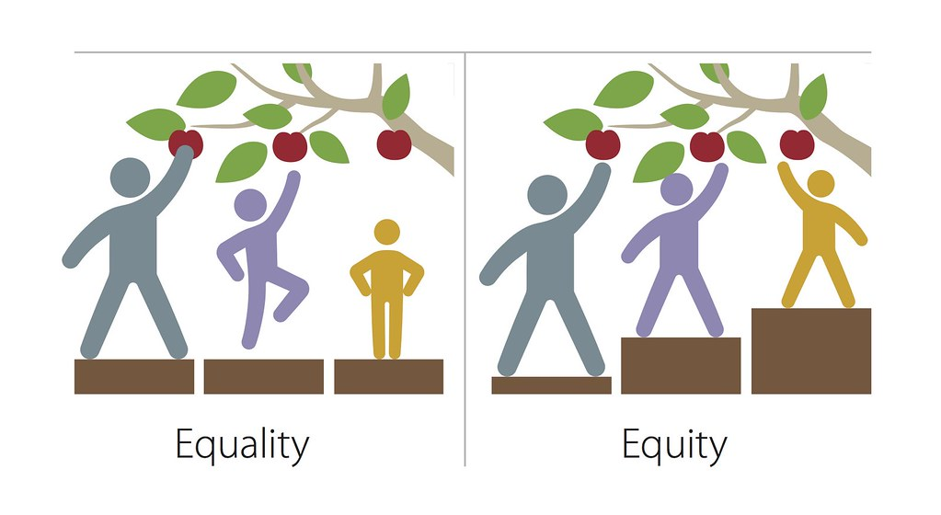
What is health equity?

Health equity means we all have a fair and just opportunity to be as healthy as possible, no matter who we are, where we live, or how much money we make.

How can faith communities promote health equity?

