July is Social Wellness Month
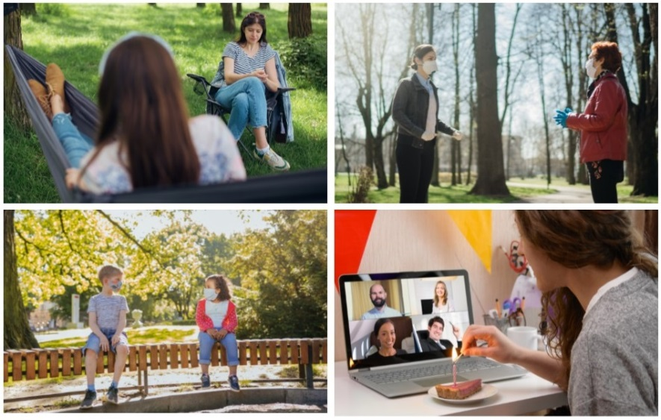
July is Social Wellness Month – a time to nurture relationships and build stronger ties with friends, family and other loved ones.
Having healthy relationships provides numerous health benefits. Those with strong social networks tend to live longer, respond better to stress and adversity, have healthier endocrine and cardiovascular systems and have enhanced immune systems, which are vital to fighting off infectious diseases.
As we continue to live through the COVID-19 pandemic, we still can stay connected with one another and build our social connections:
- Plan virtual gatherings, such as a remote dinner party or movie night, with family and friends
- Join a virtual classroom or remote gathering focused on a favorite hobby, such as woodworking, painting, scrapbooking, reading and cooking.
- Volunteer for activities at your faith community, such as mission outreach programs, youth events and food pantry, making sure to wear a mask and carry out physical distancing, hand hygiene and other safety precautions.
- Start a walking routine, making sure to wear a mask and stay six feet apart from others. It not only gives you an opportunity to stay physically active, but also creates more opportunities to meet your neighbors.
Social Wellness Month also reminds us to get involved in activities that benefit our communities:
- Share your skills as a volunteer at a school, library, community center or hospital. Many organizations now offer virtual and remote volunteer opportunities, such as data entry, online tutoring, research and opportunities to donate supplies.
- Write letters to elected officials on issues important to you, such as racial equality, healthcare access, affordable housing and climate change.
- Get involved in neighborhood events, such as cleaning a park or planting a community garden. Be sure to follow safety practices, such as wearing a mask and staying six feet apart from others, when participating.
Prayer: Thank you for the relationships we have with family, friends and neighbors. May we take the time to nurture this precious gift. Open our eyes to new ways we can serve and connect with others.
For more ideas, see the National Institutes of Health
Social Wellness Toolkit: www.nih.gov/wellnesstoolkits

Volunteer and Grow Your Social Connections

Studies show that volunteering for a worthwhile cause provides numerous benefits. It can reduce stress, combat depression and loneliness, provide a sense of purpose and boost your overall happiness.
Many organizations now offer virtual and remote volunteer opportunities, such as data entry, online tutoring, research, letter writing and opportunities to donate supplies. When volunteering in person, make sure you wear a mask and carry out physical distancing, hand hygiene and other safety precautions.
To learn more about volunteer opportunities, contact:
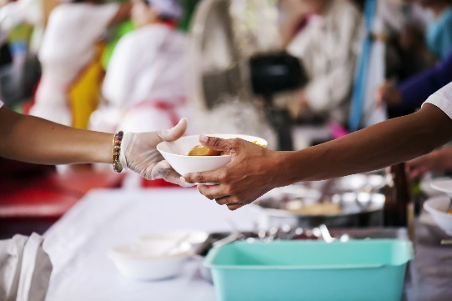
- Your Faith Community
- Food Pantry
- Habitat for Humanity
- Local Library
- YMCA
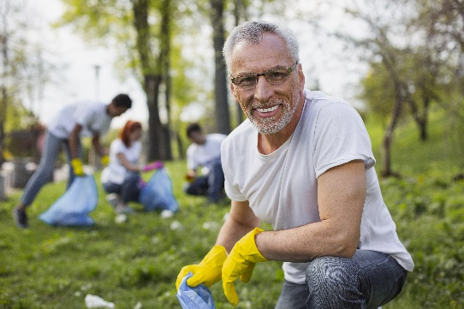
- Local Hospital
- Homeless Shelter
- Meals on Wheels
- Park District
- Social Service Agency
- Area Agency on Aging

Find remote volunteer opportunities in your area:
VolunteerMatch.org
AllForGood.org

