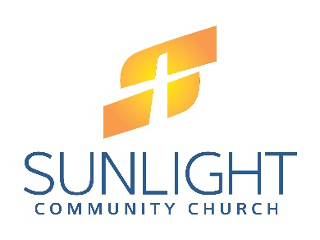

December 7, 2017
Dear Members and Friends of Sunlight,
Merry Christmas! As we approach the end of 2017 I wanted to review and celebrate some of what God has been doing to build His Kingdom through us this year. It is so important to stop, reflect and celebrate important events on our journey. I hope you are encouraged and challenged as you read this letter, as well as the attached letter from Pastor Scott at our central campus.
We began 2017 with some significant challenges coupled with great joys. Our flow of visitors slowed, our giving dipped, and we said goodbye to some good friends who moved on to other places. It felt for a time like walking through sticky mud. The dream of a preschool hung in the balance with the potential to fall flat on our faces always around the corner. But, God was faithful. We put our noses to the grindstone and went to work pursuing His mission to be rooted in the Gospel, planting churches, and growing disciples.
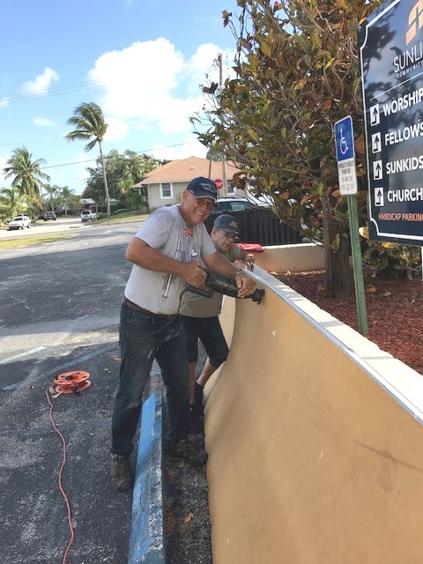
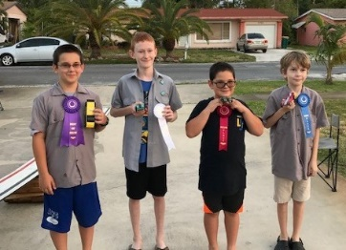
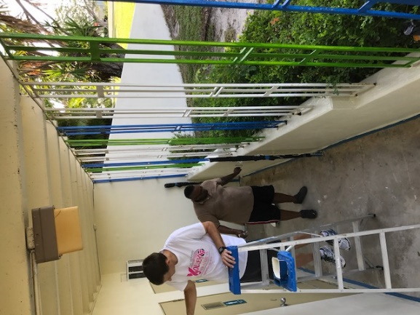

Preschool Prep & Pinewood Derby Winners!

As we remained faithful to the mission, God began to break down the barriers. Slowly, we regained momentum and CROS Summer Camp kicked in. We enjoyed connecting in small groups, celebrated a baptism, and had some fun along the way. Final preparations went in to Sunlight Christian Academy and we prayed hard for God to pave the way for us to serve children and families in our neighborhoods.

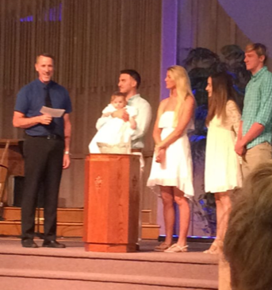
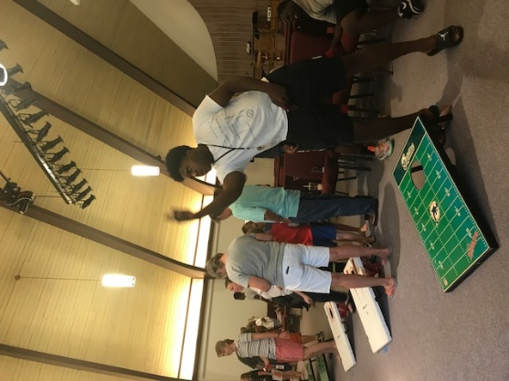
Bags, Baptism and Preschool Staff!

Fall brought the Fall Festival, the long-awaited opening of Sunlight Christian Academy of Lake Worth and a new coat of paint for our facility! Along with this came new visitors to our weekend services and a new sense of God’s hand at work. We gathered Blessing Bags for those in need and we welcomed new faces.
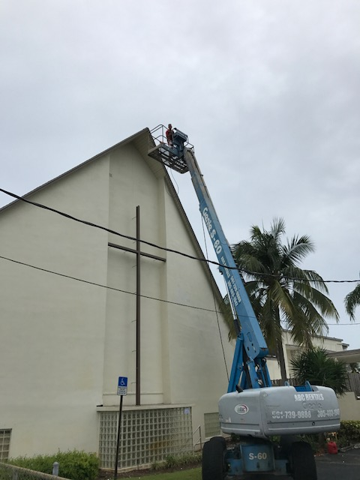
The past few months of working with the children and families of our preschool has been such a joy! As your pastor I am so thankful to serve with you on this journey and I am so proud of your prayers, hard work and faith in God. I know God has more good things in store for us as we move into another year of ministry. There will undoubtedly be obstacles, but we know what faith can produce when we lean on Him. Join me in renewing our covenant to serve this community! It is not about us, it is about giving God glory and serving those outside our church.
I hope you have a great Christmas Season celebrating the closeness of God. As we wrap up the year I would ask you to:
- Continue to pray for the work of Sunlight
- Consider an extra financial gift so that we can finish strong as we look to the New Year. The need is great!
- Sign up for Alpha. I believe God is going to use it to transform lives in the New Year.
In His Grip,
Kris Vos
Pastor, Sunlight Community Church - Lake Worth Campus

