

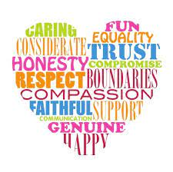
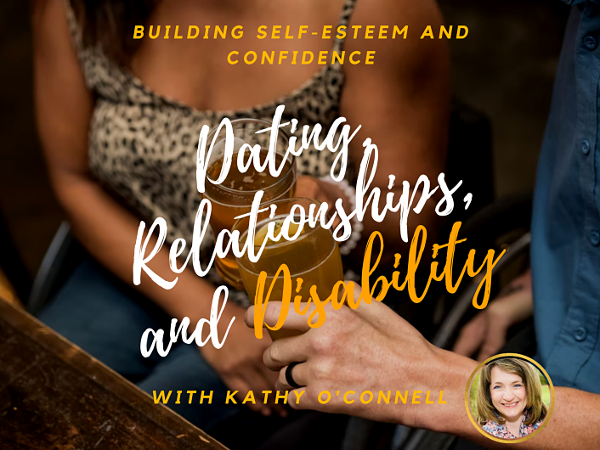
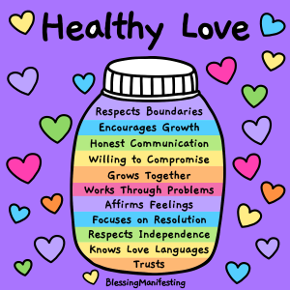

“Hear Our Voices” - Self Advocacy Group Meeting
How to Develop Healthy Relationships
Wednesday, March 16th, 2022
6:00-7:00pm
https://www.wihd.org/event/how-to-develop-healthy-relationships/

Kathy O’Connell, is one of the country’s leading advocates for helping people with
disabilities create healthy romantic relationships and sexual identities through her
unique methodology of increasing self-esteem.
Kathy lives with Cerebral Palsy and is happily married for over 12 years and has a
wonderful son (and two fur babies a cat & dog!)
Kathy O’Connell is one of the country’s leading advocates for helping people with
disabilities create healthy romantic relationships

********************************************
For more information contact: Brendan Klein bklein@wihd.org,
Mariela Adams madams@wihd.org or Claire Poiln cpolin@wihd.org
Please feel free to share this announcement with other self-advocates who may wish to join and their house staff or family members.

New members are always welcome to join!

