#24-7 September 2025

Competitive Feed Costs and Winter-Feeding Systems: 2024 benchmarks and trends
What is the COP Network?
The Canadian Cow-calf Cost of Production Network (COP Network) uses standardized data collection which allows for comparison both within and between provinces, and internationally. Since launching in 2021, the COP Network has collected data from over 235 producers contributing to 64 cow-calf benchmark farms that represent various management systems. Each benchmark is based on data from 3-7 producers. Data collection occurs every 5 years with annual indexing of input and output prices, as well as crop and forage yields, in subsequent years. Individual benchmark farm summaries, can be found at: https://canfax.ca/resources/cost-of-production/cop-results.html
A large proportion of cow-calf producers’ total cost of production is associated with winter feed costs. In 2024, approximate feed costs (of purchased and homegrown feed) made up 63% of cash costs and 37% of total costs (cash, depreciation and opportunity costs). This is up from 56% and 33%, respectively, in 2020 as feed costs have driven cow-calf cost of production over the last five years. Typically, to be a competitive cow-calf producer you need to be a competitive producer of winter feed.
Within the COP Network, on average only 11% of feed is purchased with 18 benchmark farms purchasing more than 5% of their feed. These are typically in regions with surplus feed production. However, in general farms with a higher proportion of purchased feed tend to have higher feed costs. Risks associated with a high reliance on purchased feed include cash flow in drought years, when feed costs surge. This makes the cost competitiveness of homegrown feed a key differentiator between profit and loss.

2024 Benchmarks
When machinery cost and fuel are considered, the average approximate feed cost was $690/cow in 2024, up 5% from 2023. This was up 3% or $20/cow in the West and up 9% or $64/cow in the East. Overall, 33% of the benchmark farms have approximate feed costs below $600/cow with the top-third most profitable benchmarks averaging $559/cow with 204 days on feed and daily feed costs of $2.76/head/day. While days on feed were not much different between the average and top-third, the daily feed cost was 26% lower, contributing to the 19% lower cost for the entire winter.
Metric | Range | Average | Top 3rd | Top 3rd vs. Avg
Daily feed costs ($/hd/day) | 2.04-11.72 | 3.73 | 2.76 | -26%
Days on feed | 60-250 | 194 | 204 | +5%
Approximate feed costs ($/cow/year) | 368-1173 | 690 | 559 | -19%
The daily feed cost is calculated by dividing approximate feed cost by the number of total winter-feeding days, based on the assumption that most of the costs for feeding and feed production are incurred during the winter-feeding period for most benchmark farms, except for year-round grazing operations. Daily feed cost for year-round grazing operations, is likely overestimated due to a short (60 days) winter-feeding period.
2024 Top 3rd Benchmark feed costs are:
- $2.76/head/day
- $559/cow/year

Winter Feeding Systems
Benchmark farms were categorized by primary type of forage fed in the winter diet. These were:
- Annuals: including greenfeed, straw, swath graze, corn graze, crop residues
- Hay (perennial forages): including dry hay, haylage, baleage
- Silage (annual forages): including oat silage, barley silage, pea silage, corn silage
Figure 1. Approximate feed costs ($/cow) by primary feedstuff on benchmark farms in 2024

There is a wide range of costs observed across different feed types (Figure 1). Farms can be either high-cost or low-cost using any of the feedstuffs. This suggests that it is not the feedstuff itself that determines whether a farm is high or low cost, but rather how effectively the management and utilization is within the overall operation. Efficient management practices, rather than feed type alone, play a crucial role in controlling feed costs.
As input costs rise, it has raised questions about the relative competitiveness of different feedstuffs. Over the last five years Hay/Silage has seen the largest increase in cost structure at 53%; while Annuals/Silage has seen the smallest at 43% and has maintained its position as the lowest cost on average.
Approx Feed Costs ($/cow) | 2020 | 2021 | 2022 | 2023 | 2024 | 2024 vs. 2020
Annuals/Hay | 453 | 601 | 605 | 653 | 681 | 50%
Annuals/Hay/Silage | 410 | 586 | 546 | 601 | 612 | 49%
Annuals/Silage | 342 | 568 | 480 | 485 | 487 | 43%
Hay | 536 | 625 | 697 | 746 | 789 | 47%
Hay/Silage | 401 | 528 | 484 | 566 | 615 | 53%
Daily Feed Costs ($/hd/day) | 2020 | 2021 | 2022 | 2023 | 2024 | 2024 vs. 2020
Annuals/Hay | 2.58 | 3.38 | 3.43 | 3.75 | 3.90 | 51%
Annuals/Hay/Silage | 2.14 | 3.04 | 2.84 | 3.11 | 3.17 | 48%
Annuals/Silage | 1.71 | 2.84 | 2.40 | 2.43 | 2.44 | 43%
Hay | 2.82 | 3.32 | 3.70 | 3.99 | 4.19 | 49%
Hay/Silage | 2.00 | 2.67 | 2.42 | 2.82 | 3.06 | 53%

Cost effective forage production
While relatively higher productive regions have a yield advantage that supports competitiveness it is possible for lower productive regions to be cost competitive.
It is not because things are difficult that we do not dare; it is because we do not dare that things are difficult. ~ Seneca
- Forage Yield per Acre - select species and varieties appropriate for your soil type, moisture conditions and growing season. Soil test to manage fertility and pH if needed. Cut at optimal maturity to balance yield and quality.
- Reduce Harvest Costs and Losses - minimize machinery passes. Optimize bale size and density to reduce labour, transport and storage costs.
- Reduce Storage Losses - use net wrap or plastic wrap to reduce leaf loss. Store bales off the ground and cover/tarp to avoid weathering.
- Feed Efficiency - test forage quality to match cow nutritional requirements and avoid overfeeding protein or energy. Use lower-quality feed for dry cows and save higher-quality for lactating cows and heifers. Reduce waste during feeding, providing only what is needed for 1-2 days.
Key Takeaways:
- You can be high or low cost with any feedstuff. Cost control is more about management than feed choice.
- Input cost inflation has impacted each feedstuff differently over the last five-years with some increasing more or less than others.
- Controlling homegrown forage production costs is key to being a competitive cow-calf producer.
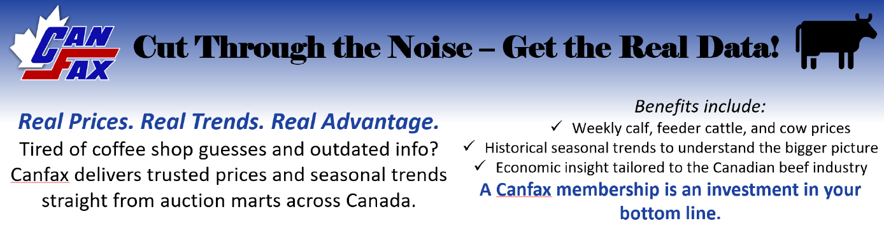

Canfax is funded by Memberships: Subscribe Now!
Or Scan the QR Code for details how

Disclaimer / Copyright Notice: Canfax Research Services (CRS) tries to provide quality information, but we make no claims, promises, or guarantees about the accuracy, completeness, or adequacy of the information. CRS does not guarantee and accepts no legal liability arising from or connected to, the accuracy, reliability, or completeness of any material contained in our publications. Reproduction and/or electronic transmission of this publication, in whole or in part, is strictly forbidden without written consent from CRS.

Approximation of Feed Cost is calculated as feed cost (purchase feed + fertiliser, seed and pesticides for feed production) + machinery cost (machinery maintenance + depreciation + contractor) + fuel, energy, lubricants and water (such as irrigation).

