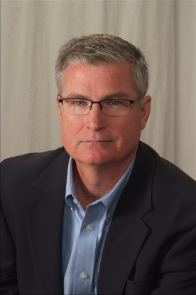
Biographical information on Mark Brooks

Few people in America know the current state of giving to the church like Mark Brooks. There are certainly not many that have written as extensively as Mark known as, “The Stewardship Coach.” From blog posts, a weekly newsletter called, “The Stewardship Coach,” books and articles he is one of the premier experts on the state of giving to the church.

Mark not only knows giving trends but how to build successful giving plans. He has worked with many of the nation’s top pastors like Ronnie Floyd, Joel Osteen, David Hughes, Craig Oliver and others either in capital campaigns or in increasing their regular giving. His out of the box thinking and plans are revolutionizing the stewardship industry. He now has twenty years of experience in the stewardship field after spending twenty years as a Senior Pastor. You can follow him on Twitter at @StewardshipMan.

With over twenty years of pastoral experience in a wide variety of church settings, Mark has been in about every church environment imaginable. In addition to pastoral ministry, Mark has also served in many state and national positions.

In 1998 Mark left the pastorate to enter into the stewardship field working for Injoy Stewardship. Before he left he had risen to the level of Vice President. Mark left Injoy in 2006 to start his own stewardship firm called, The Charis Group. After eleven years of successfully helping multiple churches he sold that company to Horizons Stewardship. Since then Mark has started a new generosity company called, Acts 17 Generosity, https://acts17generosity.com

Mark has worked in a cross section of churches across the nation. He has experience in virtually every type of church setting from small to large, from main line denominations to seeker sensitive settings. He has worked in campaigns that range in size from the largest church in North America, Lakewood in Houston, which raised $100 million, to emerging churches. His experience in campaigns, range from debt reduction to total relocations.

A prolific writer, Mark has written several print books, “Turbo Charge Your Giving,” “Stewardship Myths,” “Recession Proof Your Offerings,” “The Top Ten Stewardship Mistakes Churches Make” and “The Digital Church.” In addition to his print books he has also written many e-books, manuals and articles on giving and generosity. Currently Mark writes for Online Giving at https://www.onlinegiving.org/blog

Mark has been married forty three years to his wife Valerie. They have two children. His son Jon, a decorated Iraqi war veteran who spent two tours of duty in Baghdad and is now a consultant with Iron Arch in Chantilly, VA. Jon and his wife Lianna have one daughter, Zoe. Mark and Valerie’s daughter Amy is married to Major Nick Cherry who is currently stationed in the Mobile, AL area. Amy and Nick have three children, Jackson, Paige and Graham.

Mark and Valerie are active members of Seacoast Community Church in Charleston, SC.

