Gravel Surfacing – New Specification
By Dale C. Heglund, NDLTAP

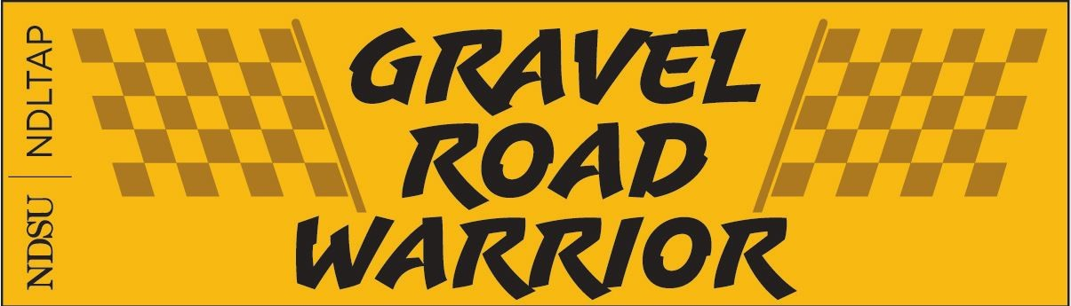

In 2014, NDLTAP launched an effort to improve gravel roads in the state. With approximately 60,000 miles of local county, township and city gravel roadway miles in the state, the need to provide outreach became a core focus item for the NDLTAP team. Blade training was developed to help operators understand the need for a 4% cross slope (i.e., twice the slope of a paved road), the importance of binder in quality gravel, roadway shape, equipment technologies, motor grader maintenance, gravel road failure mechanisms, pretend blading and much more. Special thanks to Bryon Fuchs, Justin Ramsey and Eric Gaasland, NDDOT team members, for their efforts to create the new Gravel Surfacing specification.
NDDOT Special Provision – Gravel Surfacing SP 714(14)
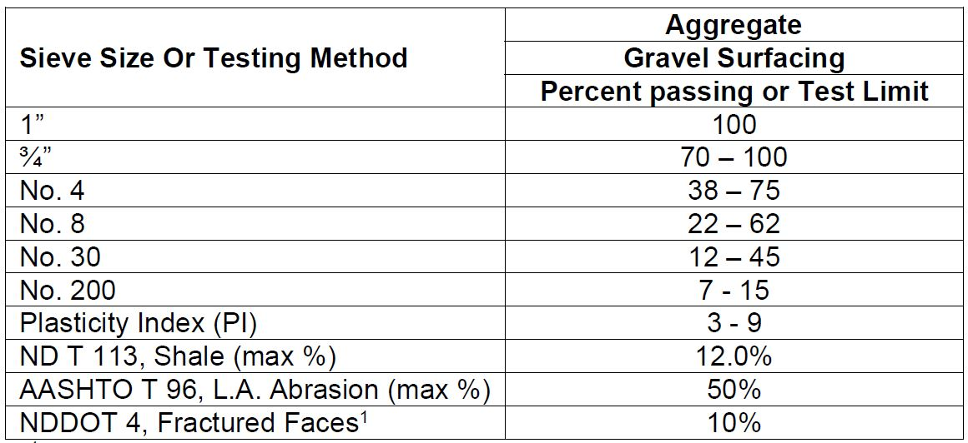
Continuous improvement, a way of life for local leaders.
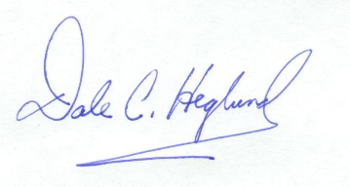
October 1, 2018

