Gravel Road Surfacing

The North Dakota DOT maintains only PAVED ROADS. As such, the DOT uses gravel for pavement base and shoulder material. They typically specify:
Cl 5 Gravel – drainable base material that is placed beneath a paved surface. Water that passes through pavement cracks enters the Cl 5 base. Since the Cl 5 base has limited fine material, water easily drains to the outer edge of the roadway rather than progressing down into the subgrade. By keeping the subgrade (i.e., natural soil foundation) dry the NDDOT maximizes the roadway’s load carrying capacity.
Cl 13 Gravel – shouldering material for highways. Cl 13 shoulder material is essentially a Cl 5 material with more fine material allowed (i.e., a dirty Cl 5). The fine material provides a reduction in water passage and allows sensible utilization of pit materials.
___________________________________________________________________________
Local roadway gravel surfacing requires modifications to the typical pavement base and shouldering gravel. Gravel without binder leads to wash boarding, dust, and float – all critical safety risks. By adding a binder we can create a quality gravel surfacing material for local gravel roads.
Quality gravel surfacing includes a binder material to hold the stone and sand together. Clay is a natural binder that can bind the stone and sand into a gravel matrix. Generally, fines may be clay or silt. Clay has good binder properties, silt does not. Clay has good engineering strength properties, silt does not. A gradation test tells us the amount of rock, sand and fines. A PI test (Plasticity Index – clay value) – this tells us how cohesive or ‘sticky’ the fine material is and as such how well it will perform to hold the rock and sand together. Combined, the tests help tell us how well the gravel will function as a surfacing material. See spec info below.
Specifying and testing gravel are key to insuring that you get the correct gravel for your gravel road driving surface.
- Do you specify the gravel surfacing that you purchase?
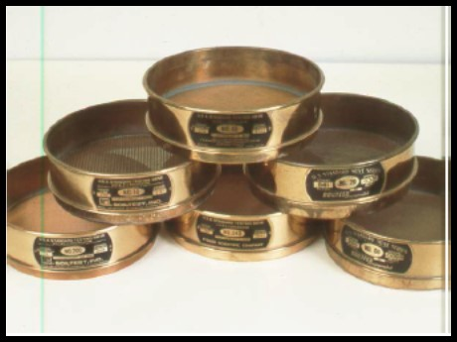
Gradation – y/n
PI (clay) – y/n

- Do you test the gravel surfacing as part of your quality assurance/payment plan?
Gradation – y/n
PI (clay) – y/n

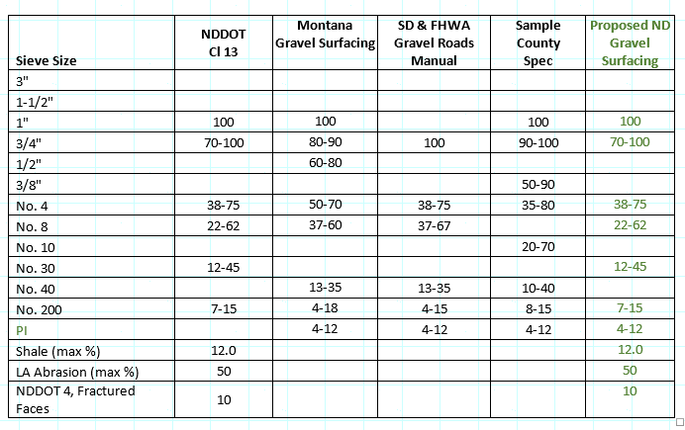

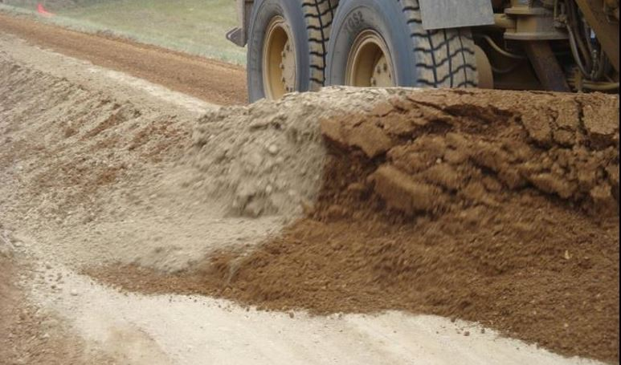
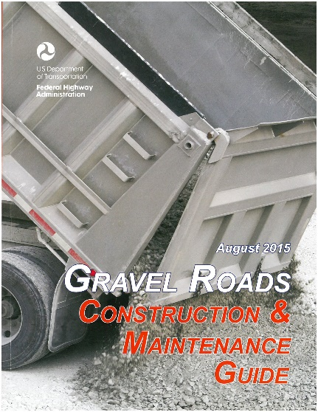

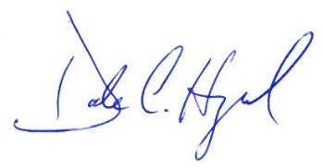

February 1, 2018
Dale C. Heglund, PE/PLS, NDLTAP Program Director -701-318-6893, dale.heglund@ndsu.edu
Check out the gravel resource page at www.ndltap.org.

