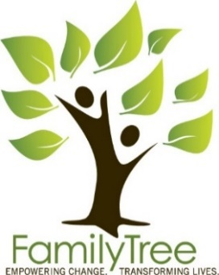

Contact: Carly Bolliger
Email: cbolliger@thefamilytree.org
Direct: 303-403-5896

Family Tree’s 26th Annual Celebration of Achievement

[Wheat Ridge, CO] (March 18, 2019) – Family Tree is excited to announce the 26th annual Celebration of Achievement will be held May 9, 2019, at 6pm at the Denver Museum of Nature and Science. This event raises critical funds to support vital programs and services for people impacted by child abuse, domestic violence and homelessness in the Denver metro area.
Dinner, drinks, silent and live auctions, and a signature activity all make this evening a unique experience. Guests will help celebrate the accomplishments of individuals and families who have created positive, lasting change in their lives as they support Family Tree’s work.
“Celebration of Achievement is an exceptional opportunity for our community to honor the successes of these strong and self-reliant individuals while helping Family Tree serve even more individuals and families,” said Scott Shields, Family Tree Chief Executive Officer.
One of last year’s celebrants, a Family Tree volunteer, Julia, commented, “It feels good to be recognized. I would consider myself successful and definitely happy. I couldn’t have done it without you.”
Another celebrant, Liz, shared, “I’m proud! It’s touching; it makes me want to cry and also smile.”
Liz and her son Sam found Family Tree after leaving a violent situation in Idaho, and having no choice but to sleep in a tent when they had nowhere else to go. The two were stabilized and now have a home of their own and are self-reliant. Liz enjoys her career and Sam is in his senior year in high school.
Family Tree serves more than 8,000 individuals like Liz and Sam each year with child and youth services, domestic violence services, and housing and stabilization services. Family Tree’s partnership with the Denver Museum of Nature and Science will allow for double the guests to join in this year’s celebration. Family Tree hopes to raise $200,000 to continue impacting lives.
Tickets, tables and sponsorship opportunities are available by visiting www.TheFamilyTree.org/Events, the Facebook event or by contacting Tami Mawhir at tmawhir@thefamilytree.org.

-End-
Family Tree Inc. – For over four decades, Family Tree has provided innovative, life-changing services designed to end child abuse and neglect, domestic violence and homelessness. As one of the only non-profit organizations in the Denver metro area working to address the interconnectedness among these issues, Family Tree is changing how individuals, families and communities see, respond to, and overcome these challenges.
NOTE TO EDITOR: 2018 Celebrant Liz is available to discuss Celebration of Achievement. All Family Tree’s 2018 Celebrant stories can be viewed on YouTube.

