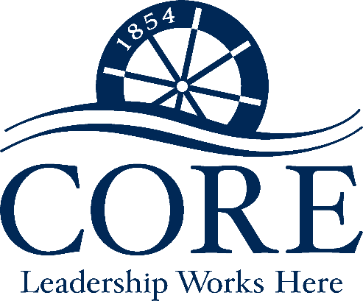
City of Roswell’s
CORE Program
2023 - 2024

You don’t just work here, you belong here!

The CORE program (City of Roswell Education and Engagement) offers employees the opportunity to gain insights on the many different departments and dimensions of working at the City. By participating in this program, employees will:

- Learn more about the City of Roswell
- Understand the culture at the place you work
- Meet other employees in different departments

This program offers employees hands-on experiences during a tour of the facilities, and then ongoing learning about the City operations in the EnCORE meetings throughout the year.

Tour of Facilities  Fridays, 9:00 am – 11:30 am  2023 | EnCORE Meetings  Tuesdays, 10:00 am – 12:00 pm  2024
- October 13, 2023 – City Hall  - November 3, 2023 – Bus Tour of City Parks  - November 17, 2023 –Transportation and Environmental/Public Works  - December 8, 2023 – Fire and Police | January 23, 2024 July 16, 2024  February 13, 2024 August 13. 2024  March 19, 2024 September 17. 2024  April 16, 2024 October 15. 2024  May 21, 2024 November 12, 2024  June 18, 2024 December 10, 2024

Eligibility:
- Approval from both Department Director and Supervisor for participation in the program,
- Full-time employee with six months of service, and
- Has not participated in CORE in past years.

Application Procedure:
Interested employees must submit the application to Mary Lynn Savelle, Organizational Development Manager in Human Resources, no later than September 15, 2023. The application must include the Department Director’s and Supervisor’s signature.
City of Roswell’s
CORE Program 2023-2024

First Name: |  | Last Name:

Department: | Department | Current Position:

Date of Hire: | ___/____/______ | Date in Current Position: | ___/____/______

Supervisor: |  | Department Director:

By applying to the CORE Program, you are agreeing to attend and participate in the scheduled sessions below:

Tour of Facilities  Fridays, 9:00 am – 11:30 am  2023 | EnCORE Meetings  Tuesdays, 10:00 am – 12:00 pm  2024
- October 13, 2023 – City Hall  - November 3, 2023 – Bus Tour of City Parks  - November 17, 2023 –Transportation and Environmental/Public Works  - December 8, 2023 – Fire and Police | January 23, 2024 July 16, 2024  February 13, 2024 August 13. 2024  March 19, 2024 September 17. 2024  April 16, 2024 October 15. 2024  May 21, 2024 November 12, 2024  June 18, 2024 December 10, 2024

This application is due to Mary Lynn Savelle, Organizational Development Manager in Human Resources, no later than September 15, 2023. Only applications with the appropriate signatures of approval will be accepted.

I would like to be considered for the City of Roswell’s CORE Program. I understand that I will be required to attend the above-mentioned scheduled sessions. I have received my Department Director’s and Supervisor’s approval to apply as indicated below by their signature.

Signature: |  |  |  |  | Date:
Mgr/Supv. Signature: |  |  |  |  |  | Date:
Dept. Director Signature: |  |  |  |  |  |  | Date:

To Be Completed By Human Resources | Date Received | Resume Received | Discipline | Performance Eval. | DOH | Date of Current Position

