
City of Roswell’s
Project Management Training
Fall 2023

Project management is the process of achieving project objectives through a set of activities that start and end at certain points in time and produce measureable deliverables. Successful project management is the bringing together of the tasks, resources and people necessary to accomplish the City goals and objectives within the specified time frame and within the established project budget.

This training course will cover a typical project life cycle:
- Initiation: Defines objectives, scope, purpose, and deliverables
- Planning: Creates plans that will guide the team throughout all project phases
- Execution: Works toward completing the project deliverables
- Monitoring and Control: Observes the project progress throughout the entire life cycle of the project, from initiation to close out in order to identify and mitigate threats to the project
- Close Out: Brings a project to closure, including reporting, review and archiving

The Project Management Training course is a five (5) month intensive program with in-person meetings as well as self-guided course work. Selected participants are expected to meet each month for sessions that last approximately 3 hours, and to complete all assigned coursework.  We will use the standard operating guidelines (SOG) established for the City of Roswell. The program will begin September 29, 2023 and conclude on February 2, 2024. By the end of this program, participants will be able to use the guidelines to complete their own (real or example) project using the SOG. | 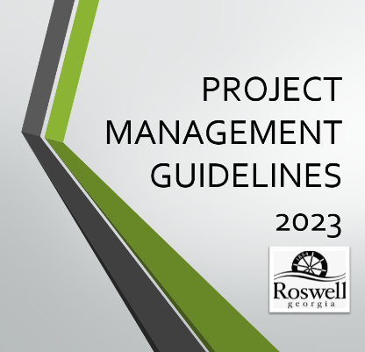
Eligibility:
Employees who meet the following criteria are eligible to apply for the Project Management Training course:
- Received approval from both Department Director and Supervisor for participation in the program
- Actively working on a project that would benefit from the Project Management process

Application Procedures:
Interested employees must submit the application to Mary Lynn Savelle, Organizational Development Manager in Human Resources, no later than September 15, 2023. The application must include the Department Director’s and Supervisor’s signature.

Application for
City of Roswell’s
Project Management Training 2023-2024

First Name: |  | Last Name:

Department: | Department | Current Position:

Date of Hire: | ___/____/______ | Date in Current Position: | ___/____/______

Supervisor: |  | Department Director:

By committing to the program, you are agreeing to the following:

- To attend and participate in each of the scheduled sessions

2023 | 2024
September 29  October 12 and 20  November 16 and 30  December 15 | January 12 and 26  February 2

- To complete all required coursework no later than their scheduled due dates

The application is due to Mary Lynn Savelle, Organizational Development Manager in Human Resources, no later than Friday, September 15, 2023.

I would like to be considered for the City of Roswell’s Project Management Training course. I understand that I will be required to attend scheduled sessions during the five (5) month program and complete all required coursework. I have received my Department Director’s and Supervisor’s approval to apply as indicated below by their signature.

Signature: |  |  |  |  | Date:
Mgr/Supv. Signature: |  |  |  |  |  | Date:
Dept. Director Signature: |  |  |  |  |  |  | Date:

To Be Completed By Human Resources | Date Received | Resume Received | Discipline | Performance Eval. | DOH | Date of Current Position

Project Management Training, Fall 2023

- DATES: September 29, 2023 to February 2, 2024
- DAY/TIME: Thursdays and Fridays, 8:30 – 11:00
- Location: Roswell City Hall, G-35

Session # | DATE | TOPIC
1 | Friday,  September 29,  2023 | Introductions, expectations, guidelines, terms and tools  Building and presenting an approvable Project Charter
2 | Thursday,  October 12,  2023 | Planning 1  Work breakdown structure and responsibilities
3 | Friday,  October 20,  2023 | Planning 2  Risk, budget and procurement
4 | Thursday,  November 16,  2023 | Budget, estimating and authority
5 | Thursday,  November 30,  2023 | Execution  Staffing, status meetings, reports and reviews
6 | Friday,  December 15,  2023 | Monitoring and Control  Earned value analysis and change requests
7 | Friday,  January 12,  2023 | Close Out  Dispute resolution  Acceptance, warranty, close out report and files
8 | Friday,  January 26,  2024 | Class Project  Deliverable briefings
9 | Friday,  February 2,  2024 | Class Project  Deliverable briefings

