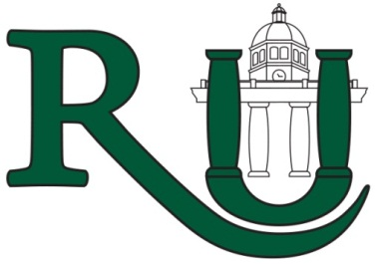
City of Roswell’s
SDP Leadership Program
2023 - 2024

Learn how you can be more effective in your position by discovering your strengths and applying them to your position. The goals of the program include, but are not limited to:

- Understand and make connections to the mission, vision and values of the City of Roswell
- Recognize leadership opportunities in work situations
- Discover team-building strategies that address the needs of team members
- Increase interaction with the City of Roswell’s departments

The SDP Leadership Program is a nine (9) month intensive program with in-person meetings as well as self-guided course work. Selected participants are expected to meet each month for sessions that last approximately 2 hours, and to complete all assigned coursework.  We will use Gallup’s Strengths-Based Leadership as our course foundation. The program will begin September 7, 2023 and conclude on May 16, 2024. | 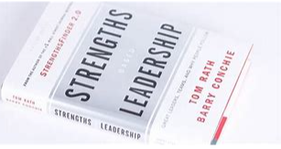

Eligibility:
Employees who meet the following criteria are eligible to apply for the SDP Leadership Program:
- Received an overall “Successful Performer” rating or above on the most recent performance evaluation
- Received no adverse disciplinary action within the last 12 months (see the Human Policies and Procedures Manual Policy 13.4 for a list of adverse disciplinary action)
- Received approval from both Department Director and Supervisor for participation in the program

Application Procedures:
Interested employees must submit the application and a resume to Mary Lynn Savelle, Organizational Development Manager in Human Resources, no later than August 31, 2023. The application must include the Department Director’s and Supervisor’s signature.

Application for
City of Roswell’s
SDP Leadership Program 2023-2024

First Name: |  | Last Name:

Department: | Department | Current Position:

Date of Hire: | ___/____/______ | Date in Current Position: | ___/____/______

Supervisor: |  | Department Director:

Let us know what you hope to learn in this program that will help you meet your career goal:

Career Goal:

Please attach a current resume to this application form for the SDP Leadership Program. By committing to the program, you are agreeing to the following:

- To attend and participate in each of the scheduled sessions

2023 | 2024
September 7 and 21  October 19  November 9  December 7 | January 18  February 8 and 22  March 14  April 11 and 25  May 9 and 16

- To complete all required coursework no later than their scheduled due dates

The application and a current resume are due to Mary Lynn Savelle, Organizational Development Manager in Human Resources, no later than Friday, August 31, 2023. Only applications with the appropriate signatures of approval will be accepted.

I would like to be considered for the City of Roswell’s SDP Leadership Program. I understand that I will be required to attend scheduled sessions during the nine (9) month program and complete all required coursework. I have received my Department Director’s and Supervisor’s approval to apply as indicated below by their signature.

Signature: |  |  |  |  | Date:
Mgr/Supv. Signature: |  |  |  |  |  | Date:
Dept. Director Signature: |  |  |  |  |  |  | Date:

To Be Completed By Human Resources | Date Received | Resume Received | Discipline | Performance Eval. | DOH | Date of Current Position

SDP LEADERSHIP TRAINING 2023 - 2024

- DATES: September 7, 2023 to May 16, 2024
- DAY/TIME: Thursdays, 9:00 – 11:00

Session # | DATE | TOPIC | LOCATION
1 | September 7,  2023 | Launch +  Strength-Based Leadership (SBL) | City Hall,  Room 220
2 | September 21,  2023 | SBL Leadership  (Telling Your Story) | City Hall,  Room 220
3 | October 19,  2023 | Mentor Program | City Hall,  Room 220
4 | November 9,  2023 | Strategic Planning | City Hall  Room 220
5 | December 7,  2023 | Innovation | City Hall,  Room 220
6 | January 18,  2024 | Conflict Management | City Hall,  Room 220
7 | February 8,  2024 | Motivating Employees | City Hall,  Room 220
8 | February 22,  2024 | Team Building | City Hall,  Room 220
9 | March 14,  2024 | Accountability | City Hall,  Room 220
10 | April 11,  2024 | Communication Skills | City Hall,  Room 220
11 | April 25,  2024 | Public Speaking: Innovation Panel | City Hall,  Room 220
12 | May 9,  2024 | Manage Time and Work | City Hall,  Room 220
13 | May 16,  2024 | Graduation | Mimosa Hall

