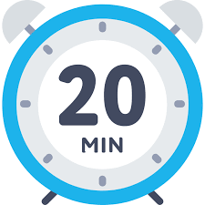
CCA of A Twenty Minute Talk-Episode Eleven
Michele Gambino-Gambino Investigative Services
You are invited to a Zoom meeting.
When: Aug 21, 2025 02:00 PM Central Time (US and Canada)

Register in advance for this meeting:
https://us02web.zoom.us/meeting/register/n4QGGPIiT2C023ynslLW6Q

After registering, you will receive a confirmation email containing information about joining the meeting.

