Children’s Mental Health Services Coordination Call
Thursday, April 18, 2024

Welcome!

Our greatest hope is for these calls to accomplish:
1. Create real-time opportunities to identify services for children boarding in EDs (Emergency Department) – by bringing a community of providers together to help identify real-time solutions
2. Build more cohesive relationships and understandings of services and possibilities to
serve children in the short and medium terms – by learning together more about real-
time needs/gaps/opportunities.
3. Bringing together the experts on this topic to create a space to identify solutions to
these situations
4. Do SOMETHING DIFFERENT!

11:20 Workshop to Getting to YES
Can we discuss “what would it take to treat this child” in your setting?
- What resources would be needed?
- What is driving the “NO” so we can address that?
  - What if you had no choice but to take this child – what would you and your staff have to do?
What plan with the hospital or county would enable you to provide care for this child?
- How can we creatively get to a “YES” for these children?

How do we prioritize these kids with the open spaces? If we cannot prioritize, we are
just talking.
__________________________________________________________________________
There were 24 cases on the Hub today.
This week we had a school group join us, from Moundsview and the Ramsey County Children’s Mental Health Collaborative. They wanted to see what we were all about and how we could potentially work together in connecting children to the resources they need.
One of their big struggles is when their students return to school from the ED or a hospital stay, they will have paperwork stating recommendations for further treatment. The social workers/school staff are involved as the parents often ask to help to find resources for their child.
Less than 1% of their students have a case manager or county worker, and the typical barriers of long wait lists and limited options come into play. There is also a great need for CTSS (Children’s Therapeutic Services and Supports), Neuropsych testing and MN Choices assessments.
Wendy from RCCMHC stated that there 89 collaboratives in the state, which act as a resource in the community and support mental health. If a child is DC’d from a hospital, they will most likely do a hand off to a collaborative to get involved.
It was an engaging conversation about what schools are faced with. We took up the entire hour and it could have gone on much longer. Connecting resources and collaborations are so important. We hope to connect with this group again to further our conversation on how to join forces and Get to Yes for these kids.
-RCCMHC Ramsey County Children Mental Health Collaborative | Ramsey County, Minnesota
- RCCMHC is a community-led collaborative that uses an “it takes a village” approach to support youth mental health and family wellbeing. Founded in 1997, RCCMHC has grown to become an essential hub that identifies gaps, streamlines access, and provides free direct services for youth and families who typically fall through the cracks of traditional service systems.

RCCMHC was created through a joint powers’ agreement between the MN Association for Children’s Mental Health, Ramsey County, and six School Districts. We also collaborate with family service and basic needs agencies, hospitals, clinical and nonclinical specialized care professionals, and healers. And we share joint initiatives with the Suburban Ramsey Family Collaborative. These public-private partnerships make it possible for us to bridge gaps, streamline care, and transform how families navigate systems.
- If you haven’t visited this site, take a look. There are a lot of great things tools/resources/information here.
-Home | SRFC Site (howarethechildren.org)
- The Suburban Ramsey Family Collaborative (SRFC) is a partnership of schools, county, public health, corrections, nonprofit agencies, mental health service providers, faith communities and youth organizations. SRFC works on behalf of children and families to improve formal and informal support systems with a focus on wellness, learning, safety, and security.
​
Impact | rccmhc This is a link to the impact page of the RCCMHC

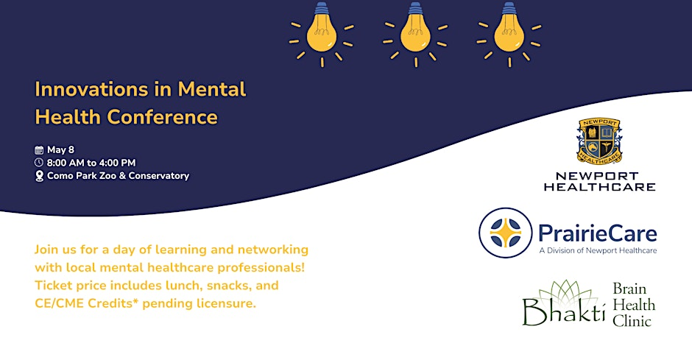
https://www.eventbrite.com/e/innovations-in-mental-health-tickets-865544796787
Please note the discount code is: IMHdiscount100
The code is available until this Friday the 26th

_________________________________________________________________________________________________________
Our next meeting will be 4.25.24 at 11:00.
Thank you for your partnership in finding solutions for these children and GETTING TO YES!

