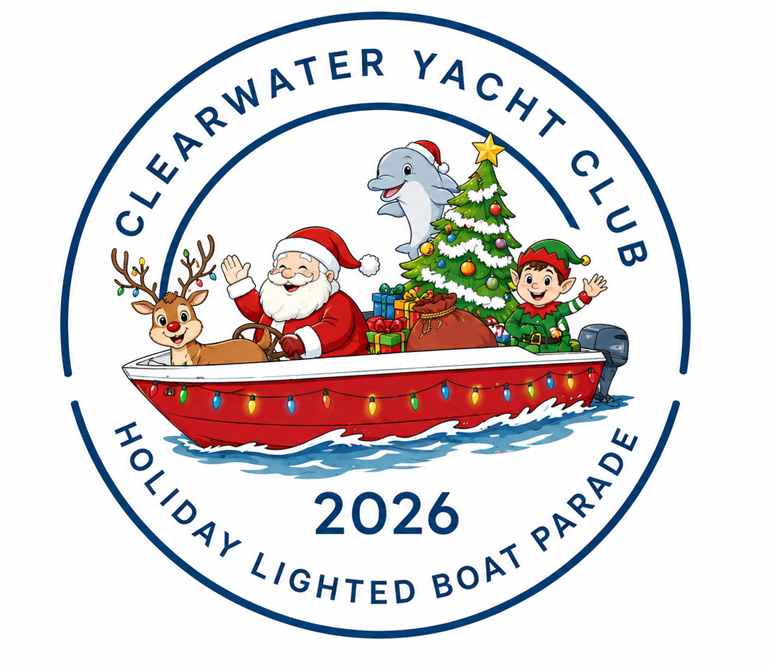
In Partnership with Clearwater’s “Holiday in Lights”

SPONSORSHIP OPPORTUNITIES

GRAND SPONSOR — $5,000
Santa says thank you with:
- VIP Parade Viewing
- Logo featured in pre-event social media posts with a link to your business
- Logo prominently displayed on event signage
- 90-Day Membership to Clearwater Yacht Club
- Prominent logo recognition in local media & publications
- Opportunity to contribute promotional items to Captain’s Bags
- Invitation to CYC’s Gasparilla Party

DIAMOND SPARKLE — $2,500
Santa says thank you with:
- 60-Day Membership to Clearwater Yacht Club
- Logo featured in pre-event social media posts with a link to your business
- Logo recognition in local media & publications
- Holiday Boat Parade sponsor poster to display at your business
- Opportunity to contribute promotional items to Captain’s Bags
- Invitation to CYC’s Gasparilla Party

PLATINUM ANGEL — $1,500
Santa says thank you with:
- 30-Day Membership to Clearwater Yacht Club
- Logo featured in pre-event social media posts with a link to your business
- Holiday Boat Parade sponsor poster to display at your business
- Invitation to CYC’s Gasparilla Party

GOLD TWINKLE DUST — $1,000
Santa says thank you with:
- Brunch for four at Clearwater Yacht Club
- Opportunity to contribute promotional items to Captain’s Bags
- Recognition in pre- and post-event social media
- Recognition in CYC’s Monthly Newsletter
- Invitation to CYC’s Gasparilla Party

SILVER BELLS — $500
Santa says thank you with:
- Recognition in post-event social media
- Recognition in CYC’s Monthly Newsletter
- Invitation to CYC’s Gasparilla Party

Please complete the form below so we can list your sponsor name exactly as you would like it to appear in event materials.
- Sponsor name: ______________________________________________
- Company name: ____________________________________________
- Contact name: ______________________________________________
- Phone: _____________________________________________________
- Email: ______________________________________________________

Please email your company logo for recognition materials to Boat.Parade@clearwateryachtclub.org.

PAYMENT INFORMATION
Sponsorship Level Selected: ______________________________________

Payment Method:
☐ Check ☐ Credit Card

Checks payable to: Clearwater Yacht Club

Credit Card Information
Name on Card: ____________________________________________
Card Number: _____________________________________________
Billing Address: ____________________________________________
Expiration Date: __________________ CVC: _______________

Please return your completed sponsorship form and payment by November 30, 2026.

MAILING ADDRESS
Lindsey Edwards – Holiday Boat Parade
Clearwater Yacht Club
830 South Bayway Boulevard
Clearwater, Florida 33767

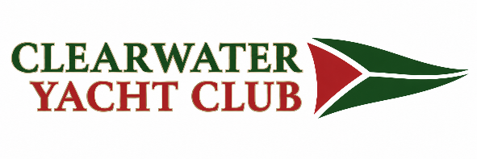
Boat.Parade@clearwateryachtclub.org/ 727-447-6000

