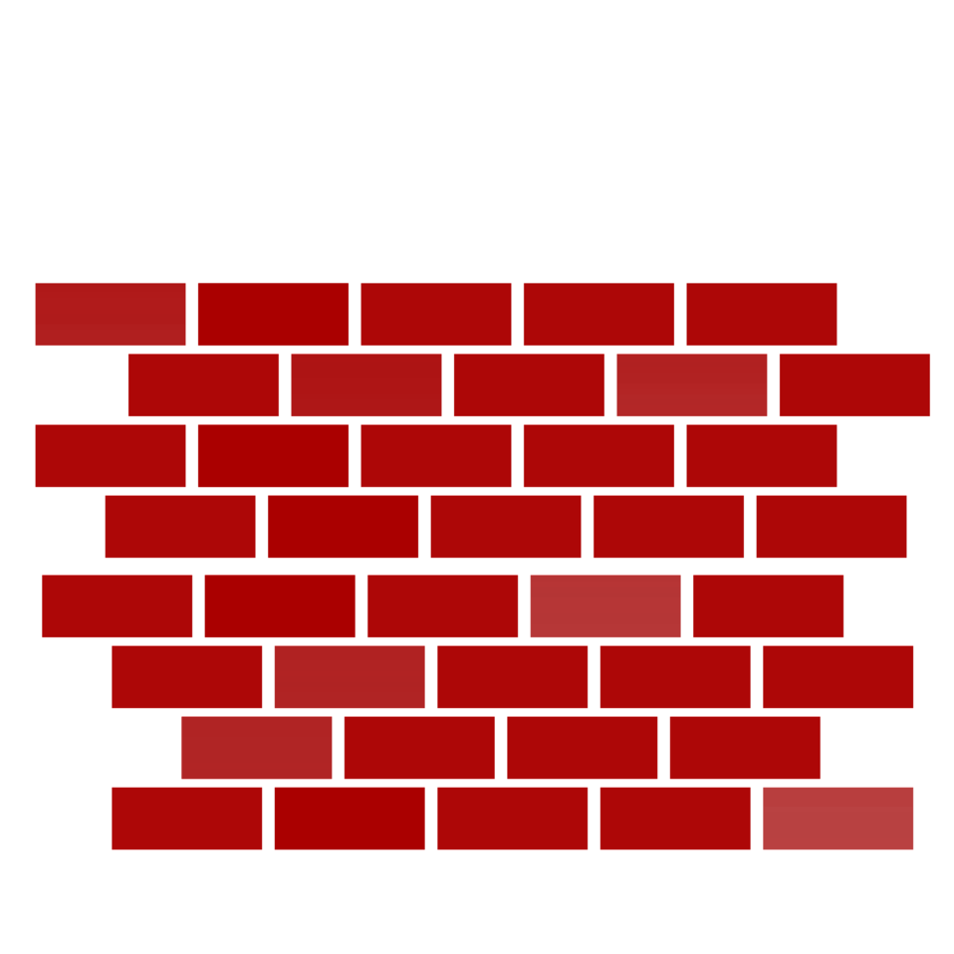
Order Your Lafayette HSA Commemorative Brick for your graduate, teacher, alumni or friend
SALES END 5/31
IT’S NOT TOO LATE TO ADD YOUR NAME OR YOUR CHILD’S NAME TO OUR SCHOOL!
If you have been near the front of the school lately, you will see the beautiful results of our first Annual Brick Program at Lafayette - a special commemorative area in our new school where current and former Lafayette families or community members can buy engraved bricks to honor students, teachers, friends, and even special moments. It’s a great way permanently cement special Lafayette memories, plus you’re helping to support Lafayette.

As you will see, we had a very productive fall rollout of the program but we decided to reopen the program for spring, so you can still honor your 5th grade, Pre-K grad or just regular student, your favorite teacher, alumni or parent. All proceeds go to the HSA to fund programs that make LAFAYETTE GREAT!!!

It’s so easy. You can pay via check or online at lafayettehsa.org. Just fill out the form below and on back, attach a check or your receipt from paying on line at lafayettehsa.org and return it to school via your child’s backpack or drop it in the HSA Box or the Bricks Drawer in the Main Office.

ORDERS MUST BE SUBMITTED BY MAY 31 2017 in order to make our installation deadline in June.

Please Select Your Choice of Brick Paver Below
_____ 4"x8" $150.00 3 lines of engraving up to 17 characters per line, spaces, numbers and letters
_____ 12"x12" $300.00 5 lines of engraving up to 17 characters per line, spaces, numbers and letters
Purchased by:
Name:____________________________________________

Address:____________________________________________
City:__________________ State: _________ Zip: ___________
Telephone No:________________ Email:___________________

Please return completed form by May 13, 2017 along with check payable to the Lafayette HSA or PayPal receipt from lafayettehsa.org.

PLEASE TURN OVER FORM TO SUBMIT TEXT FOR BRICKS

Lafayette HSA Commemorative Brick Program

Engraving: PLEASE PRINT LEGIBLY
ALL ENGRAVING SUBJECT TO COMMITTEE APPROVAL

LINE 1
LINE 2
LINE 3
LINE 4 (12x12)
LINE 5 (12x12)

PLEASE NOTE - Brick placement in sidewalk is random. Bricks are available on a first-come first-served basis, and there is no guarantee of actual location placement in the sidewalk.

Please return completed form and payment ( check or receipt from online payment from lafayettehsa.org) to Lafayette by May 13. You can send via your child’s backpack folder or drop in the HSA Box or Brick Drawer in the Main Office.

Thank you for supporting Lafayette.

QUESTIONS: ?????

Contact: SONYA MATZA
sonyajo1972@gmail.com

