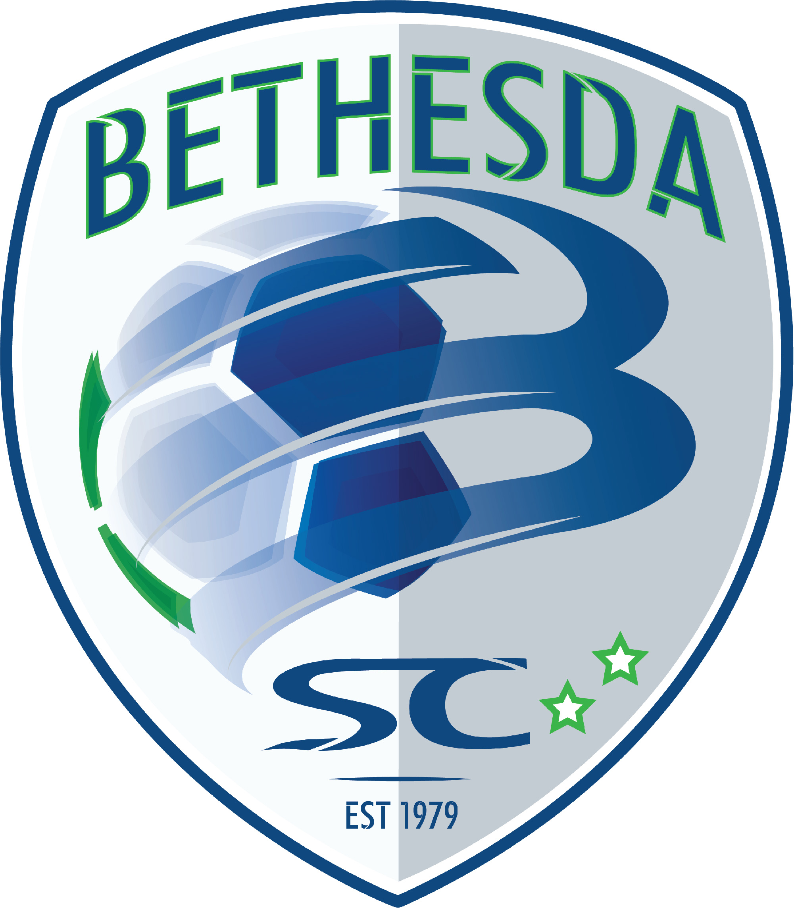


2019/2020 State Cup Teams
Player Guide


WELCOME AND GENERAL INFORMATION
Congratulations on being selected to play for Bethesda Soccer Club during this upcoming year.

OUR MISSION

The Bethesda Soccer Club (BSC) is committed to creating a competitive, supportive, challenging, and fun environment for all our players to reach their potential through the beautiful game of soccer. With commitment to our goals and appreciation for the opportunity, we accept the responsibility to develop every player to their highest level of skill, athleticism, teamwork, and leadership in soccer. We strive to use all of our faculties - strength, spirit, courage, compassion, and intelligence - to achieve positive results on and off the pitch for our players and families. BSC’s passionate leadership and detailed, holistic approach to long-term elite development at every age group support our uncompromising resolve to be the best youth soccer club in the country. We also strive to be a positive role model for our community, including through the provision of financial support for needy families to the best of our ability.

REGISTRATION AND GENERAL INFORMATION
Please go to our website www.bethesdasoccer.org to learn more about the club.
BETHESDA PREMIER CUP TOURNAMENT
Every year we host our Bethesda Premier Cup during the month of November. Our success in the Bethesda Premier Cup allows us to provide much needed player scholarships as well as subsidizing our annual players’ fees. This event, comprised of over 1,100 teams, is one of the top tournaments in the country and the major fundraiser of the club throughout the entire year. We ask Every BSC family to volunteer possibly 3 to 5 hours during the weekend. Contributions include telephone calls, organizational responsibilities, registration, and field marshals. Each age group has a coordinator who will ensure completion of all of the responsibilities for that age group. The assistance from each of our "club families" has been instrumental to the continued success of the tournament! We appreciate all of the support you provide to help make this event a success.

DESCRIPTION OF FEES AND FINANCIAL POLICIES
Costs Included in Annual Fees:
- BSC Club Fees
- MSYSA Registration and/or US Club Registration
- Practice Sessions: Two/three sessions per week (NOTE: U16-U19 will have one session per week through the fall).
- Access to Soccer Parenting Association organization and resources
- 10% Discount at All PJ Sports locations
- Goalkeeper Training: Weekly specialized training for team keepers
- Speed & Agility, Fitness and Strength Training
- 2019/2020 League Fees (NCSL, ERL, EDP, NPL)
- Game Fields and referees
- Minimum of four (4) non-BSC tournaments
- Bethesda Premier Cup Tournament
- State Cup/Presidents Cup fees, fields and referees

The fee does not include required player uniforms, warm-ups, practice jerseys or player travel-related costs.

Fees: Fees are determined annually on a per player basis.

Uniforms: The club updates its uniform kit every two years. 2019/2020 is a non-uniform cycle year and players will be utilizing last year’s uniforms. However, new players will be required to purchase a new uniform kit. The approximate cost of the kit is $96 for U08, $325 for youth sizes and $345 for adult sizes.

What comes with the standard uniform kit?

Field Players:
- U08 Kit: Two Game Jerseys, Two Pairs of Game Shorts, and Two Pairs of Socks
- U09-U12 Kit: Two Game Jerseys, Two Practice Jerseys, Two Pairs of Game Shorts, Two Practice Shorts, Two Pairs of Socks, a Hooded Sweatshirt, Warm-Up Pants, and a BackPack

Goalkeepers:
- If your player is a field player (i.e. plays defender, midfielder, etc.) they will purchase the regular kit and can purchase an Adidas goalkeeper jersey for an additional fee.

- If your player plays just goalkeeper they will receive the standard kit with the goalkeeper jersey substituted in for the game jerseys.

For more information on Uniforms please contact PJ Sports at 301-365-3355.

Once you have accepted a roster spot and been assigned to a team, you will receive a jersey number from your coach or manager. We have posted further instructions on our website under the Information/Uniforms tab.

Mid-Season Roster Additions: Fees for players added/transferred during a season will be adjusted according to a set schedule based on the month the player joins the team. Please contact the Director of Coaching for more information about joining mid-season.

Bethesda Soccer Club is proud to offer financial assistance to those members of our community who have demonstrated need. Please visit the resources section of our website for more information on the financial aid process. The majority of financial aid is given in the form of a partial scholarship. Any remaining fees are the responsibility of the family and will need to be paid on time to avoid penalties.

Scholarships: Bethesda Soccer Club is proud to offer financial assistance to those members of our community who have demonstrated need. Please visit the resources section of our website for more information on the financial aid process. The majority of financial aid is given in the form of a partial scholarship. Any remaining fees are the responsibility of the family and will need to be paid on time to avoid penalties. Please note that COMPLETE applications for assistance are due within 10 days of acceptance of an offer to join a Bethesda Team.
You are required to pay your deposit even though you may be applying for a scholarship. Scholarships WILL NOT be awarded to anyone who has not paid their deposit.
Payment Schedule: Payments are by credit card or debit cards only, here are the following options:

- Pay in full at time of registration.
- Automatic Charge Payment Plan: The non-refundable deposit of $400 will be charged at check out. The balance is divided into 5 additional monthly payments. Please note that this plan does incur an additional finance charge of 3%. When registering for a team, select Automatic Payment Plan as your Payment Method on the checkout screen. The balance of the payments will be automatically charged on a set schedule as listed at check out.

Players joining after November 1st will be offered a shortened payment plan.

If you do not have a credit or debit card, please contact the BSC office to discuss registration options.

It is the responsibility of the player’s family to remain current with the payments and maintain the membership in good standing.

In the event that payments are not made within 30 days of the payment due date, the club will take the following actions:

31 days late: Notify Director of Coaching, Coach and Manager of balance due and that member is not in good standing. Player will receive a warning that if payment is not made within 30 days, the Director of Coaching will be notified and appropriate actions taken by the Executive Director (suspension from games, suspension from practices and games, suspension from club, etc.)

61 days late: Director of Coaching will discuss past due balances with the Executive Director and appropriate sanctions of player and family will take place until such time as player and family become a member in good standing.
Member Player accounts with balances that are greater than 60 past due should expect that their participation in team and club activities will be suspended until such time as the balance due is paid in full.

Refund Policy: Accepting a position on a Bethesda Soccer Club team is a commitment to the club and to the other members of the team to play for the full soccer year, which includes any commitments after tryouts. In accordance with MSYSA regulations, there may be circumstances that result in a player asking to be released from a team. This refund policy applies to players who voluntarily request a release from a team prior to the completion of the year (August 1 to July 31). Please note that the $400 deposit for each player is non-refundable in any circumstance.
The Bethesda Soccer Club depends on the receipt of payments to pay for expenses during the seasonal year. As such, refunds are strongly disfavored and will be granted only in the rarest of circumstances.

Discounts: As a member of the Bethesda Soccer Club family, you are eligible to receive a 10% discount at PJs Sports! Please identify your Club affiliation upon checking out at the store to receive your discount.

WELCOME AND STAY IN TOUCH
We look forward to great soccer year! Your team manager and coach should be your first stop for information regarding the team. Please feel free to contact us if we can be of help to you during the year.
Jonathon Colton jcolton@bethesdasoccer.org (240) 224-7363
Technical Director, Boys and Girls Programs

Brett Colton bcolton@bethesdasoccer.org
Age Group Coordinator, Younger Boys (U12-U14)

Dave Greene dgreene@bethesdasoccer.org
Age Group Coordinator, Younger Girls (U12-U14)

Matt Ney mney@bethesdasoccer.org
Age Group Coordinator, Older Boys (U15-U19)

Kevin Layton klayton@bethesdasoccer.org
Age Group Coordinator, Older Girls (U15-U19)

Lisa Frates lfrates@bethesdasoccer.org (240) 224-7363
Executive Director

Zane Campbell zcampbell@bethesdasoccer.org (240) 224-7363
Office Manager


8655 Grovemont Circle Gaithersburg, MD 20877
Phone: (240) 224-7363
www.bethesdasoccer.org
PLAYER’S CODE OF CONDUCT
Parent and Player Pledge: I* recognize that players need to conduct themselves in a manner that is supporting to the development of the player, the team and the positive experience of all person’s they interact with in the context of the BSC soccer program.
Player Code of Conduct: As a Player, I agree that I will abide by the following, and as the Parent of a Player, I* agree to that my player will abide by the following:
Individual Conduct
- I will maintain a high level of fitness and nutrition and I fully understand my role in enhancing performance and preventing injuries
- I will spend time on individual player development, before, after and outside of practice
- I understand my commitment to BSC is from August-June (even after tryouts)
- I understand that I am not allowed to guest play with other clubs or teams outside of BSC
- I will embody the “Values” of BSC
Conduct with Team
- I will be respectful and professional on and off the field all of the time
- I will challenge, support, encourage and motivate my teammates
- I am fully committed to my team’s success and will maintain a high level of competitive spirit
- I am fully committed to the BSC style of play, which separates us from other clubs
- I will embody a winning mentality in all activities all the time
Practice Conduct
- I understand that practice is mandatory and there are no excused absences
- I understand that punctuality is a requirement: players must arrive 15 minutes before the start of practice or according to coach’s requirements.
- I understand that I will be ready to play at that time, and when needed support the team in practice setup and takedown, including getting equipment ready: pinnies, balls, cones, etc…
- I will have 100% focus and commitment in all activities
- I understand that practice performance impacts playing time in games
- I will wear the correct BSC practice gear
Game Conduct
- I will wear the correct uniform for game and travel
- I will arrive early for games according to my coach’s instruction.
- I will behave professionally during games and on trips
*“I” shall include any relatives and/or friends of Parent attending any BSC function.

8655 Grovemont Circle Gaithersburg, MD 20877
Phone: (240) 224-7363
www.bethesdasoccer.org
PARENT’S CODE OF CONDUCT
Parent’s Pledge:
“Soccer is a players’ game. The paramount concern of the adults involved is the holistic development, welfare, enjoyment and safety of their players.” - Code of Ethics NSCAA
I* recognize that parents are the most important role models for their children and that amateur athletics help develop a sense of teamwork, self-worth and sportsmanship. I will encourage my child to play by the rules and respect the rights of others. I understand it is important to enforce rules of play and conduct standards as necessary components in athletics and life. I will at all times encourage my child to respect the game officials’ decisions and not criticize a game official’s ruling during or after a game.
Parent’s Code of Conduct:
As a parent, I* agree to abide by the following:
I will encourage good sportsmanship by demonstrating positive support for all players, coaches and officials at every game, practice, or other youth sports event.
I will insist that my child play in a safe and healthy environment.
I will demand a sports environment for my child that is free of drugs, tobacco, alcohol, and abusive language, and I will refrain from their use at all youth sports events.
I will place the emotional and physical well-being of my child and other players ahead of a personal desire to win.
I will ask my child to treat other players, coaches, fans and officials with respect regardless of their race, sex, creed or ability.
I will do my best to make youth sports fun for my child.
I will remember that the game is for the children, not adults.
I understand that the coach has the right to remove parents/spectators from the sideline.

Additionally, I* abide by the following BSC policies:
I will demonstrate positive sideline behavior and never “coach” from the sideline.
I will ensure my players are available for all activities
I understand my players are committed to the entire 10 month season (August-June)
I understand that U13-u18 Parents are not allowed around the fields during practices
I will abide by the “24 Hour Rule” – Which requires that I not contact a coach within 24 hours after a game to discuss issues
*“I” shall include any relatives and/or friends of Parent attending any BSC function.

