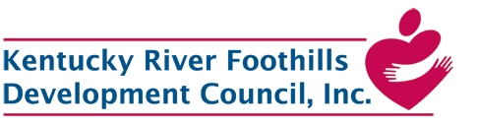
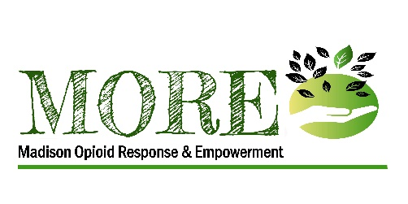
The Madison Opioid Response and Engagement (MORE) project works to achieve the goal of RCORP-Implementation by reducing the morbidity and mortality of substance use disorder (SUD), including opioid use disorder (OUD) in Madison County, Kentucky. The target population is individuals who are at risk for, have been diagnosed with, and/or are in treatment and/or recovery for OUD; their families and caregivers, and other community members who reside in Madison County.
The MORE project strengthens the organizational and infrastructural capacity of the project’s multi-sector consortium. Led by Kentucky River Foothills Development Council, Inc. (KRFDC), the consortium includes White House Clinic, Madison County Health Department, and the Madison County Fiscal Court Agency for Substance Abuse Policy (ASAP).
In alignment with the HHS Five-Point Strategy, and as part of the RCORP initiative, MORE implements a set of core SUD/OUD prevention, treatment, and recovery activities that are grounded in evidence-based or promising practice models and tailored to address Madison County’s unique needs.
This project is addressing the escalating opioid epidemic that has impacted Madison County for the past several years resulting in a consecutively increasing number of opioid overdose deaths. The opioid crisis has led to sharp increases in opioid-related crime and arrests nationwide.
The success of the MORE project is dependent upon not only its Consortium membership but even more so on the powerful partnership effort resulting from the MORE Community Stakeholder Network. Every other month, this group of more than 50 community representatives meet for listen-and-learn sessions focused on OUD/SUD issues. The Stakeholder Network is robust in both commitment and energy born out of recognition that action must be taken to address this epidemic by improving current OUD – and other SUD - response efforts, developing new responses and resources, and not overlapping what already exists. The membership of this group is diverse and includes prevention, treatment and recovery as well as law enforcement, emergency management services, court systems, health care providers, social services, education (public school systems and university/college), elected officials, self-help support groups, (including people with lived OUD/SUD experience and their family members) faith community, employment services and employers, and others including representation from U.S. Senate and U.S. House of Representatives.
CSBG funded staff participate in needs assessment and strategic planning efforts, coordination of data management, participation in the MORE community stakeholder network, and assisting low-income individuals to participate in the project’s services and activities including project planning and continuous quality improvement.
HRSA Rural Communities Opioid Response Program (RCORP) originated in 2018 with the first round of planning grants being awarded. In 2019, a second cohort of planning grants was awarded as well as the first round of implementation grants was announced. In 2020, 89 more implementation awards were made, and a third round of planning grants are currently under review. So far, the federal government has invested $250 million in the RCORP initiative including enlisting the TA services of JBS International, creating a RCORP Resource Portal, and linking its grantees through conferences, teleconferences, and other activities. Four Community Action Agencies (two in Kentucky) are 2020 Implementation grantees. There are many resources available to assist in the replicability of this project in similar communities. This includes a detailed three-year project work plan that has several activities that can be implemented at varying levels of intensity without RCORP funding.
By reducing the occurrence of OUD/SUD, this Community Action led project has the potential to transform Madison County society resulting in a measurable community-wide improvement in living conditions.
The goal of the project is to reduce the morbidity and mortality associated with OUD/SUD by strengthening and expanding prevention, treatment, and recovery services to enhance Madison County residents’ ability to access treatment and move towards recovery. Among the benefits of reduced OUD/SUD, are the following:
- stronger families with decreased rates of domestic violence, child abuse and neglect (and therefore less demands placed on adult and child protective services, domestic violence shelters, family/custody court, law enforcement, and foster care/custodial care providers including grandparents);
- improved levels of self-sufficiency and higher incomes resulting from being stably employed (which also reduces poverty and dependency on public assistance);
- improved community health and safety through the reduction of infectious diseases and unsafe syringe disposal, decreased crime, and lessened demands on public health programs and third party insurers;
- improved economies resulting from decreased rates of tax-dollars spent on drug-related incarceration; and
- stronger workforces who are not affected by OUD/SUD.

