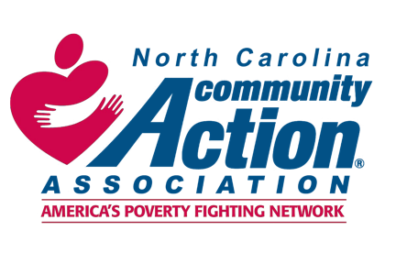
For Immediate Release
Contact: Sharon C. Goodson, Executive Director
Email: sharon.goodson@nccaa.net
Phone: 929-790-5757
North Carolina Community Action Association
4428 Louisburg Rd, STE 101
Raleigh, NC 27616
NCCAA RECEIVES $1.2 MILLION TO HELP ALLEVIATE DIAPER NEED AS PART OF A COMPREHENSIVE ANTI POVERTY STRATEGY
North Carolina - The North Carolina Community Action Association (NCCAA) announced they are recipients of the Diaper Distribution Demonstration and Research Pilot grant. The Office of Community Services (OCS) within the Administration for Children and Families at the U.S. Department of Health and Human Services launched the new Diaper Distribution Demonstration and Research Pilot on September 27, 2022.

This program, also known as the Diaper Distribution Pilot, channels new funding to expand existing diaper distribution services, using the robust network of anti-poverty services that OCS already provides through community action agencies via the Community Services Block Grant (CSBG).

Founded in 1966, the NCCAA provides resources and advocacy for its statewide network of 34 Community Action Agencies. NCCAA collaborates with a network of community action agencies, local governments and public-private partners to invest in holistic community-based, anti-poverty strategies.
Using the $1.2 million awarded from the Diaper Distribution Pilot, NCCAA will partner with the statewide non-profit community organization, Diaper Bank of North Carolina, and five community action agencies including: Choanoke Area Development Association of NC, Inc. (CADA), Economic Improvement Council, Inc. (EIC), Franklin Vance Warren Opportunity, Inc., Greene Lamp, Inc. and Wayne Action Group for Economic Solvency, Inc. (WAGES).
The award will serve 14 rural, underserved and economically depressed counties across the eastern, NC. The Diaper Distribution Pilot Program will provide diapers, wipes, and ointments to more than 800 families.
“Almost 47,000 children in the 14 most underserved counties of North Carolina currently live with diaper needs. We are proud to partner with the Diaper Bank of North Carolina and local community action agencies to address this issue,” says Sharon C. Goodson, Executive Director of the NCCAA.
‘We appreciate the opportunity the Diaper Distribution Demonstration & Research Pilot provides to harness the infrastructure created by diaper banks to facilitate positive outcomes for families through the connection to local resources, while receiving free hygiene items they need and deserve,’ says Michelle Old, CEO and Founder, Diaper Bank of North Carolina.
The Diaper Distribution Pilot puts another anti-poverty tool in the hands of Community Action Agencies and their partners, as part of their efforts to provide wraparound services for individuals and families with low incomes. The Diaper Distribution Pilot also connects families to economic mobility services like job training, Early Head Start, housing services, caregiver support, and more. OCS understands that this Diaper Distribution Pilot is about more than just diapers – it is about lifting a real and tangible barrier to health and wellbeing for low-income families, and about connecting those families with other programs that address the conditions and causes of poverty and help them take steps toward self-sufficiency.

For more information about the Diaper Distribution Pilot or OCS’s seven anti-poverty programs, visit the OCS website.
For more information about North Carolina Community Action Agency visit https://www.nccaa.net.

###

