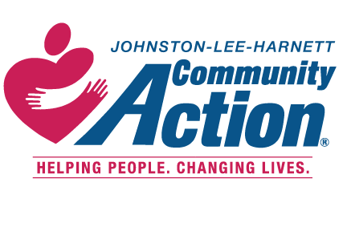
S
AVE ~ THE ~ DATE

ANNUAL BANQUET DINNER & SILENT AUCTION
5:30 PM

5.12.20 Johnston County Agricultural Center
2736 NC-210, Smithfield, North Carolina

FORMAL INVITATION TO FOLLOW

