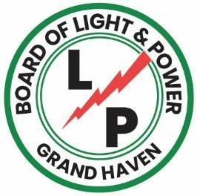

FOR IMMEDIATE RELEASE

GRAND HAVEN BLP COMPLETES UNDERGROUND DOWNTOWN ELECTRICAL LINE PROJECT
GRAND HAVEN, MICH., June 24, 2026 – The Grand Haven Board of Light & Power (BLP) has completed the undergrounding of electrical lines along Harbor Drive in downtown Grand Haven. The project converted the 13.2 kilovolt overhead distribution electrical lines along Harbor Drive from Columbus Avenue to Howard Avenue at a final cost of $1.39 million.

“This was a major project for the BLP and one that had been years in the making,” said Austin Gagnon, BLP Distribution and Engineering Manager. “The successful completion of the project reflects the value of long-term planning. By installing underground conduits during the Harbor Drive reconstruction in 2018, we were able to streamline this conversion and minimize future disruptions. Kent Power was an outstanding partner, and our local crews did a great job bringing the project across the finish line.”

The project included the installation of two new underground three phase circuits, pad mount switchgear, sectionalizing cabinets, underground secondary conductors, as well as the removal of utility poles and overhead wire.

The Harbor Drive undergrounding project is part of a series of significant electrical system upgrades and infrastructure investments completed by the BLP over the past decade throughout its service territory, including the City of Ferrysburg, Grand Haven Township, Spring Lake Township, and the City of Grand Haven. These system modernization and hardening efforts have already produced significant reliability improvements, helping reduce outages and enhance service resilience for customers across the BLP's service area.

“Completing the Harbor Drive undergrounding project has made a dramatic difference in the look and feel of our downtown,” said Mike Westbrook, Chairman of the BLP Board. “Grand Haven has always had a vibrant downtown, and this investment further enhances its beauty and character. After more than a decade of work to modernize our electric system, we’re seeing the benefits firsthand. The progress we’ve made is something our entire community can take pride in, and it reflects the value of having a locally owned BLP.”

Project updates, including before-and-after drone videos, are available on the BLP’s website at: www.ghblp.org/about-us/projects.

About the BLP
The Board of Light and Power provides reliable, affordable, and sustainable power for over 15,000 residential, commercial, and industrial customers in the City of Grand Haven, City of Ferrysburg, Grand Haven, Spring Lake, and Robinson Townships.

