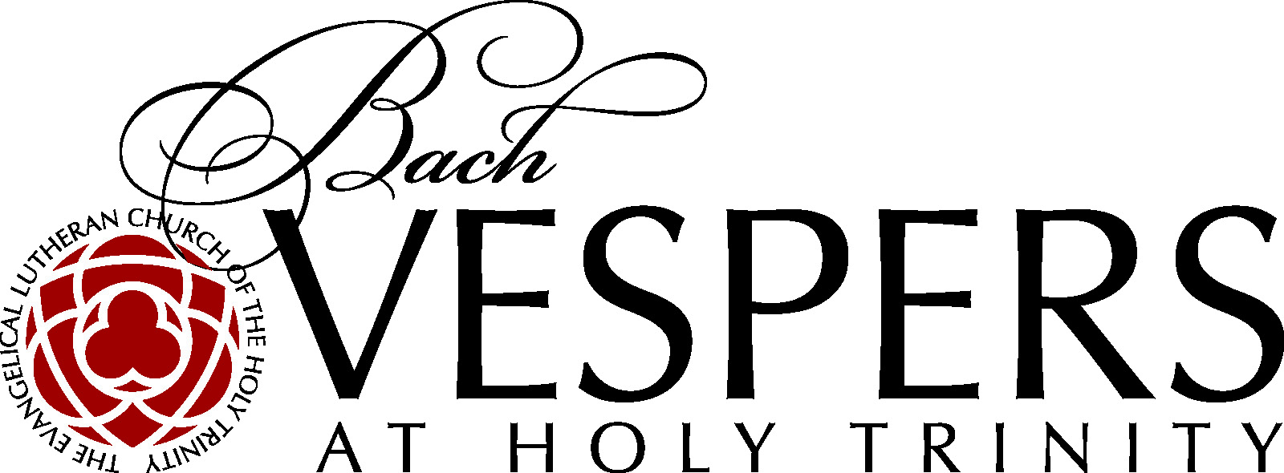

SEASONAL GIFTS OF MUSIC FROM BACH VESPERS
AT THE EVANGELICAL LUTHERAN CHURCH OF THE HOLY TRINITY

From Advent to Christmas to Epiphany, enjoy musical gifts of the season from Buxtehude, Britten and Bach:

Sunday, December 2: Dietrich Buxtehude - Wachet Auf, ruft uns die Stimme, BuxWV 100 -- Sleepers Awake! The text is from the parable in the gospel of Matthew of the wise and foolish virgins.
Sunday, December 9: Jan Dismas Zelenka - Magnificat in D Major, ZWV 108 -- A musical setting of the biblical canticle Magnificat, known as the song of the Virgin Mary.
Sunday, December 16: Benjamin Britten - Ceremony of Carols -- Britten’s choral piece for Christmas written in 1942.
Sunday, January 6: JS Bach - Sie werden aus Saba alle kommen, BWV 65 -- Bach’s church cantata composed in 1724 for the Feast of the Epiphany.

Cantor Donald Meineke previews the Bach Vespers holiday offerings of music in the podcast Notes on Bach Vespers. To listen, click here:

https://soundcloud.com/user-726209763/season-51_episode-3_seasonal

Bach Vespers – Sunday at 5:00 PM
The Evangelical Lutheran Church of the Holy Trinity
3 West 65th Street
New York, NY 10023
www.BachVespersNYC.org

