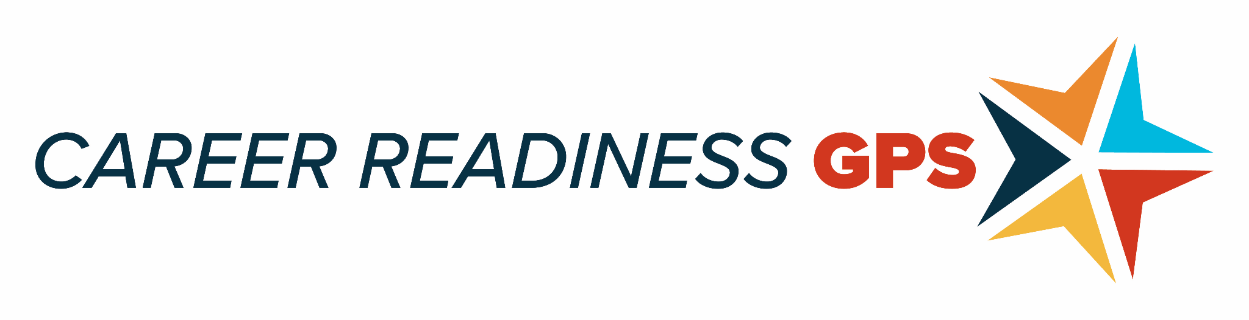
RESOURCE BRIEF
Making the Case for Adopting Personalized Career and Academic Plan Policies and Programs

V. Scott Solberg

This Resource Brief by the Coalition for Career Development Center (CCD Center) in collaboration with the Boston University Center for Future Readiness is designed to provide career and workforce development leaders with the resources needed to persuade policymakers and key stakeholders (e.g., school district leaders, employers, families, philanthropic organizations) about the nature and value of adopting personalized career and academic plan (PCAP) policies and programs. The CCD Center is an industry-led coalition focused on making career readiness the number one education priority in America.
To elevate the importance of career readiness, nearly all states mandate or encourage schools to adopt personalized career and academic plan (PCAP) programs. Quality PCAP programs offer a grade-level scope and sequence of activities designed to develop self-exploration skills, career exploration skills, and future/career planning and management skills. When implemented with quality and fidelity, PCAP programs help middle and high school youth develop course plans and postsecondary plans that are aligned to their personal future and life goals. This planning also engages youth in seeking early college and work-based learning opportunities that deepen their self and career exploration while also developing the skills needed to pursue a range of postsecondary training and education options.
The aim is to graduate all youth from high schools with the skills and certifications needed to directly enter high-wage occupations as well as possess the career navigation skills to pursue additional training opportunities (e.g., stackable credentials), two-year, and four-year education opportunities.
To encourage the adoption of Personalized Career and Academic Plans (PCAPs), consider designing a “white paper” that describes the evidence base for how PCAP policies and programs facilitate a range of education, youth development, and workforce development outcomes. A report commissioned by the Executive Office of Education from the Commonwealth of Massachusetts offers a good example of how to make a case for adopting PCAPs.

Personalized Career and Academic Plan is the generic term used by the Coalition for Career Development Center. The traditional generic term used by the American School Counseling Association and Education Commission of the States is “individual learning plans” (ILPs). In the United States, each state selects its own naming convention. Massachusetts refers to PCAP as MyCAP – My Career and Academic Plan. See the CCD Center State Resource Map for a list of state naming conventions.

Background
To introduce and offer background context, consider providing a description regarding the nature of PCAPs as well as offer data on the postsecondary outcomes of your students.
Support for describing the nature of PCAPs, consider reviewing PCAP toolkits developed by Arizona, Colorado, and Wisconsin. Each state offers excellent and concise descriptions about the nature of PCAPs as being both a process for developing students’ self-exploration, career exploration, and career planning and management skills as well as a tool that relies on the use of career information systems to support this process. Additional resources introducing PCAPs can be found in a How To Guide 2.0 and a book that also describe the nature of PCAPs. Wisconsin offers a poster that summarizes the key features of quality PCAPs.
The How to Guide 2.0 uses the model below to describe the process translating science into effective practice (Wilson et al., 2011). This Resource Brief is focused on supporting the decision to adopt PCAPs policies and programs.

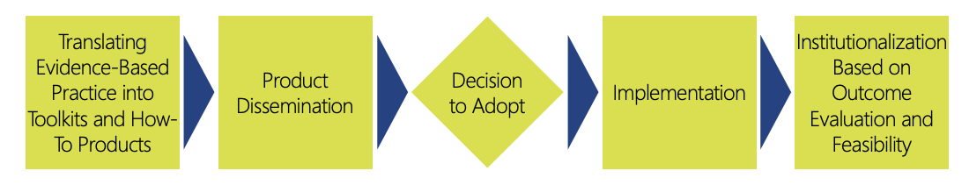

It is also important to frame the need for adopting PCAPs in relation to key student academic and postsecondary outcomes. The 2022 report on the Condition of Career Readiness in the United States offers a national perspective on the post-school challenges youth are currently experiencing. The CCD Center is also preparing Policy Briefs that compare states across a range of career readiness indicators. The Massachusetts 6-year plan report also offers a number of education datapoints for making a case for the need to adopt PCAPs.
Making the Case for the Impact for Adopting Personalized Career and Academic Plans
The background section describes the nature of “what” a PCAPs looks like in practice. Policymakers and key stakeholders also need to understand the value and potential impact of PCAPs on academic outcomes and postsecondary readiness.
Many policymakers and key stakeholders want to know that PCAPs offer an “evidence-based” solution. The original research on PCAPs was sponsored by the U.S. Department of Labor’s Office of Disability Employment Policy and the conclusion based on correlational studies and interviews with educators, families and students was that PCAPs could at that time be considered a “promising practice.” An excellent overview of the evidence-base supporting the adoption of PCAPs can be found in a Southwest Regional Education Laboratory blog post by Helen Duffy.
Recent results using longitudinal data increases the strength of evidence in support of PCAPs
- An OECD report on the value of Career Readiness found that young adults record higher wage earnings and employment rates if they receive access to quality PCAP-related activities throughout middle and high school. The strongest future economic gains were among youth from diverse backgrounds and individuals with disabilities.
- A report from WestEd found higher postsecondary engagement among youth who participated in PCAP-related activities throughout high school.
Colorado found that adding PCAP coordinators into high-need schools resulted in better academic outcomes and post-secondary engagement.
National Examples of PCAP Implementation
There is a wide range of examples of PCAP policies and programs that can be found in the How to Guide 2.0 and the Condition on Career Readiness Report. The CCD Center State Resource Map also identifies model PCAP practices.
Wisconsin contracted with the Wisconsin Center for Research to conduct annual evaluations of their state-wide PCAP implementation and identify effective practices for increasing full adoption of PCAPs.
Wisconsin, Delaware, and Kansas were each featured in case studies sponsored by CASEL to describe their respective efforts to connect social emotional learning skills with PCAPs and career pathways.
Synergy of Existing Policies and PCAPs
CASEL in collaboration with the Coalition for Career Development Center and Civic created a national report describing the intersection of social emotional learning skills, PCAPs, and workforce development.
Recommendations
Sample state PCAP policy language was proposed as part of a Work Matters report developed by the Council of State Governments and National Conference of State Legislatures for the U.S. Department of Labor’s Office of Disability Employment Policy’s (ODEP) State Exchange on Employment and Disability (SEED).
A number of “next-step” recommendations for PCAP adoption can be found in a Policy Brief that was generated based on feedback from state and district PCAP leaders and coordinators from 13 states.
Key recommendations drawn from Policy Brief related to supporting the adoption of PCAPs include:
- Establish a statewide and/or regional cross-sector task force to study the nature and relevance of PCAPs.
- Develop communication and marketing materials that provide the tools needed to effectively inform students, teachers, business leaders, and community-based organizations about the value and nature of PCAPs as well as identify ways they can be engaged.
- Ensure PCAP policies promote and “all means all” approach by ensuring whole-school engagement of all educators and full inclusion of all students regardless of ability or language status.
- Facilitate buy-in for adopting PCAPs by establishing community-wide conversations that explore the value and relevance of PCAPs as a workforce development strategy that aligns with efforts to ensure all youth graduate ready for work and in possession of the career navigation skills needed to access training and two-year and four-year postsecondary programs that align with their future goals.
- Encourage workforce development boards and local Chambers of Commerce to support business engagement that provides students with a range of work-based learning opportunities.
- Engage parent advocacy groups at the outset in order to gain their support in developing family friendly and culturally relevant information about the purpose and relevance of PCAPs.
Open-Access PCAP Resources:
Jaques, E. S. & Solberg, V. S. H. (2021). BPS MyCAP User Guide. Boston Public Schools District.

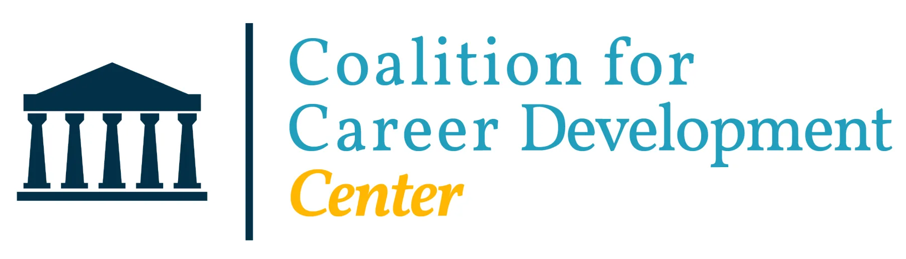

The CCD Center is an industry-led non-profit, non-partisan organization focused on making career readiness the number one education priority in America.

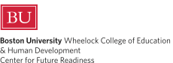
The BU Center for Future Readiness is internationally and nationally recognized for supporting the design, implementation, and evaluation of equitable and responsive career readiness programs and services.

Sponsors:
