**14 Jenny’s Canyon Trail**

*General Description:* This easy hike features a short, sculpted, deep, and narrow slot canyon with vertical rock walls at the end, and an overlook for viewing a broad expanse of Snow Canyon.

*Trailhead Access (Roads) and Vehicle Recommendation*: Easy access in a standard vehicle.

*Average Hiking Time*: Less than one hour at a leisurely pace with many stops for photos.

*Distance*: Less than one mile round trip including the short walk to the overlook.

*Fee and Permits*: The entrance fee is $10 per vehicle (up to eight people) for Utah residents or $5 per vehicle (up to eight people) for seniors 65 and older who are Utah residents with a Utah driver’s license. For non-Utah residents the fee is $15 per vehicle (up to eight people). No permit necessary. Managed by Snow Canyon State Park.

*Elevations*: The trailhead is approximately 3,150 feet elevation with about a 75 feet elevation change from the lowest to highest point (top of the overlook trail).

*Best Season*: September through May.

*Trail Rating (Difficulty)*: Easy with no major obstacles.

*Type of Hike*: Out and back.

*USGS Topographic Map*: Santa Clara, Utah Quadrangle: 7.5 minute series, 2017.

**Finding the Trailhead:** From St. George go north on State Highway 18 (Bluff Street) and turn left (west) onto Snow Canyon Parkway. Continue approximately 3.6 miles and turn right (north) at Snow Canyon Drive. The Snow Canyon State Park south entrance is .8 miles ahead. Pay the fee and continue north on Snow Canyon Drive .5 mile past the entrance station and park in the signed Jenny’s Canyon Trail trailhead/parking area (there is room for about five cars) on the right (east). There are no toilets or water at the trailhead.

*****

I’m pretty sure the hike to Jenny’s Canyon in Snow Canyon State Park is the shortest hike my wife, Deb, and I have done in many years of southwest desert hiking. While short, less than one mile round trip, it is well worth the minimum time required.

Deb and I have explored the American Southwest for more than 35 years and trekked along nearly 250 different trails. While virtually all of it is wonderful, what we especially enjoy are slot canyons. The high swoopy rock walls and not knowing what’s around the next bend. Maybe barely squeezing through a particularly narrow section. Yes!

Snow Canyon State Park just outside of St. George has one particular slot canyon we overlooked. It is a very short canyon, but with all the elements of a wonderful slot—Jenny’s Canyon. If you are a novice slot canyon explorer, this hike is a great introduction.

The canyon is named after a young woman, Jennifer Patchett, who fell to her death from cliffs in Snow Canyon State Park in 1994. Since that time, the canyon has borne her name. Some reports I found via Internet research say she fell from cliffs that rim Jenny’s Canyon, others do not mention a specific area in the park where she fell.

In 1959 the 7,400 acre Snow Canyon State Park was created and has views that rival the much better known Zion National Park. There is evidence that the Ancestral Puebloans/Anasazi used the canyon for hunting and gathering and were followed about 1200 AD by the Paiutes. In the 1850s Mormon pioneers discovered the area. The Park is home to a diversity of plant and wildlife species. We only saw a couple of birds.

From St. George we went north on State Highway 18 (Bluff Street) and turned left (west) onto Snow Canyon Parkway. Continuing approximately 3.6 miles, we turned right (north) at Snow Canyon Drive. The Snow Canyon State Park south entrance is .8 miles ahead. The entrance fee is $10 per vehicle (up to eight people) for Utah residents or $5 per vehicle (up to eight people) for seniors 65 and older who are Utah residents with a Utah driver’s license. For non-Utah residents the fee is $15 per vehicle (up to eight people).

Jenny’s Canyon Trail

After paying the five dollar entrance fee, we continued north on Snow Canyon Drive .5 mile past the entrance station and parked in the signed Jenny’s Canyon Trail trailhead/parking area (room for about five cars) on the right (east). There are no toilets or water at the trailhead.

We arrived at the trailhead about 9:00 am on a late August morning. The sky was Utah blue and the temperature in the high 70s. The trailhead elevation is approximately 3,150 feet with about a 75 feet elevation change from the lowest to highest point (top of the overlook trail). Since we started fairly early, we only shared this popular trail with seven other hikers.

Just as we parked, another car pulled in behind us. We got to talking with that couple and did the hike with them—Kent and Sarah. Good people visiting from Canada who are now our new best friends.

We assembled our gear and headed east, descending into a sandy wash walking toward red rock cliffs. After crossing the wash, we made a small uphill climb to Jenny’s Canyon. The trail is mostly sandy up to the canyon mouth and a little rocky after that. Just before entering the canyon is a fork in the trail, the canyon to the left (north) and an overlook trail to the right (east).

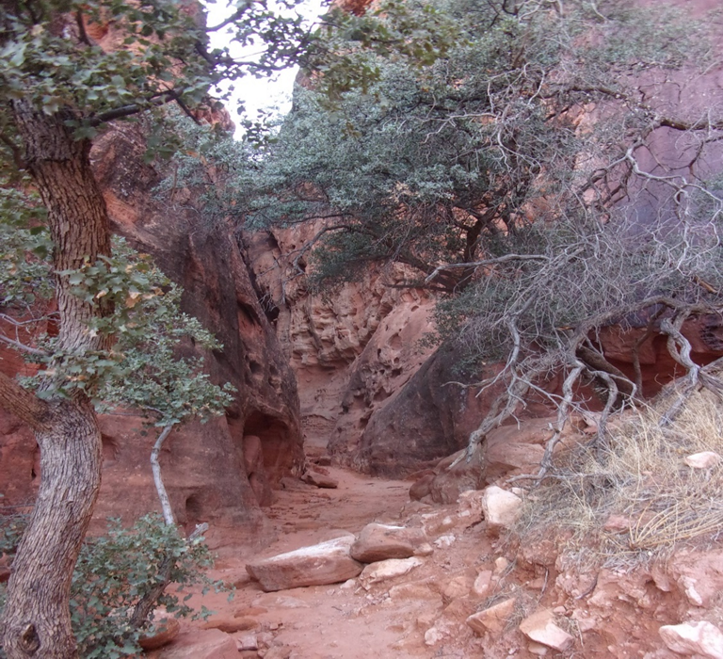

Entrance to Jenny’s Canyon, Jenny’s Canyon Trail

Heading into the canyon we were amazed at the 100 feet walls of textured and sculpted sandstone of this short, maybe 75 yards long, and narrow canyon. The rock seemed twisted as we made our way to the end—it was a slot and box canyon.

After exploring the canyon, we climbed uphill on a rocky trail, 100 feet or so, to the overlook for magnificent views of Snow Canyon. We then headed back to the trailhead.

I highly recommend this short easy hike that should take less than one hour even with much exploring and stopping for photos. Jenny’s Canyon is a treat for anyone. You might want to consider this hike a warm-up and couple it with another of the many close by great hikes in Snow Canyon State Park—Hidden Pinyon Trail, Butterfly Trail, Lava Flow Trail, and several others.

Inside Jenny’s Canyon, Jenny’s Canyon Trail

*****

This story was first published online under the title “Jenny’s Canyon Trail, Snow Canyon State Park” by *The Independent* on September 8, 2024.

**Resources**

AllTrails. “Jenny’s Canyon Trail.” Last modification unknown. <https://www.alltrails.com/trail/us/utah/jennys-canyon-trail>

Hike St. George website. “Jenny’s Canyon—Snow Canyon State Park.” Last modification unknown. <https://hikestgeorge.com/hiking-trails/jennys-canyon/>

Ockey, Natalie. “Jenny’s Canyon, Snow Canyon State Park.” Utah’s Adventure Family website. Last modified December 5, 2020. <https://www.utahsadventurefamily.com/jennys-canyon-snow-canyon-state-park/>

Road Trip Ryan. “Hiking Jennys Trail, Snow Canyon.” Last modification unknown. <https://www.roadtripryan.com/go/t/utah/zion/jennys-trail>

Utah State Parks website. “Snow Canyon State Park.” Last modification unknown. <https://stateparks.utah.gov/parks/snow-canyon/>