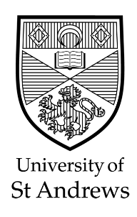
PARTICIPANTS WANTED

Project Title
Interdependent Religious Identities and Symbolic Threat: The interpersonal effects of church-leavers on the still-religious

This study is being conducted as part of Hannah James’ research study in the School of Divinity at the University of St Andrews.

* * * * *

We invite you to participate in a research project!

Do you have a close friend or family member who is not religious? You will be asked to answer several interview questions about your faith, particularly in relation to this person. The interview will be semi-structured, meaning that interview questions are not necessarily set in stone. While I will have some guiding questions, you will be able to direct the conversation to what you believe is most relevant to your experience. The interview will take place over Zoom and will be recorded so that I can reflect on the data at a later point. The interview should last no more than 90 minutes.

If you are interested in participating, please fill out the survey linked below to see if you qualify.

https://standrews.eu.qualtrics.com/jfe/form/SV_3ekujwf6m8M8v30



Contact Details

Researcher: Hannah James

Contact Details: hj42@st-andrews.ac.uk

