State of New Mexico
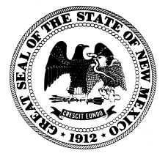
CHILDREN, YOUTH and FAMILIES DEPARTMENT
BRIAN BLALOCK
CABINET SECRETARY

TERRY L. LOCKE
DEPUTY CABINET SECRETARY

MICHELLE LUJAN GRISHAM

GOVERNOR

HOWIE MORALES

LIEUTENANT GOVERNOR

Alert: Multisystemic Therapy (MST) RFA

The New Mexico Children, Youth and Families Department (CYFD) Behavioral Health Services (BHS) is looking to identify locations to launch at least four and up to five Multisystemic Therapy teams associated with New Mexico’s Multisystemic Therapy (MST) Expansion Program.

What Is MST
Multisystemic Therapy (MST) is an evidence-based and intensive home, family and community based treatment for youth with serious antisocial behavior. MST enrolls youth between the ages of 12-17 who meet the criteria of having an imminent risk of out-of-home placement; physical and/or verbal aggression at home, school or in the community; delinquency; antisocial behaviors, and/or substance abuse.

Please see attached RFA for the full details including the full description of the program and the RFA application

The deadline for applications is: June 5, 2020, 5:00PM MDT

An information webinar will be held Tuesday May 19th, 2020 – 9:00AM MDT
Webinar Link: https://www.eventbrite.com/e/mst-new-mexico-expansion-rfa-webinar-tickets-103472501036

For general questions about MST or the application process, please reach out to the Center for Effective Interventions at gssw.cei@du.edu

Feel free to share this information with any interested parties.

