Wearable & Tradeable: 5 Swap Ideas for the National Youth Gathering

The ELCA’s National Youth Gathering is coming up next month! If it’s your first time attending, you may not be familiar with the Gathering’s swap culture. Swaps are items that can be traded with the awesome people you meet! They often represent the state or congregation you’re coming from, so you can keep track of what parts of the country all your new friends are from.

This list focuses on wearable swaps because they’re easy to keep track of throughout the Gathering, but plenty of groups bring painted rocks or seashells, frisbees, or other fun keepsakes. Here are our ideas for what kind of swaps to bring or expect to see at the event:

- Buttons
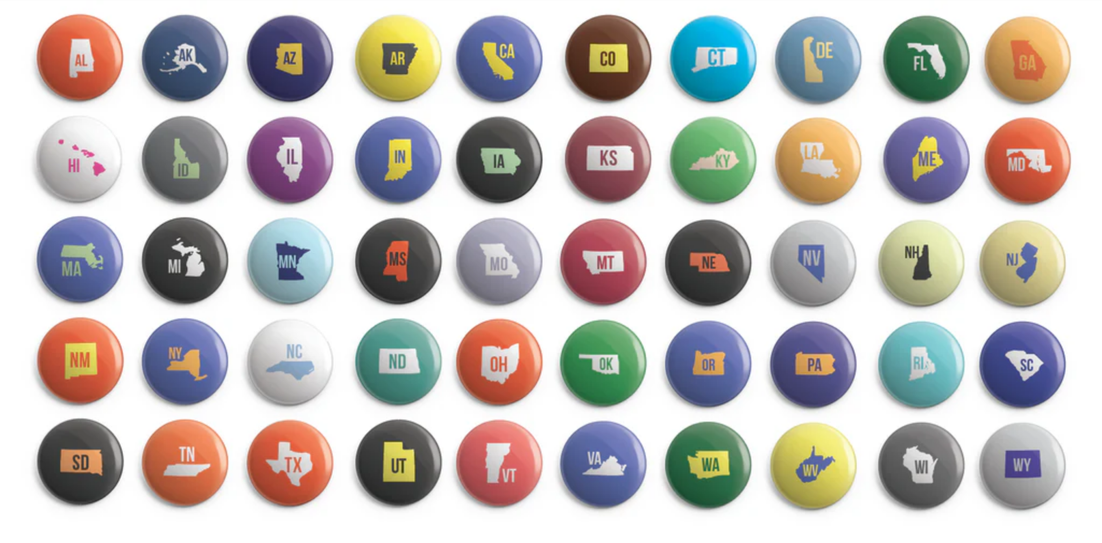
Old Lutheran, the go-to brand for official Youth Gathering gear, carries collections of state and synod trading buttons that make for a quick and easy swap that’s also easy to show off! Can you collect all 50 states or all 65 synods? For those who do, Old Lutheran offers a prize!

- Clothespins
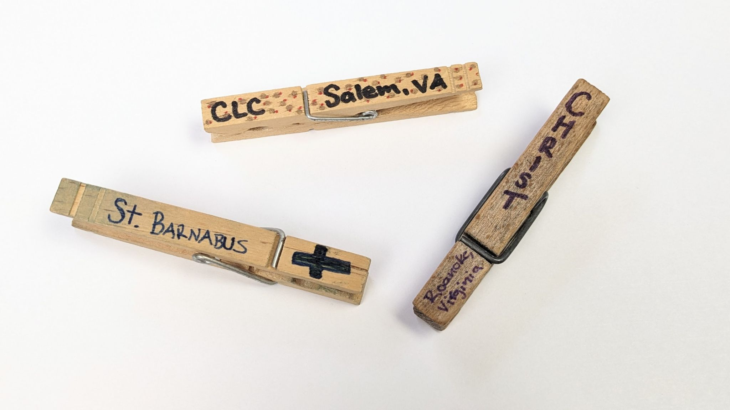
Clothespins are a cheap and easy option for clipping to bags especially. They have been a Gathering staple for quite some time. Use a permanent marker to write your Synod or congregation name and location on wooden clothespins and see how many you can trade and collect!

- Bracelets
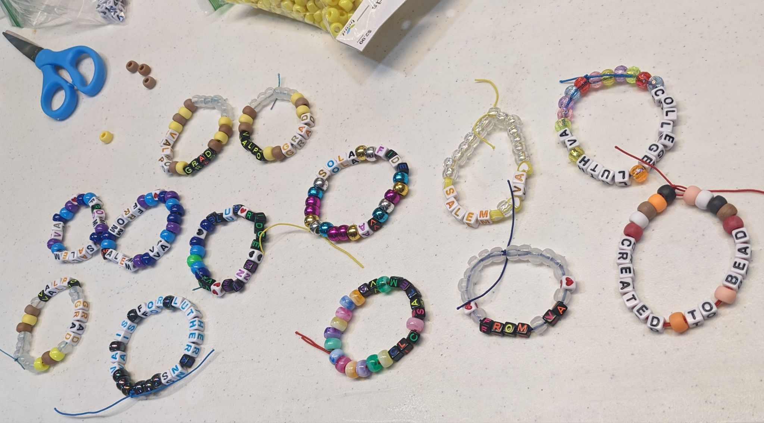
This is a great option for crafty attendees. Make your own beaded bracelets with the name of your Gathering group or synod, or a favorite Bible verse. We’re fans of this play on the Gathering theme: “Created to Bead!” Bracelet making is a great activity for all those long car rides to the Gathering! If you’re not particularly craft-inclined, bulk-ordering a batch of rubber bracelets works just as well for a stylish swap.

- Mardi Gras Beads
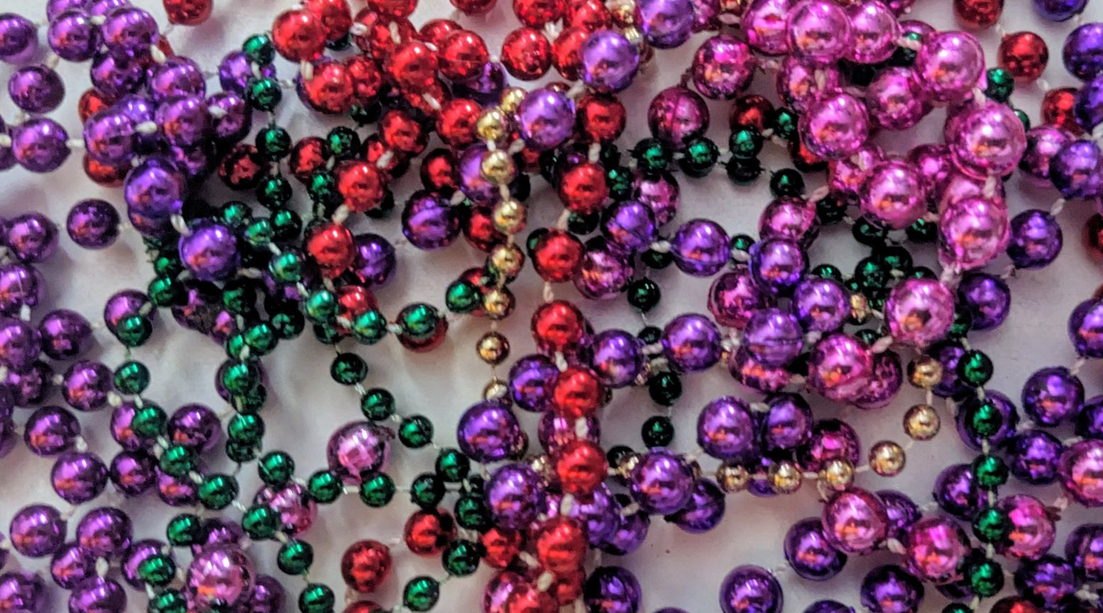
When in New Orleans! Mardi Gras beads are trickier to customize, but certainly add a lot of bling to your collection of swaps. They are also another great option for congregations or Gathering groups to order in bulk. Think about what color beads might best represent you!

- Stickers
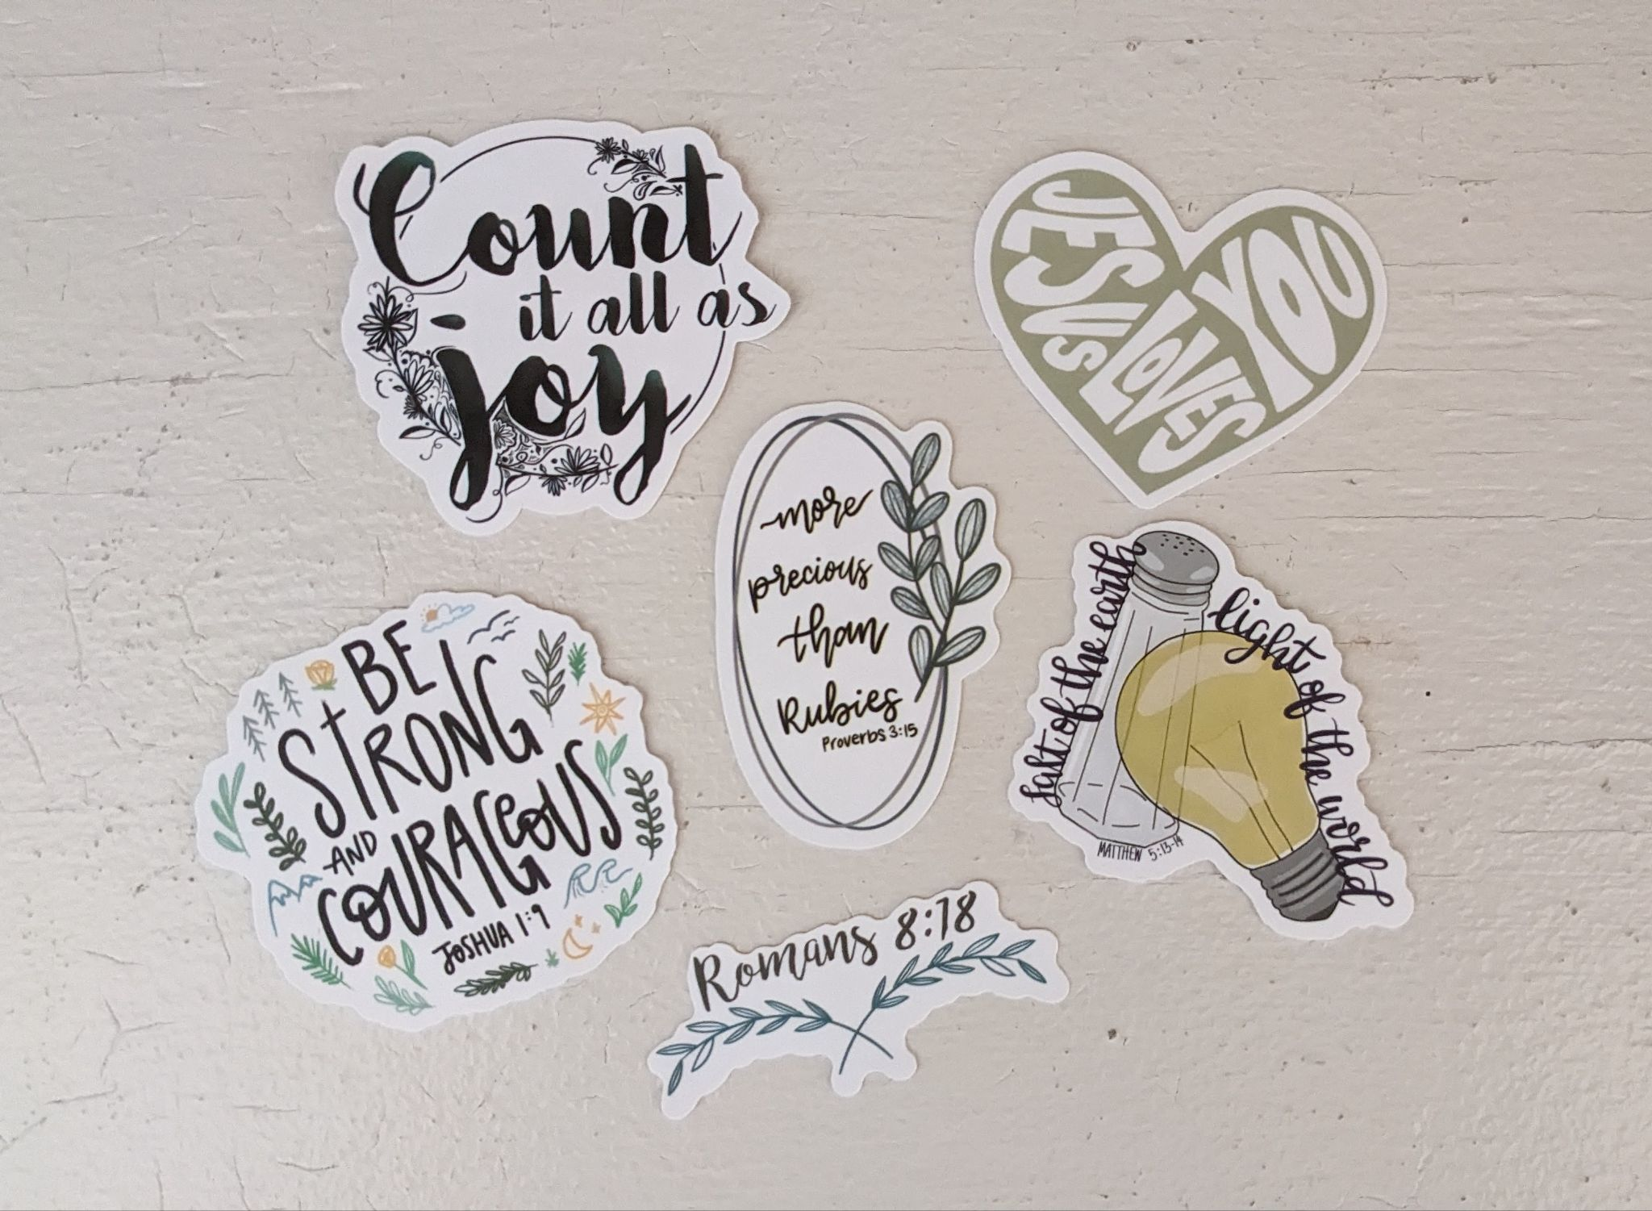
Like buttons, stickers will be available to purchase at the Gathering. So if you run out of time to custom order a batch for your group, don’t fret. Stickers are also great keepsakes to remind you and your new friends of your time at the Gathering. Add them to a water bottle or laptop that you use everyday to help those Gathering memories really stick around.

