ERIN MILLS UNITED CHURCH

3010 The Collegeway

Mississauga, ON L5L 4X9
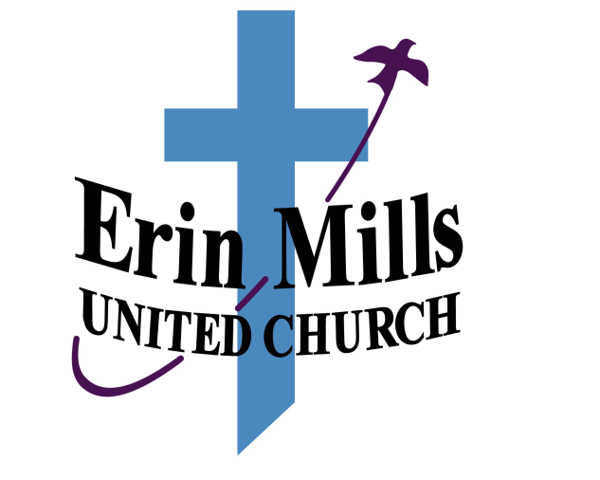

2019
ANNUAL REPORT

Table of Contents
Church Officers - 2019 4
Ministry Staff 4
Chair of EMUC Leadership Circle 7
Nominating Committee 8
Worship and Music 9
Worship Committee 9
Director of Music 12
Choirs 12
Chancel Choir 12
Bell Choir 13
Impromptu and Off the Cuff 13
Community Life 14
Community Outreach 14
Open Door Dinner 14
Winter Coats for the Open Door 14
Comfort kits 14
Christmas Hampers 14
Deacon’s Cupboard 15
Greening Sacred Spaces 15
Interfaith Justice and Peace Committee 15
Refugee Task Group 16
MEMBER DEVELOPMENT and CARE 17
Membership and Pastoral Care Committee 17
Fellowship Groups 18
The Circle of Friends 18
Adult Education 2019 19
Prayer Shawl Ministry 19
Book Club 19
EMUC Striders 20
Welcome Group 21
Daytime Men's Group 21
Bunch for Lunch 21
Bridge Club 22
Women for Women 22
Bogeys to Birdies 23
Communications Committee 24
FINANCE 26
Finance Committee 26
FUNDRAISING REPORT 2019 27
Office Administration 28
Office Administrator 28
Other Group Activities (Renters) 28
Ian MacRae Bursary 29
MINISTRY and PERSONNEL COMMITTEE 29
BUILDING and PROPERTY 30
EMUC Outside Concrete Stairs 30
Organ Repairs 30
Tables 30
Cleaning of Church 30
HVAC System 31
Other Items 31
TRUSTEES 31
Members of the Trustees 31
Investments 32
Insurance 32
Financial Records 32
Policies and Procedures 32
Other 32
INVESTMENT SUMMARY 32
In Memoriam 33
Celebrations 33
Baptisms 33
Welcomed Into Membership 33
Retirement of Peter Kiteley 33
Statistics (2015-2019) 34
FINANCIAL STATEMENT AND OPERATING BUDGET 35

ERIN MILLS UNITED CHURCH

3010 The Collegeway, Mississauga, ON L5L 4X9
Telephone: 905-820-9466; Fax 905-820-7087
Email: office@emuc.ca
Website: www.emuc.ca

Church Officers - 2019

EMUC Leadership Circle Chair: Dianne Hope
Vice Chair: Deb Sturgeon
Leadership Circle Secretary: Lorraine Moore
Treasurer & Finance: David Leeder
Worship & Music: Sylvia Arnold
Community Life: Sandra Witterick
Membership Development & Care: Sandy Hayes
Ministry and Personnel: David Hope
Children & Youth: Joanne Hines
Building and Property: Ian Love
Communications Barb Jennings

Member at Large: Trish Campbell

Presbytery Representative: Janet Morrison

Offering Recording Secretary: Mike Ogilvie

Ministry Staff

Kathi Phillips Minister
kathi@emuc.ca

Peter Kiteley (Retired June 2019 Office Administrator & Building
Tina Driscoll (Hired July 1/19) Coordinator, office@emuc.ca

Len Feldman Director of Music,
office@emuc.ca

Minister’s Report 2019
Tell me the stories of Jesus I love to hear,
Things I would ask him to tell me if he were here:
Scenes by the wayside, tales of the sea,
Stories of Jesus, tell them to me.
William H. Parker
Voices United #357

There is something in our nature that just loves a good story. Our parents instinctively knew that telling us a story could help us make the transition from a busy day to bedtime. Our ancestors used stories to explain the world around them and to pass on their history to new generations. In the church we use the stories of the Bible to teach about our faith and to understand our relationship with God.

An annual report is like telling a story – the story of the past year in our church life. It’s a wonderful story about a faithful people and how we express that faith in our words and actions, both within our walls and outside, in the community and around the world. It is, at its most basic, a love story – the love our God has for us and the love we share in response.

There is a lot to say about the story of our church family in 2019. We worshipped in diverse ways: trying out café church and a pet blessing for the first time; with a 5-part summer series on the Lord’s Prayer; and 2 different Jazz Vespers services featuring our music director, Len Feldman. Len and the Chancel choir, and our 2 ad hoc choirs – Off the Cuff and Impromptu - directed Nancy Blackport, always bring beautiful music to our services along with the gifts of other musical guests.

Other special events that added to our faith story included a Lent Film Study on The Way, the dedication of a new memorial banner, and Peter Kiteley’s retirement after 13 years as our Office Administrator and Building Manager. We were all excited to welcome Tina Driscoll and she has seamlessly blended into our story line, bringing her enthusiasm and compassion to the position.

There were happy stories when we welcomed new members: celebrating new life with the Fearon and Madill families as we baptized Ada Lily; and receiving 6 members by transfer or profession of faith. I was also very pleased to officiate at a beautiful wedding in cottage country.

There were stories of loss as I conducted 4 funerals or memorial services and an interment service. Some of these folks were long-time members of our congregation; some were community members without a faith family of their own. As a congregation we do our best, to walk with those in the midst of grief. We offer them hope in their darkness. We accompany them in their pain and allow them, if only for a short time, to lean on our strength and faith which comes from God.
There were other losses within our congregation this year: some of our church family struggled with issues of ill-health and aging. Some lost jobs, some relationships ended. This year I provided much more pastoral care in these types of situations. I tried to provide an ear to hear, a hand to hold, a shoulder to lean on

Minister’s Report (cont’d)

and a voice of hope when there seemed to be none. And always there are hugs – a sign of support - God’s embracing of both of us. I have been humbled this year by the trust that people have placed in me, and I have thanked God for each and every one of you - for your ability to reach out and share your stories with me. Through our times together we have witnessed the moving of the Spirit and for that I am grateful.
The start of 2019 was the end to the stories of Presbyteries and Conferences in the United Church and the beginning of the Horseshoe Falls Regional Council. I have found a place on the Covenanting Commission, working with faith communities in transition. The United Churches in Mississauga, have joined together to plan city-wide events like a pot-luck dinner in October and an Advent worship that, unfortunately was cancelled by an early storm. The point of these events is to help us get to know each other and build a stronger community.
The story of my ministry has expanded this year as I took a course in Transforming Issues of Prejudice, Power and Privilege in March and completed my Racial Justice training in June. I hope that these courses help me to be a better minister.
I feel so blessed to have been called to serve this faith community, you are truly family to me, and I look forward in joyful anticipation to see what story the Spirit has planned for us in 2020.

Shalom,
Kathi

Chair of EMUC Leadership Circle

As I reflect on the past year in the life of EMUC here are some of the words that come to mind – energy, creativity and dedication. I also think of goodbye, change and love.
I think of the energy that is expended to keep our church building and premises in good condition. Until I stepped into the role of Chair of the Leadership Circle, I certainly didn’t have a full appreciation of this. While you will read in the reports of the various Circle Leaders about the many activities and events that took place at EMUC during the past year, it can sometimes be easy to forget how much time, mental and physical energy goes into the planning and execution of these activities and events. Time and energy with the spice of creativity have brought us innovation, laughter and beauty. I think of the Café Style services, the organization and promotion of the Garage Sale, and the decorations for Easter and Christmas. HATS OFF to all who have been willing to devote their time, energy and creativity to life at EMUC!
That leads me on to dedication – I see it played out in so many ways and I’ll highlight just a few. There is the constant monitoring, research and planning that are needed to keep the building in a good state of repair (and at the right temperature!). There is the commitment of those who engage in on-going fundraising activities to supplement our individual givings. Choir members come out week after week to work on music for worship services. The Deacon’s Cupboard outreach is supported by a band of regular volunteers from EMUC and this year, as for many in the past, congregants prepared Christmas Hampers for community members. Finally, I cannot forget that week after week members prioritise being at EMUC to worship or gather for fellowship and friendship.
I think of goodbyes when I remember that we continue to mourn the passing of those who have been part of our community and who have enriched our lives – David Thomson, David Lee and Trevor Appleby. There were changes in our office staff when, after 14 years, Peter Kiteley retired as our devoted Office Administrator and Tina Driscoll came on board to fill this position. And I think of Love – as week after week Rev. Kathi reminds us that we are beloved children of God. And I think of love, as we support each other through the tough times in our lives.
A significant part of the Annual Report is devoted to the presentation of EMUC’s financial statements. Our Trustees and Finance Committee continually assess our financial health and have devoted much time to the preparation of the reports that help us see where we stand. We will have the opportunity to consider and approve the draft budget when it is presented at the Annual Meeting on March 1st. It is a hopeful sign that we begin this year with a more positive financial outlook. We will need your continued contributions to remain financially viable and I encourage you to continue to support EMUC with your financial gifts and by enthusiastic participation in fundraising initiatives.

Chair of EMUC Leadership Circle (cont’d)

As we look towards the coming year of congregational life, I encourage you to reflect on the values identified by the Congregational Growth Committee over the past year - Living Spiritually, Openness to All, Helping Others and Connection and Friendship. May our spiritually support and strengthen us and inform all we do. May we be intentional as we open our minds and hearts to others (could this look like examining the possibility of becoming an Affirming Congregation?). Let us also continue our tradition of helping those in need in our community and further afield, and may our social connections and friendships continue to brighten our days. Submitted by Dianne Hope, Chair, Leadership Circle

Nominating Committee
The work of the Nominating Committee is to engage individuals of the congregation to help run our church by ensuring positions on the Leadership Circle (LC), Committee Chairs and key event coordinator positions are filled as they become vacant, and by assisting/supporting Committee Chairs to fill any vacant positions on their committees.
The Nominating Committee reports to Dianne Hope, Chair of LC. In 2019 it consisted of 3 members: Sandy Hayes, Barbara Jennings, Paul Marot.
In 2019, the LC positions filled were:
- Chair, LC - Dianne Hope informed the Nominating Committee that she would be stepping down as Chair in March 2020. Paul Marot volunteered to take the position and was recommended to the LC at its Dec. meeting as the next Chair. This candidate needs to be approved by the congregation at the annual meeting in March 2020.
- Vice-Chair, LC – Debbie Sturgeon has agreed to remain in this position for a third year.
There are currently no vacancies on the LC.
Committee Chair or Coordinator and member positions filled in 2019 were:
- Congregational Growth Committee members changed late in 2019 to Kathy Andres (Chair), Lynda Appleby, Barbara Jennings, Patti King, Cathy Kiteley, Joanne Hines and Kathi Phillips
- Garage Sale Coordinator Team – Sylvia Arnold, Pat Beck, Cathy Kiteley, Cindy Young (2019)
- Ministry and Personnel, Liaison for the minister – Trish Campbell
- Rental Assist Team was formed under the Treasury group

We, the entire congregation, are the church. Participation is a wonderful way to meet people and to contribute to the life and mission of the EMUC. Speak to any member of the Nominating Committee, the LC members or the minister, Rev. Kathi about ways of becoming more engaged in EMUC.

Submitted by the Nominations Committee

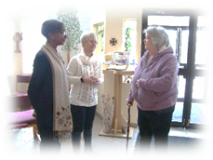
Worship and Music

Worship Committee
In 2019, the Worship Committee organized regular and special worship services. The committee ensured that worship coordinators, greeters, ushers, readers and refreshment hosts were available for each Sunday service as well as pulpit supply ministers for the minister’s vacation and study week etc.. In 2019, we enjoyed pulpit supply messages from Ruth Noble, Brian Takayesu,
Dale Burkhart and Barb Finlay. The Worship Committee worked with all committees to ensure that all needs for services were met. ( e.g. 2 Café Sundays, Black History Sunday etc.).
The Worship team consisted of a core group of people: Sylvia Arnold, the Focus Circle Leader, Cathy Scattergood, Hermine Bingham, Terry Loffree, Mary Anna Williams, Cindy Young, Cathy Kiteley, Fred Shepley, and Karen Colwell.
Kathi Phillips, our minister, attended our meetings to support us and together we discussed plans for the various church seasons and potential changes to worship.
Mary Anna Williams continues to be responsible for scheduling worship coordinators, ushers, greeters and coffee hosts. We thank her for doing this important job.
Coffee hour after church continues to be enjoyed by everyone each Sunday. Many people continued to provide treats of their own accord. Thank you! Finding “Hosts” each Sunday continues to be a struggle. People are encouraged to sign up for this, as it is a great way to meet everyone! Thank you to those people who have hosted over the year.
During 2019, we continued to offer one service for worship on Sunday morning at 10:00 a.m. and a weekly intimate Wednesday evening prayer and communion service at 6:45 p.m. to 7:15 p.m. Even though this Wednesday service is small, it meets the needs of the faithful who attend.
On a rotational basis, the worship team scheduled the various Leadership Circle committees to serve Communion on the first Sunday of each month and for special celebrations. This year the Worship Committee continues to serve gluten free bread as well as regular bread at communion. This means that anyone with dietary restrictions is able to participate in communion. Since some committees are small- in-number, we continue to encourage anyone not on a committee to consider volunteering to help serve Communion on an occasional basis. Instructions are always provided in advance.
Throughout the year (except for summer months) the Worship Committee continued to use Audio Visual media for Sunday services as well as during special services during Advent and for Christmas Eve. Every week, with some help from the office, Sylvia Arnold and Cindy Young prepared the AV for Sunday by posting hymns, call to worship; complimenting each with visual images to enhance the words of the service. Lorraine Brignall in addition to being the backup, was the prime projectionist on Sundays, with Cindy Young filling in when Lorraine was unavailable. Photos submitted by members of the congregation enhanced the visuals and are always welcome. Thank you to those who share their pictures with us!

Worship Committee (cont’d)

The Worship Committee was responsible for ordering and purchasing the weekly Sunday bulletins. It is the core committee involved in planning and carrying out the special services/events and ensuring there are the appropriate decorations for these services/events. During Lent we made and hung cocoons in the sanctuary to signify “waiting” during Lent and then on Easter morning they “morphed” into beautiful butterflies.”.

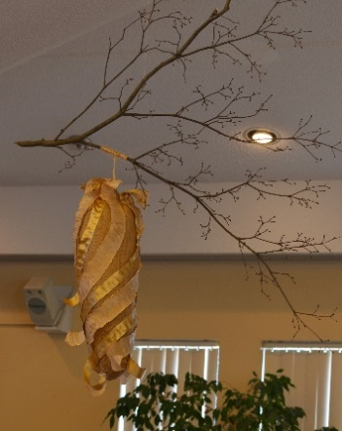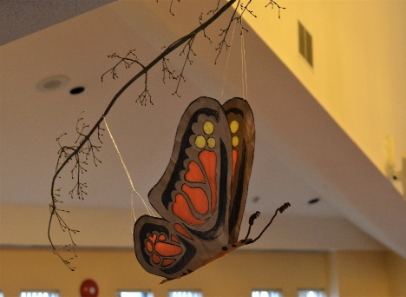

At Advent we portrayed the words from the hymn “Joy to the World” …. “And heaven and nature sing” ….by setting up a forest of green trees and hanging stars from above. These were popular highlights of decorating according the different “themes

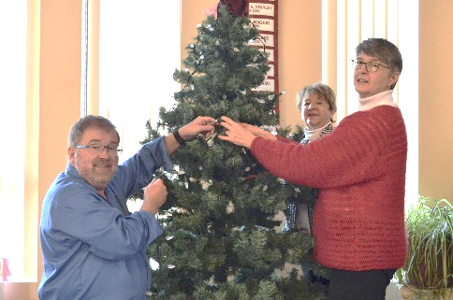

Special services/events for 2019 included:
  - February – Black History Month Sunday with special guest speaker and soloist
  - Shrove Tuesday – Special Service of Ashes (after pancake supper)
Holy Week
- Palm Sunday - with a palm parade!
- Maundy Thursday - a new service flow using a self guided service wiith Kathi serving communion
- Easter 48-hour Vigil – members of the congregation signed up to come to the church for one hour to pray in quiet solitude
- Good Friday – 9:00 a.m. service followed by a hot cross bun/continental breakfast (hosted by the Worship Committee)
- Easter Sunday Celebration with communion
- June – Celtic Service
- September – Café Sunday

Worship Committee (cont’d)

- October – Celebration of Worldwide Communion offering different breads representing countries around the world.
- Thanksgiving – special decorations
- First “Blessing of the Animals” Service – well attended!
- Hanging of the Greens – Decorated the sanctuary with many enthusiastic helpers, after a bread and soup luncheon

Advent/Christmas services, events, and special gifts for 2019
- Advent Theme: “Joy to the World” was chosen by the Kathi and the Worship Committee to pay tribute to the 300th anniversary of the carol. A special resource was purchased, which was a wonderful, providing new music, different themes and liturgy each week. Kathi tweaked it to be more meaningful for our church.
- Giving Sunday (previously known as White Gift Sunday). The name was changed to be more meaningful since we don’t wrap the gifts for the food bank in white tissue any more. Kathi blessed the gifts being placed in the “Christmas Hampers” and food brought for the foodbank.
- Candlelight Carol Service - special carol singing with all the choirs participating. There were many who attended from the community, which showed that this service is meeting a need.
- Hope and Healing and Longest Night service was held on Wednesday December 18 in conjunction with the regular Prayer and Communion Service. It was a beautiful and meaningful service with special music from a small group from the chancel choir. It was evident that this service meets the need for those who are grieving in one way or another as there were many in attendance from EMUC as well as from the community.
- Christmas Eve. This year we had 2 services:
- 6:30 pm - A Family Service. This service was very well attended by the community as well as EMUC folk. The message was illustrated by the dramatic reading of the book, “A Very Noisy Christmas by “Tim Thornborough” …. a delightful service for all ages complete with glow sticks in the shape of stars.!
- 9:00 p.m. – Candlelight Communion Service – this service was also very well attended with many people as guests from the wider community. The message and the music moved us spiritually into Christmas.

The worship committee will continue to work together with Rev. Kathi Phillips and all committees to ensure vibrancy in our services for 2020.

Submitted by Sylvia Arnold Chair of Worship and Music

Director of Music
As Director of Music I met regularly with our minister, Kathi Phillips, and the Music Committee to discuss music choices for weekly and special services. The Music Committee is mad up of Kathi Philips, Nancy Blackport, Janet Reid (President of the choir), Hilton Jeffers, and Sylvia Arnold. I led and rehearsed the Chancel Choir and selected anthems for each service; and I accompanied musical performances of the choir and other performers on the piano or organ during services.
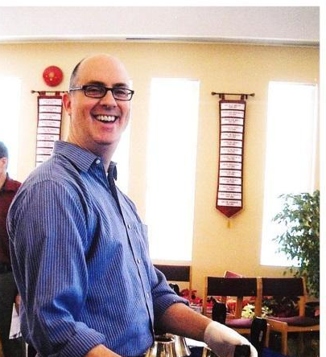
In 2019, I enjoyed accompanying Impromptu, the women’s choir, and Off the Cuff, the men’s choir, both under the direction of Nancy Blackport. During the year I set up tuning and service on the grand piano. I arranged music for special performances, including some guest performers, during Sunday services. During the summer, when the Chancel Choir takes a well deserved break, I brought in guest singers almost every week. Sadly, again, this year we had several funeral and memorial services with specially selected music. This year we will be continuing to add to our music library and preparing for Vespers and special musical services. I am looking forward to another stimulating year in the music at Erin Mills United Church.
Submitted by Len Feldman, Director of Music

Choirs

Chancel Choir
I would like to make special mention of the members of the Chancel Choir. These men and women donate a great deal of time and energy preparing and performing music for the purpose of enhancing and guiding the worship experience of everyone who attends Erin Mills United Church. Each week, about twelve singers (sometimes as many as 15!) gather to rehearse for two hours on Thursday evening. It is a fun, social time, but also hard work - we all leave quite drained of energy.
The choir leads the congregation in hymns each Sunday morning, and performs a specially selected anthem, and often other songs. We try to prepare a wide variety of pieces from many different musical traditions, with messages that fit the readings and themes for each service. The anthems are often quite challenging, with separate parts for the four vocal ranges (Soprano, Alto, Tenor and Bass), and careful listening and counting required.
Choir members are also often asked to give extra time to special services and extra rehearsals. Several individuals go above and beyond these commitments by taking part in Music Committee meetings, helping to select the Bible Carrying Song, the Doxology, and other common pieces for services in each season. The Music Committee also works on putting together special events such as Vespers, music-themed services, and others. Janet Read and Barb Jennings have taken on the burden of managing our library, keeping everything organized and helping to find music for many occasions.

Choirs (cont’d)

Choral singing is a very rewarding experience. Our singers bring a variety of musical backgrounds ranging from no formal training to decades of training. Our mix of cultures is a valuable asset when it comes to understanding different styles, rhythms, pronunciations and the messages conveyed in song lyrics. We are always eager to welcome new members to the Chancel Choir, regardless of vocal range and experience.

Bell Choir
In 2013/2014, we received a generous donation of hand bells and hand chimes. We started up a Bell Choir; unfortunately, during 2019, the Bell Choir did not perform. Maintaining a large enough group to tackle the learning curve involved and prepare pieces has been an ongoing challenge. The Music Committee at EMUC would be happy to welcome more would-be bell-ringers and anyone interested in helping with the organization of the bell choir. In the interim,
in December we received an inquiry from a local group, United2Ring, who wished to borrow our chimes. I am happy to say that in 2020, our chimes will make music again, and they will be returned to us as needed. United2Ring has extended an invitation to EMUC members, should they wish to join their group.

Impromptu and Off the Cuff
Impromptu and Off the Cuff are pick-up choirs participating in worship 3 to 4 times a year. Impromptu, our women’s choir, and Off the Cuff, our men’s choir, invite anyone who enjoys singing to join us. Over the last year, we sang at various services including our Black History Month Sunday & the Candlelight Carol service. Consider joining us and discovering the joy and community in Music. Contact Nancy Blackport if you are interested in learning more.

Submitted by Len Feldman Director of Music

Community Life

The people of EMUC believe in practicing their faith both within and beyond our local church. Within our community, we are involved in many activities which benefit those in need and promote healthy and greener living. Beyond our own community, we provide regular and special givings for special disaster appeals for the Mission and Service Fund of the United Church of Canada. EMUC is a congregation which believes in sharing the gifts we have been given.

Community Outreach

Open Door Dinner
Coordinator: Lorraine Moore.
Erin Mills United Church prepared and hosted the dinner on Thursday, Nov. 28th. at Square One’s Open Door facility. In spite of the Christmas “busyness” that seems to take over peoples’ lives at this time of year, the call for food preparation did not go unheeded. We had lasagna, meat loaf, carrots, Mac N’ Cheese, chicken stew, scalloped potatoes, lots of salads, buns, juice and an array of baked goods. There were approximately 50-60 people in attendance, children among them. Those in attendance were most appreciative and many people asked for seconds. Some of the guests are happy to linger for a little conversation and others quietly enjoy their meal and leave. Our “crew” (Gene Green, Trish Campbell and Mary Anna Williams) managed very well, loading up at Church, driving to Square One followed by set up, serving and cleaning.

Winter Coats for the Open Door
Coordinator: Lorraine Moore.
There were three deliveries, one in January and two in February courtesy of David Leeder and David Brignall.

Comfort kits
Coordinator: Lorraine Moore.
In mid-March with the help of Georganne Vickery, Muriel Hamdani, Doreen Sims and Gene Green we made up about 51 small gift bags (4 men and 47 women) and delivered to the Open door at Square One. These are small travel size toiletry items and we pack so that there is a little of something in each small gift bag.

Christmas Hampers
Coordinator: Sarah Phillips.
For many years, EMUC has demonstrated its generosity through its Christmas Hamper program. Donations were received again this year, in the form of cash, gift cards and specific personal items. Our FundScrip fundraising program was used to purchase many of these gift cards, which also benefitted other EMUC programs. These gift cards from local grocery or retail establishments, together with shoeboxes filled with personal gifts for children and youth were provided for 30+ families in December. Thank you to Sarah Phillips who coordinated the program and to Tina Driscoll for providing the wonderful office support. Volunteers for 2019: Lorraine and David Brignall, Muriel Hamdani, Debby Sturgeon, Sandra Witterick, Peter Kiteley, Pat Beck, Noreen Singh and others (who knitted items for donation), Ashley Phillips and Danielle Witterick.

Community Outreach (cont’d)

Deacon’s Cupboard
Coordinator: Linda Leeder.
The Deacon’s Cupboard celebrated its 17th year of serving the needy in our community in 2019. During the year we welcomed 1622 visits and distributed $102,395,00 worth of food. These numbers would have been higher but bad weather in February resulted in our being closed for three weeks. This year also saw our guests receive over 300 winter coats and accessories from the biennial coat drive, organized and staffed by volunteers from all our supporting churches. We are proud of the fact that all money donated to the Cupboard goes directly to buy food for our guests –we have no paid staff and our overhead costs – heating, electricity etc. are financed by St. Peter’s-Erindale.
The volunteers from the EMUC community are – David Arnold, David Brignall, Lorraine Brignall, Trish Campbell, Barbara Jennings, Cathy Kiteley, Linda Leeder, Gary Macro, Lynn Norton, Mike Ogilvie, and Cindy Young. As we begin another year the Cupboard volunteers are concerned about the rising cost of food at a time when provincial government cutbacks are reducing the support our guests receive. We thank all of the members of our congregation for their support. The Deacon’s Cupboard is an example of what denominations can do when they work together for a common good.

Greening Sacred Spaces
Coordinator: Mary Anna Williams.
Erin Mills United Church has expressed its faith to be a greener, healthier and
more resilient community. This report covers my first year as its representative
after the post was vacant for some time.
During the year we hosted an educational film on food waste organized with
Greening Sacred Spaces and Halton Peel Environment Network. A representative
from Peel Waste provided a short AV regarding Waste Management in Peel and
gave the audience a chance to ask questions. The objectives were to show the
audience the amount of food thrown out and to improve the separation of items
into recyclables, green bin and garbage streams in our homes and the church’s
property. This event was open to the wider community. Better signage was then
placed throughout our building.

During the year articles regarding environment
matters were submitted to the Communique and Friday message. A landscaping
project has been started to redesign the garden under our sign to low
maintenance.
New members of the Green Team as always welcome.

Interfaith Justice and Peace Committee
Members: Muriel Hamdani, Dianne Hope, Hilton Jeffers, Debby Sturgeon,
Larry van Goozen.
The Interfaith Justice and Peace Building Committee meets throughout the year to raise awareness of justice issues and to provide learning opportunities for the congregation. We continue to seek ways to be more informed about Truth and Reconciliation and Indigenous history. In the spring some of us attended The Interfaith Fest at the Tibetan Cultural Centre in Etobicoke where Tibetan Buddhist,

Community Outreach (cont’d)

Zoroastrian, Jewish, Christian Catholic, and United Churches were all represented.

At the annual Amnesty International Write for Rights event we wrote letters to advocate for youth activists around the world who have been unjustly imprisoned for defending individual human rights and fighting for their communities. We also signed petitions asking for the release of prisoners and asking the Canadian government to fully address the mercury contamination in the community of Grassy Narrows. Thank you to all who participated.

Refugee Task Group
Members: Hermine Bingham, Muriel Hamdani, Janet Morrison, and Debby Sturgeon.

Tarek and the Nadaff family both completed their first year in Canada late in the spring of 2019. They settled well into their apartments and elementary school. Nadeem gained good references and valuable Canadian experience in his first job which he unfortunately lost in August. He continues to work diligently to find employment. Tarek, the single man has been doing some freelance translation for a law firm and continues to look for meaningful employment.
Our financial obligations ended June 30, but the Constituent Group (Erin Mills United, Streetsville United, Erindale United and Eden United) had sufficient funds to continue our support until the end of 2019.
We also oversee the funding of an additional Syrian family, but we are not actively funding them.
Tarek and the Nadaff family are extremely grateful for all of the support that they have received since their arrival in Canada. On behalf of the Refugee Sponsorship Task Force, Hermine Bingham, Muriel Hamdani, Janet Morrison, and Debby Sturgeon, thank you to everyone for your financial donations and support over the past four years.

Thank you to everyone who has participated this past year in the various facets of Community Life. The work we do in Community Life is ongoing and we always welcome any input or assistance from members of our congregation.

Submitted by Sandra Witterick, Community Life Lead, and Coordinators

.

MEMBER DEVELOPMENT and CARE

Membership and Pastoral Care Committee
In 2019 the Membership and Pastoral Care committee (M&PC) completed a long overdue task of updating the congregational list. Extensive efforts were made to contact households of both members and adherents of EMUC, along with adult children in these households, to create an accurate list of active participants in the life of Erin Mills United. The Committee will now focus on the development of a Pastoral Care Visiting team. This team will visit members of EMUC in their homes if they are unable to attend worship and other activities at EMUC. Efforts continue on an ongoing basis to update contact information, as well. You are kindly requested to provide the office with your current contact information (both telephone and email address) if there have been any changes.

Ongoing work of the committee includes:

- Cards sent in times of sickness and grief
- Service of Healing and Hope held during Advent
- Hosting of the Annual Picnic in June
- Hosting the Annual Christmas Tea
- Drivers to support those in need of transportation for medical needs
- Communion celebrated in the home with those unable to attend worship
- Monthly worship at Erin View
- Baptismal services
- Adult Education
- Hospital visits. Please note your affiliation with EMUC when entering Credit Valley Hospital or contact the church office if you would like a visit.

Please see included reports from the following activities, also supported by this focus circle:

The Circle of Friends (daytime women's group) , Daytime Men's Group, Book Clubs, Striders (hiking group), Welcome Hosts, Bunch for Lunch, Bridge Club, Women for Women, Bogies to Birdies, Adult Education, and the Prayer Shawl Ministry (knitting group).

The work of the Membership and Pastoral Care committee, as well as the many, varied activities encompassed by the Member Development and Care focus circle reflect the core values of EMUC: Spirituality; Acceptance, Openness and Inclusion; Helping Others; and Connection and Friendship.

These activities and tasks offer opportunities and encourage engagement, which adds to the richness of our lives at EMUC. I wish to thank the many helping hands and caring hearts for their contributions which support our faith community.

Submitted by Sandy Hayes, Chair, M&PC

MEMBER DEVELOPMENT and CARE (Cont’d)

Fellowship Groups

The Circle of Friends
This is a group of approximately 20 women who gather at EMUC at 2 pm on the second and fourth Wednesdays of the month. In a friendly and informal atmosphere, the women share laughter, conversation and refreshments. Sometimes problems, big and small are discussed and solved through the wisdom of the group! Again, this year the Circle of Friends supported the Alzheimer Association by hosting the Alzheimer Coffee Hour.

Many of the women offer to help with funeral receptions, coffee time on Sundays and other EMUC events. While drinking coffee and tea and chatting, some of the 'odd jobs' of the church are accomplished such as sorting candles, stamping envelopes and stuffing envelopes. If you are available during the day, you are invited to join this group for a couple of hours of relaxation and friendship.

Thank you to Noreen Singh who faithfully calls to remind the women of meeting dates and arrives early to help make coffee and set up. Thank you to everyone who makes this a wonderful experience.

Submitted by Sylvia Arnold

Figure 1 Circle of Friends

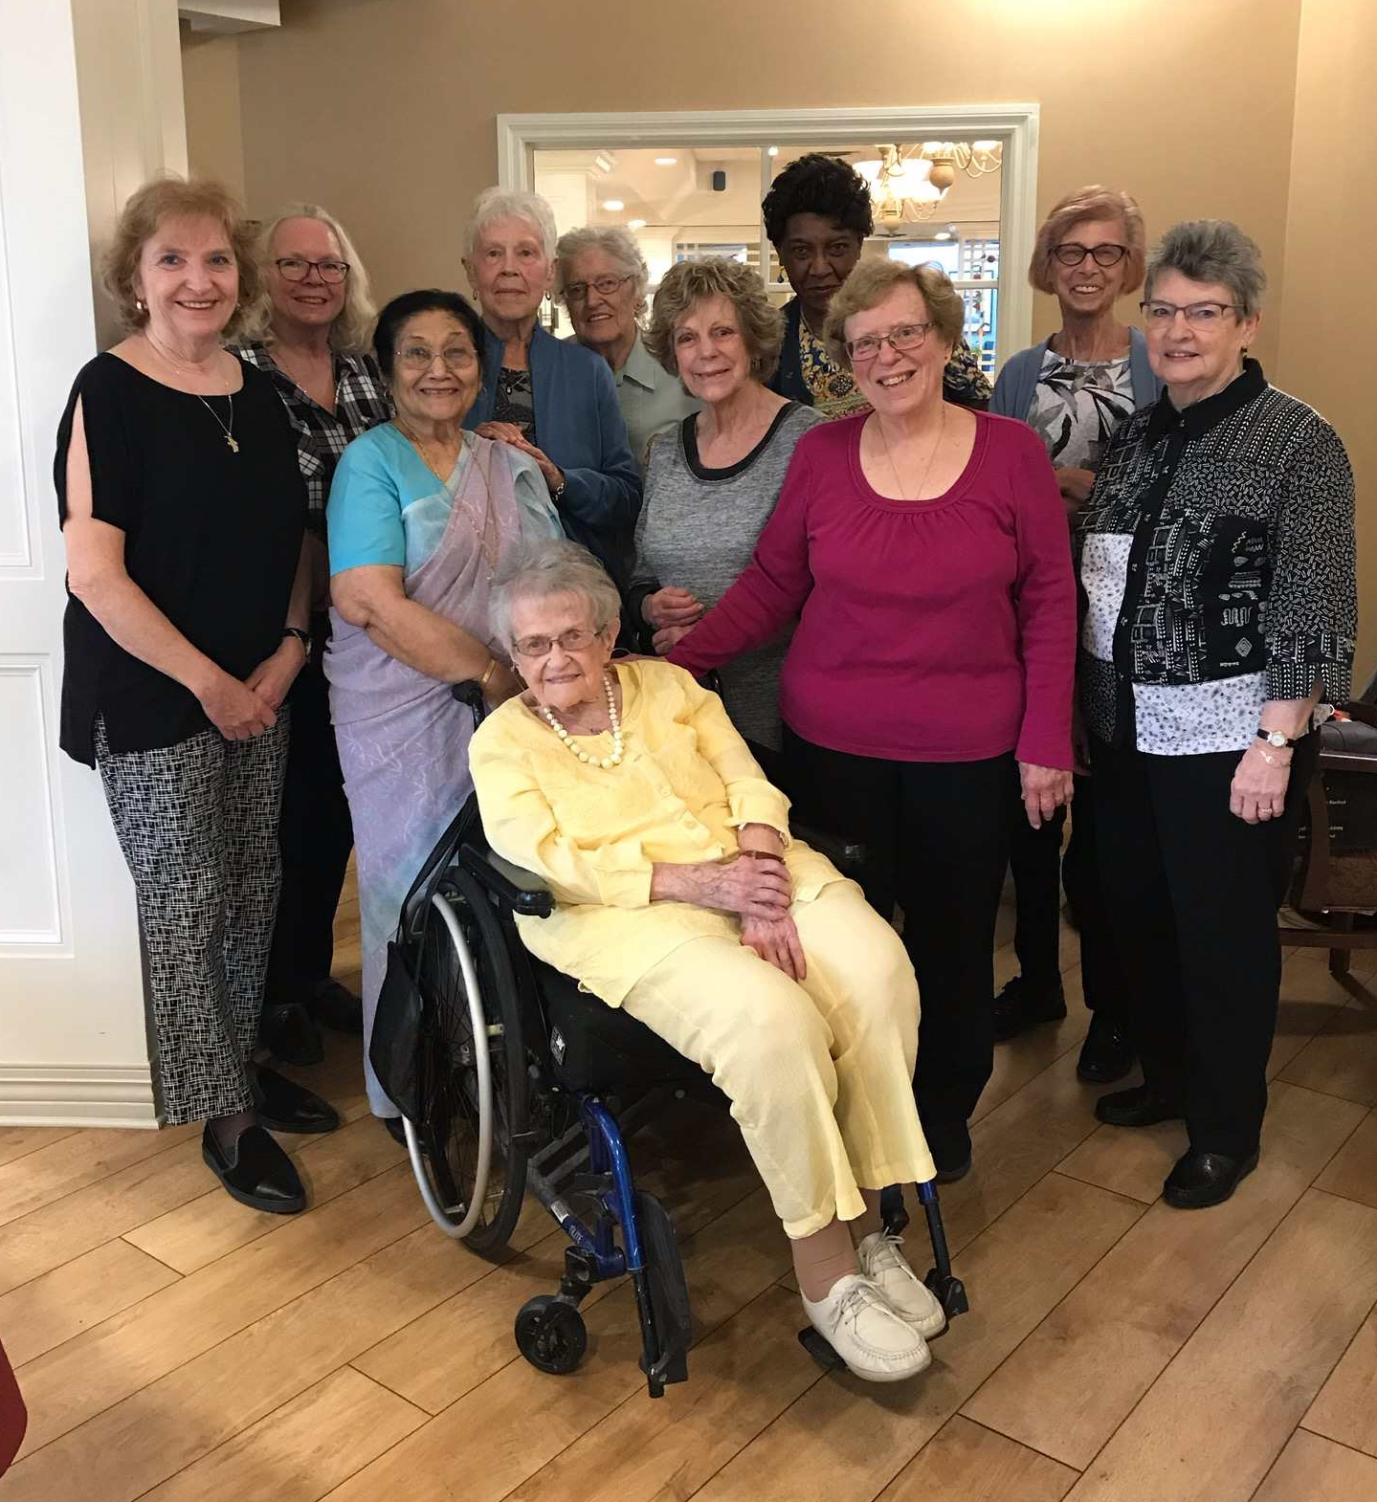

MEMBER DEVELOPMENT and CARE (Cont’d)

Adult Education 2019
Lent Film Study
For three Tuesday evenings in March and April, a group of over 20 people watched the film “The Way” and discussed it over a potluck meal. The film, starring Martin Sheen, followed a father’s pilgrimage on the Camino de Santiago, following the sudden death of his son. The impact of his journey transforms him and his travelling companions. Our conversations were diverse and engaging, and the food was delicious.

Prayer Shawl Ministry
The first Wednesday of each month at 2pm finds the narthex of the church filled with conversation, laughter and the sounds of needles clicking as long-time knitters and newbies combine our talents to create beautiful shawls that will be shared by our pastoral care visitors. The shawls are also woven or crocheted – any craft or skill is most welcome. The intent is to send out the completed shawls to those in need of prayer, if you wish to request one please speak to
Rev Kathi Phillips. New this year we also have Prayer Buddies – little dolls hand made by Carole Neely – for children in need of prayer. Everyone is welcome to join us at our monthly gathering, no experience
required!

Book Club
We are well into the third year of our book club with 10 women from EMUC who meet on a monthly basis from September to June. A variety of books including fiction, nonfiction, drama, historical, fantasy and biographies are selected by our members with each monthly meeting hosted by a different participant. Getting together on a monthly basis is not only fun, but it serves as a wonderful source of mutual support and fellowship. This February we started an additional book club made up of new members who will be supported by a few of our original members for a period of time to help get them going. There are many opportunities for these groups to collectively meet from time to time and we will be exploring ideas over the months to come.

Figure 2 One of the Book Clubs



Submitted by Cathy Kiteley

MEMBER DEVELOPMENT and CARE (Cont’d)

EMUC Striders
The EMUC Striders ventured into the outdoors to enjoy our natural surroundings on several occasions this year.
- -November 10TH– a leisurely walk through the valley of the Etobicoke Creek through Garnetwood and Fleetwood parks.
- September 22nd - explored the Forks of the Credit, starting at the Belfountain Conservation Area, and trekking to the Willoughby Property with views of the Stonecutters Dam – Quarried stone used for Ontario Legislature and Toronto Old City Hall
- June 2nd – went off to Hewick Meadows to explore a section of the David Culham trail.
- April 7th – a late spring jaunt in Meadowvale Park starting at the Credit Valley Conservation Authority lands

The Mindful Steps group from Applewood UC were invited on these walks, and we were joined by a family of four in the Spring. Look for announcements for our next outings:

Coming 2020:
- February: A visit to Eurchless Museum to honor Black History Month
- April - a walk through Timothy Street Park (another section of the Credit River)
- Later in May - possibly the Royal Botanical Gardens!!
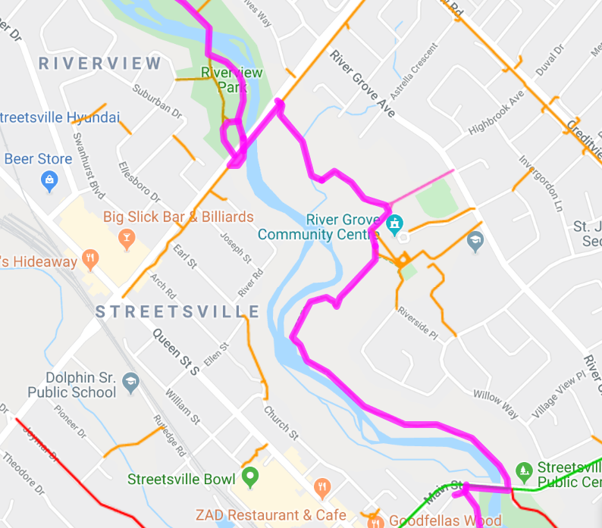

MEMBER DEVELOPMENT and CARE (Cont’d)

Welcome Group
Valerie Carter continues in her role as Coordinator of the Welcome group. There are currently 13 active members in this program. A gift bag containing a "peace candle," as well as information about the origins of the peace candle is offered to newcomers who express an interest in making EMUC their church home. A copy of the Mission Statement is also given to support engagement and dialogue with newcomers.

It was decided that the weekly Sunday announcement insert, and monthly Communique would not be placed in the bags, as the excess paper was not in keeping with being environmentally responsible. This information is provided in the worship Order of Service and on the EMUC website.

All members of the Welcome Group continue to provide support to the assigned Welcome Host each Sunday by seeking out any new attendee and redirecting them to the assigned Welcome Host.

During 2019, the group sought to keep track of how many bags were distributed. It is estimated that approximately 49 bags were given in the year. We will continue to track this information.

A small number of newcomers have been observed returning on subsequent Sundays.

The group continues the goal to engage newcomers and keep track of the number of bags being distributed as a means of capturing the approximate numbers of new attendees. Newcomers appreciate our warm reception and interest in them. Everyone at EMUC is encouraged to extend our hospitality to visitors to help them feel at home.

Submitted by Val Carter

Daytime Men's Group
The Erin Mills United Church Daytime Men's Group meets the second Wednesday morning of every month at the home of Bob Cairns. Stimulating and intelligent conversation takes place. We are lucky to be retired, alive and able to enjoy each other's company. Life is good. Friends are better! God's blessings bring us close friendship. If you are interested in joining us, please call Terry French at 905-820-2138. Everyone is welcome!

Submitted by Terry French

Bunch for Lunch
The EMUC “Bunch for Lunch” is an informal group that gathers after service at a local restaurant to share a meal and fellowship. Separate bills are provided to keep it simple. In 2019 we met on four occasions with 15 to 20 people attending each time. We will continue in 2020. All are welcome, even last-minute deciders.

Submitted by Larry van Goozen

MEMBER DEVELOPMENT and CARE (Cont’d)
Bridge Club
Partners take turns hosting and visiting month by month, giving each team a chance to play each of the other teams through the season. Being in someone’s home lends to a friendly social atmosphere. New players are welcome at any time, as well as players who wish to substitute on occasion. Keep in mind the final gathering for the season will take place on Friday June 19, 2020.


Submitted by Tim Hayes

Women for Women
Women for Women met on five Friday evenings throughout 2019 plus a one-day retreat in May. A total of almost 140 women attended our events.
- In January we were "Lighting Up the Dark" making bath salts, candles & cocoa mix.
- In March, Dianne Ticknor sang her own songs and spoke about "Help for Women in Shelters."
- In April, Mary Lynn Peters taught us the "ABCs of Healthy Aging".
- In October, we went on a guided Ghost Walk in downtown Oakville.
- November saw the return of Anne Bokma to speak about her new book.
- Women for Women (through Laura Macro) once again obtained tickets for the Salvation Army Christmas Concert.

Our annual retreat took place at EMUC in May with the theme of "Living Colours." We explored past (childhood games), present and future (making a teacup garden) in the morning followed by a delicious lunch. In the afternoon, guest artist, Khaula Mazhar, led us in a painting workshop where we each created a beautiful canvas to take home.

All women of EMUC and friends are invited to attend any of our events. Ideas for speakers/events and assistance planning or helping on event evenings are always welcome.
Submitted by Cathy Scattergood

Submitted by Cathy Scattergood

MEMBER DEVELOPMENT and CARE (Cont’d)

Bogeys to Birdies
From May to September 2019, the women golfers of EMUC enjoyed playing ‘Nine and Dines’ almost every week over the summer, although May was a slow start because of the weather. There were 18 members and between four and eight golfers played each session.

Blue Springs Academy course was our ‘home’ course; however, once per month we played alternative longer courses. The Oakville Executive course was new for the group this year. The season started with group lessons for those interested in lessons at Vic Hadfield’s Golf and Learning Centre. We closed the season with a special evening at Rattlesnake Golf course.

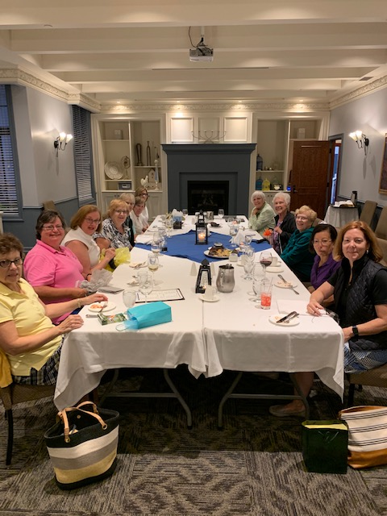

Golfing is a fun way to stay connected over the summer. New members are always welcome no matter what level of golf. Come and join us next season!

Co-ordinators: Kathy Andres and Barbara Jennings

Communications Committee

The Communications Committee supports the Leadership Circle, committees and all groups to ensure news and event information gets to the congregation and the community. In 2019, 10 Communiqué publications, 50 Friday Messages and 3 special announcements were produced and sent. The average ‘open’ rates for the Communiqué and the Friday Message were 73.1% and 73.4%, respectively. Five Women for Women invitations were sent over the year.
The EMUC website was updated on a regular basis. Seasonal banners were used during the church year. During 2019 there were 1,962 unique visitors and 3,678 visits to the website. There were 9,637 pageviews and most visits were made by people from Mississauga, Toronto, Newmarket, Brampton and Oakville. Visitors to the church for special services stated that they learned about EMUC through the website. Late in 2019, the website was changed to reflect the values/strengths identified in the Congregational Growth work and this will continue in 2020.
Communications was key for the Stewardship campaign. Stewardship information was distributed primarily through the newsletter and Friday Messages. There was a good response to these efforts which exceeded the 2018 campaign.
Other forms of communication used in 2019 were: announcements placed in the Mississauga News, church bulletins, flyers, posters and the LED sign. Announcements were posted electronically in the Mississauga News, Events page and from time to time were found in the printed paper. There were repeated electronic weekly messages for the Wednesday Prayer and Communion service as well as for Christmas and Easter activities, the annual garage sale, Black History month activities and the Blessing of the Animals. Church bulletins were completed weekly. Flyers and posters were prepared for five or six special services/activities. Facebook was used to post general information and events. Pictures of events and special services were placed on the bulletin board in the narthex for all to enjoy.
Thank you to each committee member for all the time you contribute to communications:
Janet Morrison Communiqué and Friday Message editor
Owen Luo Website design
Mary Anna Williams Newspaper advertising, lower hall and stairway bulletin boards, posters
Sylvia Arnold Bulletin inserts, bulletin boards, flyers, posters
Cynthia Young Sign messages, proof-reader for Communiqué
Barbara Jennings Chair, website content, Communiqué layout, Friday Message backup, picture bulletin board, Facebook

Communications Committee Report (cont’d)
A special ‘thanks’ goes to Tim Hayes and Karen Colwell who take most of the photographs seen on the bulletin board and in the newsletter articles.

Communications is an important function which continues to grow year over year. If you are interested in helping with any function, please speak to Barbara Jennings.

Submitted by Barbara Jennings, Chair, Communications Committee

FINANCE

The Finance committee is responsible for all of EMUC’s financial matters. The committee meets monthly to review the church’s current financial position, discuss any financial issues and report to the Leadership Circle.

Finance Committee
Dave Leeder-Chair & Treasurer
Marianne McVittie-Financial Analyst
Kathy Andres- Designated Accountant
Mike Ogilvie-Envelope Secretary
Lou Santamaria-Member representing Investment Committee
Peter Kiteley- Bookkeeper (January to June)
Nancy Ekels-Bookkeeper (July to December)

Finance Coordinators
Debbie Sturgeon -Offering Counting
Carole Neely -Payroll

To start, we wish to recognize and thank Peter for his many years of work on the Committee and extend our best wishes to him in his retirement.

We wish to thank all you who contributed financially to EMUC during 2019. Revenues were above budget in many areas: givings 2.5 %, rental revenue 14.3% and fundraising 1.4 %. Your support is greatly appreciated. The generosity of the congregation was demonstrated over-and-over again as shown by the responses to special appeals and support for the ongoing operations of the church. We still however have a revenue issue. For the last four years our operating expenditures have exceeded the revenue received.
2015-Surplus of $2,244
2016- Deficit of $2,324
2017- Deficit of $2,155
2018- Deficit of $9,329
2019- Deficit of $1,218

For 2019 a deficit of $25,650 was projected but over budget numbers for givings ($4161) and rental revenue ($6425) and under budget expenditures of $12,691 resulted in a lower than expected deficit. Volunteer help was the main contributor to the lower expenses as many individuals helped clean the building when our cleaner was off on sick leave and Nancy Ekels volunteered to be our Bookkeeper when these duties were removed from the office position reducing paid hours from 35 to 30.

We ended 2019 with more good news as our stewardship program showed a modest increase in projected givings for 2020. The draft budget that you will see at the congregational meeting on March 1st , will show a projected increase in givings in 2020 to $165,000, an increase of $2000 from our 2019 projection. The draft does have a projected deficit but only 50% of last year.

Finance (cont’d)
Fortunately, at this stage, we do have an operating surplus from previous years to cover the deficit but obviously this will gradually be depleted. We are exploring other sources of revenue such as the cell towers, but there must also be an intensive focus on congregational growth. The Leadership Circle has started this work, which will continue to be a key goal for 2020. In addition, we will review all aspects of our budget to determine if there are ways to do things differently to reduce expenditures.
Working together we are confident that we will be able to meet these challenges.

Submitted by –Dave Leeder-Treasurer/Chair of Finance

FUNDRAISING REPORT 2019
The chart below shows our fundraising results for 2019.On behalf of the congregation, the Leadership Circle would like to extend our appreciation to those who made these activities possible including the organizers and other volunteers and all those attend the events and purchase items offered for sale. The goal for 2019 was $16,000 and as you can see we were successful. Congratulations.

Loaves & Dishes | $ 4,255
Garage Sale | $ 6,014
Pancake Supper | $ 356
Euchre | $ 104
Fundscrip | $ 1,884
Peter’s Retirement Dinner | $ 2,105
Men’s Choir Concert | $ 1,510
TOTAL | $16,228

Submitted by Dave Leeder Treasurer /Chair of Finance

Office Administration

Office Administrator
“There is nothing wrong with change if it is in the right direction.”
Winston Churchill
This has been a year of transition and change in the office at EMUC. You said goodbye to Peter Kiteley, your longtime administrator, and Sylvia Arnold kept things going until I started in my new role as your Office and Building Administrator. Winston Churchill talks about change and to say my life has changed is an understatement, but I know I am headed in the right direction! I am where I want to be, and I hope the congregation of EMUC feels the same way.
Some things remain the same: Rhana and Georganne fold my bulletins, Cindy and Sylvia use their creativity to visually bring our service to life, Mary Anna searches for volunteers to assist in our Sunday services, and members of EMUC always answer her call. They are a part of my weekly routine; because of their support and hard work, I am settling into my new role, and becoming comfortable and confident in my abilities.
I have had to step into some very big shoes. Peter knew this job inside and out; while I, on the other hand, have had to rely on so many people to answer questions and to show me how things are done because everything is new. Peter, Sylvia, David L., Ian, Kathi, Laura M., thank-you for your constant support and patience in answering my questions.
To my Rental Assist Team (the RAT Pack) as I fondly refer to them: David B, David L, Mary Anna, Sylvia and Dave, Ian, Debbie S, Mike O; thank-you for stepping up to help with our rentals and lending your muscles for set ups, and tear downs.
To the many groups who add to the life and energy, and yes the coffers here at EMUC. You give us the opportunity to socialize, enable us to live our faith in the real world, and allow us to honor God outside of Sunday service. You make EMUC not just a vibrant community, you make it a family.
I encourage you all to read the individual committee/group reports, and make note of the people, and the “gifts” they give throughout the year. Church isn’t just a building, it is its people, and as a former outsider, I can honestly tell you our “church” is beautiful indeed!

Other Group Activities (Renters)
EMUC is fortunate to have many fulltime tenants: AA, EMYC, Covenant Church, Write on Q, Tai Chi, Terry’s Yoga, Ontario Male Chorus, MBCT, and our parking rentals, to name a few. Our rentals came in 14.3% above budget, which is vital and important to our sustainability, but remember, these rentals are not just about money. We have tried to enhance our focus by making EMUC an active and vibrant part of our Mississauga community. When we open our doors to children’s recitals and for local organizations like Heart House Hospice, The Lion’s Club, the Lifelong Learning lecture series (often at cost); we show off our beautiful sanctuary and provide living proof that we care about our neighbours. Thank you RAT for making this possible. Without your willingness to “set up”, “take down”, and let people in and out of our building, many of these activities could not take place. Submitted by Tina Driscoll,, Office & Building Administrator

Office Administration (cont’d)

Ian MacRae Bursary
The Ian MacRae bursary is offered annually to students entering their first year of a post-secondary education. The funds are derived from the interest of the endowment fund, supplemented by monies from the Benevolent Fund. This award is given in memory of Ian MacRae, a strong supporter for youth in the wider Erin Mills Community. One bursary was awarded in 2019.

MINISTRY and PERSONNEL COMMITTEE
The Ministry and Personnel Committee is an established committee that reports into the Leadership Circle of Erin Mills United Church. Our Committee is tasked with liaising with the fulltime ministerial and lay staff and the congregation. There is formality to the committee – as set out in the United Church of Canada Manual – and most aspects of the discussions whether internally amongst the committee or with personnel, are of a confidential nature.
Our committee make up:
Chair, M&P David Hope
Liaison to Kathi Philips David Hope until Nov 2019
Trish Campbell as of Dec 2019
Liaison to Tina Driscoll Laura Macro
Liaison to Len Feldman Muriel Hamdani

We are blessed to have a strong staff team. Kathi Philips, our minister was in her second full year in 2019. Peter Kiteley, who provided significant leadership and service as office administrator and building coordinator retired mid-year. The congregation celebrated his ongoing dedication to EMUC with a farewell to paid service, however Peter remains a committed member of our congregation. We were lucky when Tina Driscoll joined our team as the new Office and Building Administrator, bringing her many gifts and talents to the job. Len Feldman continues to provide musical leadership and talents that provide inspiration to our church community.
Our Committee met periodically throughout 2019 discussing the various administrative and human resources related matters. M & P reported to the Leadership Circle on a periodic basis.
We are blessed by the many talents and dedication of the staff team and pledge to support them as we continue to evolve in 2020.
Submitted by David Hope, Chair Ministry and Personnel

BUILDING and PROPERTY

This has been a relatively steady year for Building & Property activities with no major unexpected repairs required in 2019. The work we did in 2018 on the Tower and roof repairs, to ensure the integrity of the building, appears to be holding up well. The following summarizes the major activities in 2019.

EMUC Outside Concrete Stairs
During the winter/ spring period of 2018, the front stairs concrete had cracked and spalled, mainly from the salt use in the winter. We did some temporary repairs in August 2018 at that time to remove any potential tripping hazard on the stairs. In the winter/ spring of 2019 we had more damage occur on the main set of stairs leading to the office.
We discussed with the contractor possible fix and they recommended a full upgrade to this particular set of stairs and railings. After reviewing other work they had performed like this and getting approval of costs from LC, it was decided to upgrade this set of stairs in September 2019 as a test case. So far, the repairs and improved look of stairs has held up this winter.
Plan for 2020 is to consider, same type of upgrade to the other sets of stairs and railings, assuming there is sufficient funds to cover the costs.

Organ Repairs
The organ had not been working for some time. We had received a request in mid 2019 to try and get it fixed, since it was needed at some events. After trying several sources to get it repaired, Tina Driscoll our new office administrator, was successful in finding someone who could do it and price that was reasonable.
Biggest challenge for us was getting the speakers covers off to get the repairs done. After help from several in the congregation we were successful, and the organ repairs were completed. We can now enjoy the organ music when Len Feldman plays it so well.

Tables
Some of the plastic rectangular tables were in poor condition. After trying to fix them several times, it was decided to check them and decide to dispose of some and purchase some new replacement tables. Ten (10) new tables and two (2) trolleys for the rectangular tables were purchased in late 2019. These were delivered in 2020, assembled and now in service in the lower hallway.

Cleaning of Church
In early 2019 our contract cleaner, had an accident and broke her wrist and was not able to clean the church for at least 3 months. I am happy to report that the church was kept clean during this period with the help of many volunteers from the congregation. There are too many to name but offer you a “BIG THANK YOU” for all your help. We renewed the cleaning contract with Renata and is now being supervised by Tina Driscoll.

BUILDING and PROPERTY (cont’d)

HVAC System
Generally, system has been performing reasonably well in 2019 but there was an issue with the control program in late fall when it was found out the software version we had was no longer supported by the supplier. We were able to get the program installed our new office computer with support from Brian Takayesu,

Other Items
- Otis serviced the lift in July 2019 to meet TSSA safety inspection requirements. In October 2019 it was decided to change the service contract to Savaria. They will start the servicing of the lift in 2020.
- Performed annual maintenance and inspection of the HVAC system, fire protection system and security system during 2019.
- Signed spring /summer Property Maintenance contract with same contractor for 2019. Costs increased about 7 per cent. We also signed contract with them to perform the 2019/20-snow removal and salting since their increased contract costs were still lower than quotes we received from other contractors in 2018.
- We also performed lots of other smaller repair jobs inside the church and the maintenance of the church property in spring and fall on our own during 2019 and I would like to thank everybody, who helped get them done. I would like to give a “Big Thanks” to all the volunteers including Peter Kiteley, Sylvia Arnold, Fred Shepley, Dave Brignall, Mary Anna Williams, Barb Jennings, Gary Hines, Sue and Mike Ogilvie, Paul Marot and Dave Leeder for their continued support. If I have missed the name of others who helped out, I apologize, but know your support is very much appreciated.
Submitted by Ian Love – Chair Building & Property

TRUSTEES

The role of the Trustees is to monitor all the assets of the church to ensure that they are used in accordance with the policies of the United Church of Canada and the laws of Canada. Examples of the assets of the church include, without limitation, land, buildings, money, investments, furniture and equipment.

Listed below are the 2019 EMUC Trustees:

Chair of Trustees: Kathy Andres
Members at Large: Laura Macro, Paul Marot, Neil Ekels
Leadership Circle Members: David Leeder, Joanne Hines
Minister: Kathi Phillips

Members of the Trustees
The Trustees welcomed Joanne Hines as a new member of the Trustees. Joanne served as the Chair of the Leadership Circle from 2015 – 2017 and is currently The Chair of Children and Youth.

TRUSTEES (cont’d)

Investments
The Trustees, through the Investment Committee, reviewed the performance of our investments for the year. The markets were good this year giving us better returns than in the last few years. However, one of our mutual funds, RBC Fidelity Canadian Large Cap is underperforming and the Investment Committee is recommending changing to this fund. The Trustees will review the proposed changes in early 2020. Please see the attached investment analysis.

Insurance
The Trustees performed a detailed review of our insurance policies with the help or our investment broker to ensure that we have adequate coverage. No changes to the policies were recommended.

Financial Records
Douglas Spence, CPA, performed a review of the 2019 EMUC financial records. . There were no major changes to the year-end records, Douglas issued a clean review opinion and said that there were no internal control issues.

Policies and Procedures
There were no changes to our policies and procedures this year.

Other
The contract with Shared Network Canada to lease space for cell pole towers that they want to install has been signed but the commencement is being delayed until a meeting with the residents is held. This is the responsibility of Shared Network Canada in conjunction with the city.
The status of the EMUC rentals was reviewed. Rentals are doing well and no problems were found with the procedures currently being used.

D. Leeder gave an update on building repairs. The largest item was current and proposed repairs to the front stairs which will cost approximately $12,000 and will be done over at least 2 years.
Submitted by the Trustees

INVESTMENT SUMMARY

Type | Description | Year End  Balance | Return
Interest Accounts | RBC | 25,329 | 1.6%
GIC’s | 8 GIC’s with  Redemption Dates  From 2020-2023 | 136,098 | 2.4%
Mutual Funds | RBC | 39,557 | 3.0%
 | BMO | 29,446 | 18.9%
 | Canoe | 88,363 | 21.9%
 |  | 157,366 | 18.0%
Total |  | 618,793 | 6.4%

In Memoriam
In 2019, we mourned the death and celebrated the lives of:

David Lee
Passed Away April 17, 2019
David Peter Milton Thomson
Passed Away August 5, 2019
Trevor Harry Appleby
Passed Away September 12, 2019

Celebrations

Baptisms
Baptized at EMUC April 28, 2019
Daughter of Danielle Fearon and Blake Madill

Welcomed Into Membership
Lynda Appleby Lorraine Moore
Sarah Philips Caren Sexton
Audrey Thomson David Thomson

Retirement of Peter Kiteley
On May 31, 2019 Peter Kiteley retired, after 14 years as Office Administrator & Building Co-Ordinator at EMUC. Peter’s tenure included a period in EMUC’s history full of transition. Despite changes in staff and large building projects that impacted life in the building, Peter was always available and supportive to the ministry staff – Kathy Toivanen, Roni Beharry, Jackie Burnie, and Kathi Phillips; as well as the Leadership Circle and members of the congregation.

Peter’s willingness to ‘get to it’ with a smile, his welcoming presence toward daily visitors and his contribution to keeping the building wheels turning, no matter what, endeared him to many, both inside and outside EMUC.

After service on Sunday May 26th EMUC thanked Peter with a gift, and hospitality time. At a retirement dinner celebration on May 31st, one hundred friends joined Peter and his family to thank him with food, fellowship and song for his years of service to EMUC. Since his retirement Peter has continued to provide volunteer support in a variety of ways. Thank you Peter!

Submitted by Laura Macro, Ministry & Personnel Liaison

Statistics (2015-2019)

YEAR | 2019 | 2018 | 2017 | 2016 | 2015
*Members | 155 | 195 | 312 | 316 | 310
Households under  Pastoral Care | 183 | 189 | 214 | 204 | 209
Weddings | 0 | 0 | 1 | 1 | 0
Weddings - Community | 1 | 2 | 0 | 2 | 1
Baptism - children | 1 | 5 | 5 | 2 | 1
Baptism - adults | 0 | 0 | 1
Transfer | 2 | 0 | 0 | 0 | 2
Re-Affirmation of Faith | 4 | 0 | 0 | 4
Profession of Faith | 0 | 0 | 0 | 6
*Average Attendance | 63 | 75 | 75 | 73 | 86

* Members numbers reduced due to update of congregational list
**Calculated using the average attendance figures from October & November 2019

FINANCIAL STATEMENT AND OPERATING BUDGET

