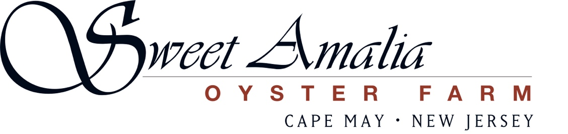

Oyster Farm Internship

Sweet Amalia Oyster Farm is now accepting applications for our high school and college student internship program for the 2023 summer season. This is a great opportunity for students who prefer hands-on work and love being outdoors. If you’re thinking about a future in environmental, marine science, conservation, aquaculture, farming, fishing, or outdoor recreation, our internship will provide a chance for you to “test the waters”.

- We are located in Cape May County
- Our daily workday is typically from 3-5 hours – start time will fluctuate daily as we can only work at low tide. Start time varies, shifting by about one hour each day
- This is a paid internship paying $14.50/hour.

About us
Sweet Amalia oyster farm produces exceptional oysters with passion and pride. Located in Cape May County New Jersey we strive to continually perfect our craft while embracing environmentally sound and sustainable aquaculture methods. We direct distribute our oysters from farm to table to our own award winning restaurant (Sweet Amalia Market & Kitchen) and to some of the finest restaurants in Philadelphia and along the southern Jersey Shore.

Our interns
We are seeking interns who share a strong work ethic, an interest in local food ways, a love of the outdoors, and a positive attitude to assist with daily operations and contribute to growing the farm to its full potential.

Interns will assist with all aspects of farm work – deployment of grow-out gear, sorting and grading oysters and oyster seed, power washing gear and oysters, and other related tasks as needed.

- Must be willing to work a tide dependent schedule with varying start and end times
- Must be able and willing to lift 50 pounds
- Must be willing to work outdoors
- Must have a positive attitude and be flexible

To Apply: Please send an email expressing your interest to sweetamaliaoysters@gmail.com. Please tell us a little bit about yourself and provide information and contact information for one person who can serve as a reference for you. Sweet Amalia Oyster Farm is woman owned and is an equal opportunity employer, or EOE.

Check us out:
www.sweetamalia.com
@sweetamaliamarket
@sweetamaliaoysters

