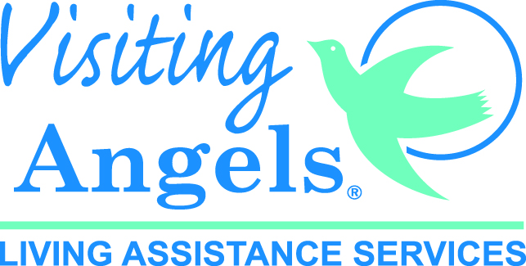
3350 Country Club Drive, Suite 101, Cameron Park, CA 95682
4465 Granite Dr, #1016, Rocklin, CA 95677
530-677-4400 916-424-4400 www.VisitingAngels.com/GoldCountry

February 1, 2022

FOR IMMEDIATE RELEASE

Visiting Angels Gold Country Receives 2022 Best of Home Care® – Leader in Experience Award

Cameron Park, CA – Visiting Angels In-Home Care announced today that it received the distinguished 2022 Best of Home Care –Leader in Experience Award from Home Care Pulse, the leading firm in experience management for home care. The Leader in Experience Award is the highest recognition awarded by Home Care Pulse and is given to select home care businesses that consistently rank among the very highest in 10 or more quality metrics. As a Leader in Experience, Visiting Angels is now recognized among the top 10% of home care providers participating in the nationwide Home Care Pulse Experience Management Program.

This accomplishment demonstrates Visting Angels’ long-term dedication to excellent care and quality improvement. To qualify for this award, 10% of Visting Angels’ clients and caregivers were interviewed each month by Home Care Pulse. Over a 12-month period, Visting Angels received high client and caregiver satisfaction ratings in areas such as caregiver training, compassion of caregivers, communication, scheduling, client/caregiver compatibility, and more. Using feedback from clients and employees, as well as quality benchmarks from Home Care Pulse, the Visting Angels management team set goals to reach the highest level of Experience possible.

“I am so blessed to have found a business that allows me to do what I love most – serving my community and our seniors. What an incredible honor to be awarded the Leader in Experience designation. This award represents the hard work and commitment of our office team and our wonderful caregivers which has been especially challenging during the pandemic,” says Gail Lohmann, president and founder of Visiting Angels Gold Country.

The Best of Home Care – Leader in Experience Award highlights the top-performing home care businesses in the nation. Home Care Pulse believes that by honoring these providers, families looking for in-home care for a loved one will be able to recognize and choose a trusted home care provider.

“At Home Care Pulse, our mission is to help home care businesses create an experience that goes beyond client and caregiver expectations,” says Todd Austin, President of Home Care Pulse. “When we see agencies like Visting Angels that have so effectively provided outstanding care and employment experiences, we know we’re on the right track. Visting Angels has worked extremely hard to prioritize high-quality care and employment, and their work hasn’t gone unnoticed. This award allows them to show proof of quality to potential clients and caregivers.”

To find out more about Visting Angels’ commitment to experience, please visit www.VisitingAngels.com/GoldCountry or call 530-677-4400

###

About Visting Angels
Since 2009 Visiting Angels Gold Country has provided non-medical home care to adults and seniors throughout Sacramento, El Dorado, Placer and Amador counties. Chosen consistently over the years as “Best of Home Care” by Style Magazine, the Mountain Democrat and by the El Dorado Hills Telegraph readers, Visiting Angels provides their clients with trained caregivers who assist their clients with simple companionship, personal care (bathing, showering, toileting, etc.), dressing, transfers, medication management, dementia/Alzheimer’s care, transportation, shopping, cooking and light housekeeping.

About Home Care Pulse
Home Care Pulse leads the home care industry in experience management, online training, and review management. Through its Care Intelligence Platform, HCP empowers home care providers to attract and retain caregivers even during a historic caregiver shortage. HCP also conducts the annual Home Care Benchmarking Study, the most comprehensive survey of home care providers in North America and administers the annual Best of Home Care awards to agencies that achieve best-in-class client and caregiver satisfaction scores. For more information, visit https://www.homecarepulse.com/.

